UNITED STATES
SECURITIES AND EXCHANGE COMMISSION
Washington, D.C. 20549
FORM 8-K
CURRENT REPORT
Pursuant to Section 13 or 15(d) of The Securities Exchange Act of 1934
Date of Report (Date of earliest event reported): July 24, 2026
FIRST WESTERN FINANCIAL, INC.
(Exact name of registrant as specified in its charter)
Colorado |  |  | 001-38595 |  |  | 37-1442266
(State or other jurisdiction of  incorporation or organization) |  |  | (Commission  File Number) |  |  | (I.R.S. Employer  Identification No.)
1900 16th Street, Suite 1200  Denver, Colorado |  |  |  |  |  | 80202
(Address of principal executive offices) |  |  |  |  |  | (Zip Code)
Registrant’s telephone number, including area code: 303.531.8100
Former name or former address, if changed since last report: Not Applicable
Check the appropriate box below if the Form 8-K filing is intended to simultaneously satisfy the filing obligation of the registrant under any of the following provisions:
o |  |  | Written communications pursuant to Rule 425 under the Securities Act (17 CFR 230.425)
o |  |  | Soliciting material pursuant to Rule 14a-12 under the Exchange Act (17 CFR 240.14a-12)
o |  |  | Pre-commencement communications pursuant to Rule 14d-2(b) under the Exchange Act (17 CFR 240.14d-2(b))
o |  |  | Pre-commencement communications pursuant to Rule 13e-4(c) under the Exchange Act (17 CFR 240.13e-4(c))
Indicate by check mark whether the registrant is an emerging growth company as defined in Rule 405 of the Securities Act of 1933 (§230.405 of this chapter) or Rule 12b-2 of the Securities Exchange Act of 1934 (§240.12b-2 of this chapter).
o |  |  | Emerging growth company
o |  |  | If an emerging growth company, indicate by check mark if the registrant has elected not to use the extended transition period for complying with any new or revised financial accounting standards provided pursuant to Section 13(a) of the Exchange Act.
Securities registered pursuant to Section 12(b) of the Act:
Title of each class |  |  | Trading Symbol |  |  | Name of each exchange on which registered
Common Stock, no par value |  |  | MYFW |  |  | NASDAQ Stock Market LLC

Item 7.01 Regulation FD Disclosure.
First Western Financial, Inc. (the “Company”) is furnishing investor presentation materials as Exhibit 99.1 to this Form 8-K, which may be presented at meetings with investors, analysts, and others, in whole or in part and possibly with modifications, during the fiscal year ending December 31, 2026.
As provided in General Instruction B.2 to Form 8-K, the information furnished in Exhibit 99.1 of this Current Report on Form 8-K shall not be deemed “filed” for purposes of Section 18 of the Securities Exchange Act of 1934, as amended (the “Exchange Act”), or otherwise subject to the liabilities of that section, and such information shall not be deemed incorporated by reference in any filing under the Securities Act of 1933, as amended, or the Exchange Act, except as shall be expressly set forth by specific reference in such filing.

Item 9.01 Financial Statements and Exhibits.
(d) Exhibits.
Exhibit  Number |  |  |  |  |  | Description
99.1 |  |  |  |  |  | First Western Financial, Inc. Investor Presentation
104 |  |  |  |  |  | Cover Page Interactive Data File (the cover page XBRL tags are embedded in the Inline XBRL document)

SIGNATURES
Pursuant to the requirements of the Securities Exchange Act of 1934, the registrant has duly caused this report to be signed on its behalf by the undersigned, thereunto duly authorized.
 |  |  |  |  |  | FIRST WESTERN FINANCIAL, INC.
Date: July 24, 2026 |  |  |  |  |  | By: /s/ Scott C. Wylie
 |  |  |  |  |  | Scott C. Wylie
 |  |  |  |  |  | Chairman, Chief Executive Officer and President


INVESTOR PRESENTATION July 2026

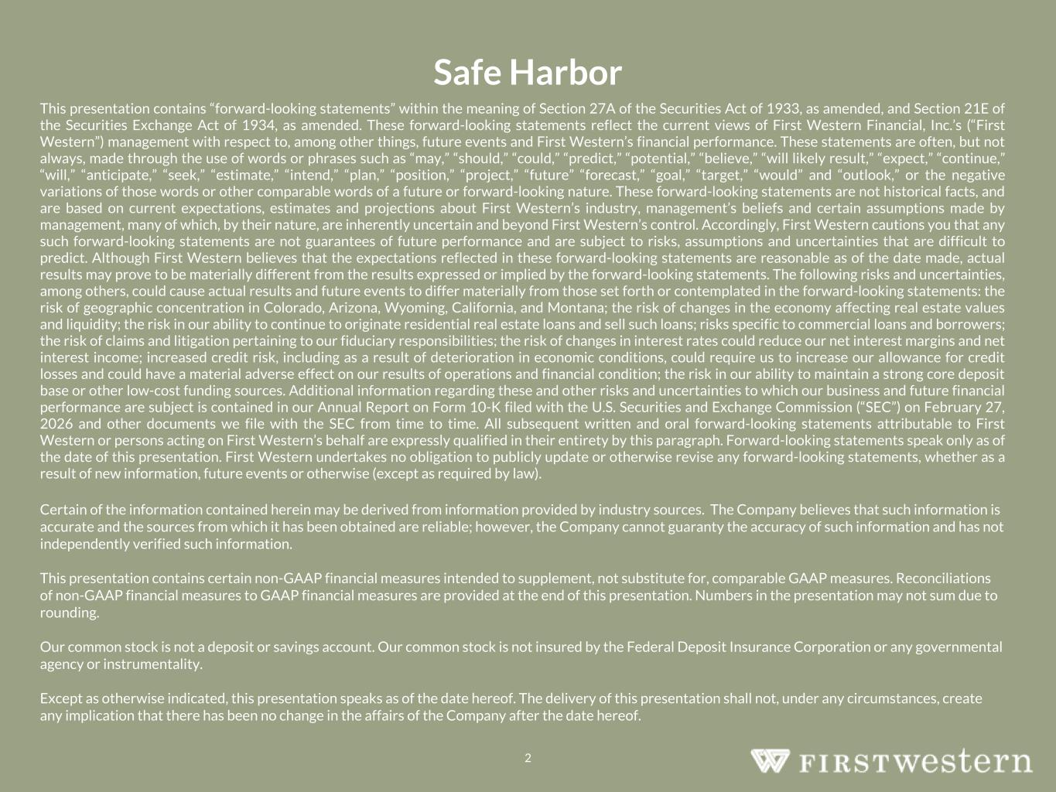
Safe Harbor 2 This presentation contains “forward-looking statements” within the meaning of Section 27A of the Securities Act of 1933, as amended, and Section 21E of the Securities Exchange Act of 1934, as amended. These forward-looking statements reflect the current views of First Western Financial, Inc.’s (“First Western”) management with respect to, among other things, future events and First Western’s financial performance. These statements are often, but not always, made through the use of words or phrases such as “may,” “should,” “could,” “predict,” “potential,” “believe,” “will likely result,” “expect,” “continue,” “will,” “anticipate,” “seek,” “estimate,” “intend,” “plan,” “position,” “project,” “future” “forecast,” “goal,” “target,” “would” and “outlook,” or the negative variations of those words or other comparable words of a future or forward-looking nature. These forward-looking statements are not historical facts, and are based on current expectations, estimates and projections about First Western’s industry, management’s beliefs and certain assumptions made by management, many of which, by their nature, are inherently uncertain and beyond First Western’s control. Accordingly, First Western cautions you that any such forward-looking statements are not guarantees of future performance and are subject to risks, assumptions and uncertainties that are difficult to predict. Although First Western believes that the expectations reflected in these forward-looking statements are reasonable as of the date made, actual results may prove to be materially different from the results expressed or implied by the forward-looking statements. The following risks and uncertainties, among others, could cause actual results and future events to differ materially from those set forth or contemplated in the forward-looking statements: the risk of geographic concentration in Colorado, Arizona, Wyoming, California, and Montana; the risk of changes in the economy affecting real estate values and liquidity; the risk in our ability to continue to originate residential real estate loans and sell such loans; risks specific to commercial loans and borrowers; the risk of claims and litigation pertaining to our fiduciary responsibilities; the risk of changes in interest rates could reduce our net interest margins and net interest income; increased credit risk, including as a result of deterioration in economic conditions, could require us to increase our allowance for credit losses and could have a material adverse effect on our results of operations and financial condition; the risk in our ability to maintain a strong core deposit base or other low-cost funding sources. Additional information regarding these and other risks and uncertainties to which our business and future financial performance are subject is contained in our Annual Report on Form 10-K filed with the U.S. Securities and Exchange Commission (“SEC”) on February 27, 2026 and other documents we file with the SEC from time to time. All subsequent written and oral forward-looking statements attributable to First Western or persons acting on First Western’s behalf are expressly qualified in their entirety by this paragraph. Forward-looking statements speak only as of the date of this presentation. First Western undertakes no obligation to publicly update or otherwise revise any forward-looking statements, whether as a result of new information, future events or otherwise (except as required by law). Certain of the information contained herein may be derived from information provided by industry sources. The Company believes that such information is accurate and the sources from which it has been obtained are reliable; however, the Company cannot guaranty the accuracy of such information and has not independently verified such information. This presentation contains certain non-GAAP financial measures intended to supplement, not substitute for, comparable GAAP measures. Reconciliations of non-GAAP financial measures to GAAP financial measures are provided at the end of this presentation. Numbers in the presentation may not sum due to rounding. Our common stock is not a deposit or savings account. Our common stock is not insured by the Federal Deposit Insurance Corporation or any governmental agency or instrumentality. Except as otherwise indicated, this presentation speaks as of the date hereof. The delivery of this presentation shall not, under any circumstances, create any implication that there has been no change in the affairs of the Company after the date hereof.

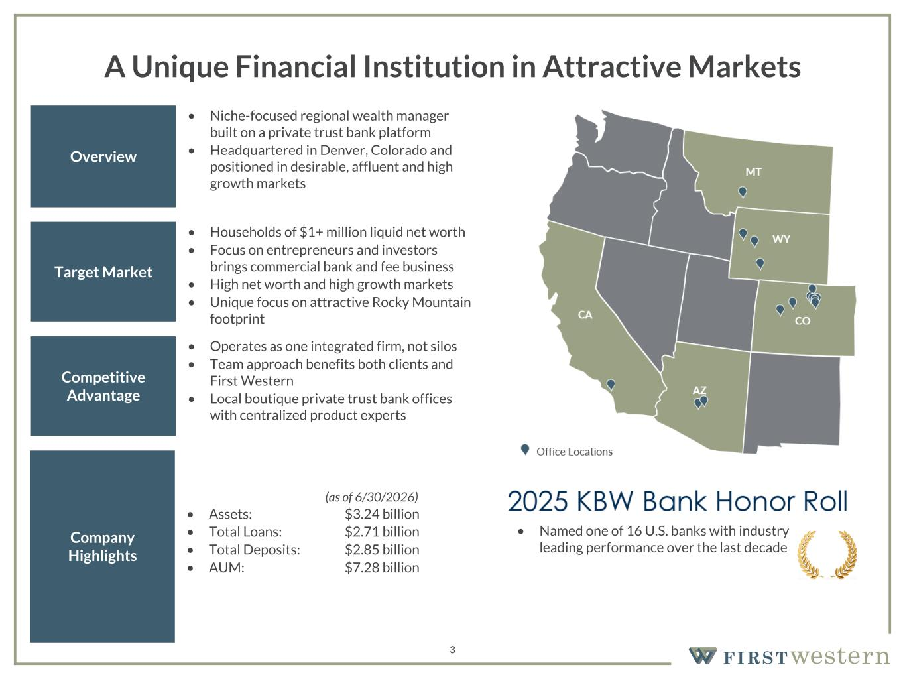
157 180 196 164 166 168 62 94 111 154 161 132 122 125 129 76 78 86 255 255 255 Chart color Table color Special Headlines Slide Headlines / Text on light background Primary Colors Secondary Colors Primary Background / Call Out Boxes / Text on dark background Chart color Table Color Tertiary Colors Chart color Table Color Chart Color Chart Color Approved Fonts AaBbCc 123 Lora (bold) Slide Headlines / Special Headlines AaBbCc 123 Lato (regular, bold, italics) Body Copy / Subheadings / Small Text Descriptions 3 A Unique Financial Institution in Attractive Markets Overview • Niche-focused regional wealth manager built on a private trust bank platform • Headquartered in Denver, Colorado and positioned in desirable, affluent and high growth markets Target Market • Households of $1+ million liquid net worth • Focus on entrepreneurs and investors brings commercial bank and fee business • High net worth and high growth markets • Unique focus on attractive Rocky Mountain footprint Company Highlights Competitive Advantage (as of 6/30/2026) • Assets: $3.24 billion • Total Loans: $2.71 billion • Total Deposits: $2.85 billion • AUM: $7.28 billion • Operates as one integrated firm, not silos • Team approach benefits both clients and First Western • Local boutique private trust bank offices with centralized product experts • Named one of 16 U.S. banks with industry leading performance over the last decade

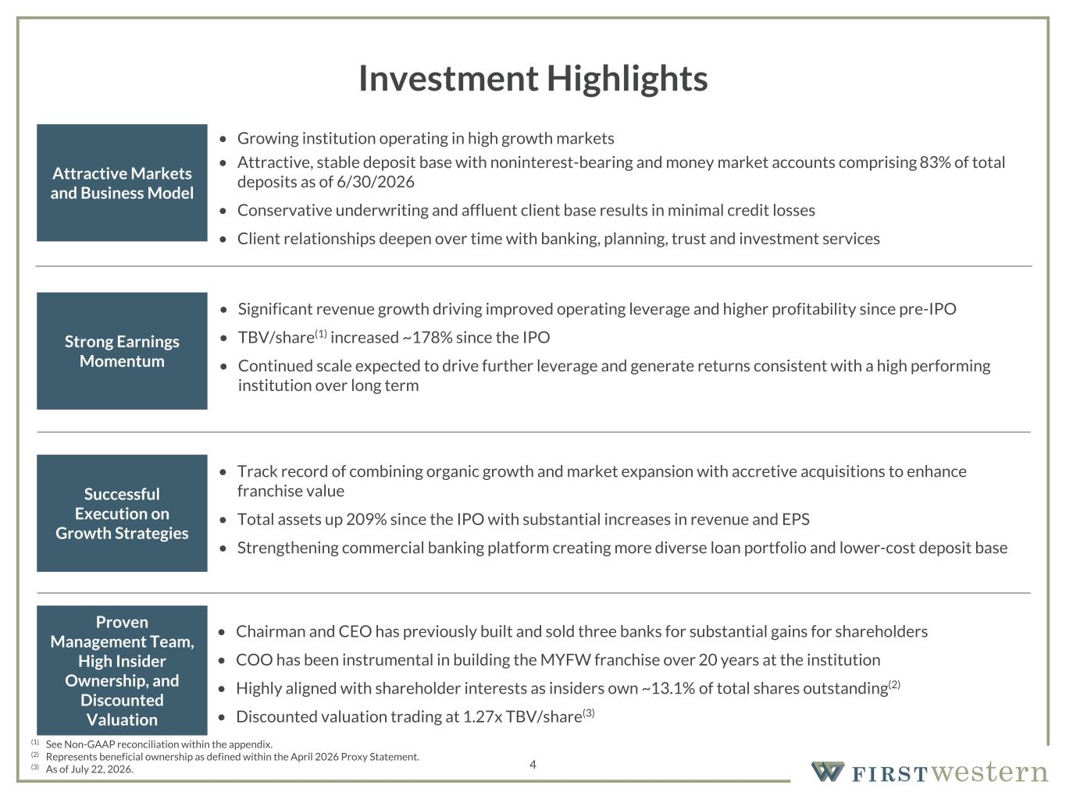
157 180 196 164 166 168 62 94 111 154 161 132 122 125 129 76 78 86 255 255 255 Chart color Table color Special Headlines Slide Headlines / Text on light background Primary Colors Secondary Colors Primary Background / Call Out Boxes / Text on dark background Chart color Table Color Tertiary Colors Chart color Table Color Chart Color Chart Color Approved Fonts AaBbCc 123 Lora (bold) Slide Headlines / Special Headlines AaBbCc 123 Lato (regular, bold, italics) Body Copy / Subheadings / Small Text Descriptions 4 Investment Highlights Successful Execution on Growth Strategies Attractive Markets and Business Model Strong Earnings Momentum • Significant revenue growth driving improved operating leverage and higher profitability since pre-IPO • TBV/share(1) increased ~178% since the IPO • Continued scale expected to drive further leverage and generate returns consistent with a high performing institution over long term • Chairman and CEO has previously built and sold three banks for substantial gains for shareholders • COO has been instrumental in building the MYFW franchise over 20 years at the institution • Highly aligned with shareholder interests as insiders own ~13.1% of total shares outstanding(2) • Discounted valuation trading at 1.27x TBV/share(3) Proven Management Team, High Insider Ownership, and Discounted Valuation • Track record of combining organic growth and market expansion with accretive acquisitions to enhance franchise value • Total assets up 209% since the IPO with substantial increases in revenue and EPS • Strengthening commercial banking platform creating more diverse loan portfolio and lower-cost deposit base • Growing institution operating in high growth markets • Attractive, stable deposit base with noninterest-bearing and money market accounts comprising 83% of total deposits as of 6/30/2026 • Conservative underwriting and affluent client base results in minimal credit losses • Client relationships deepen over time with banking, planning, trust and investment services (1) See Non-GAAP reconciliation within the appendix. (2) Represents beneficial ownership as defined within the April 2026 Proxy Statement. (3) As of July 22, 2026.

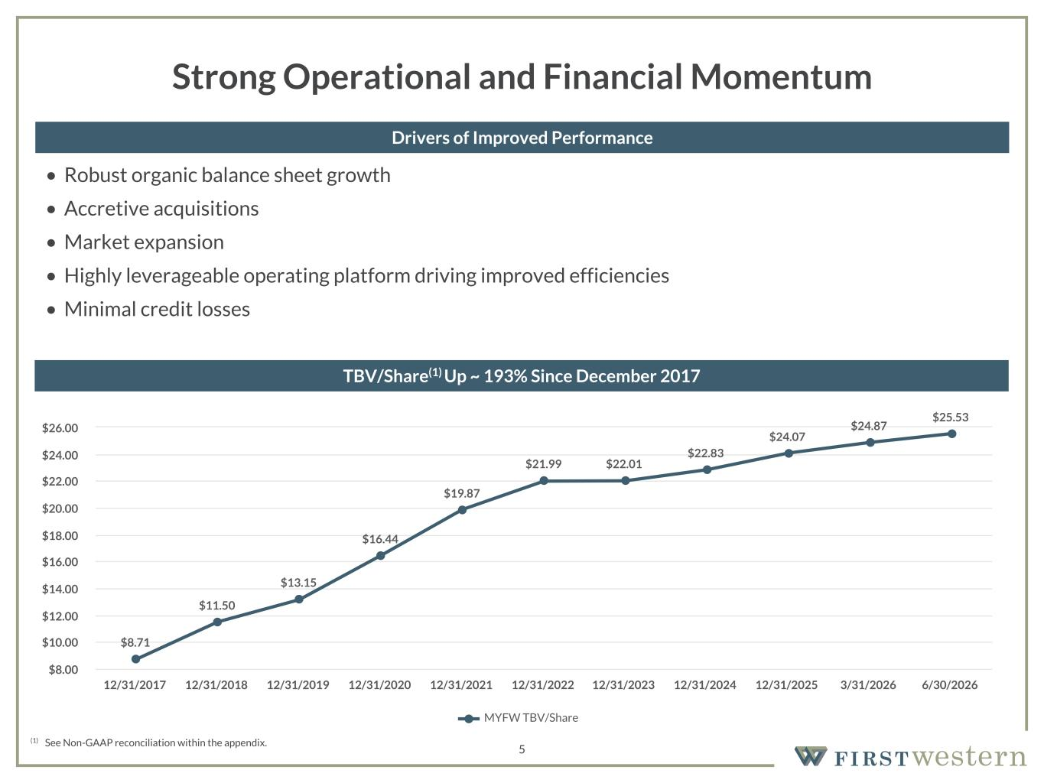
157 180 196 164 166 168 62 94 111 154 161 132 122 125 129 76 78 86 255 255 255 Chart color Table color Special Headlines Slide Headlines / Text on light background Primary Colors Secondary Colors Primary Background / Call Out Boxes / Text on dark background Chart color Table Color Tertiary Colors Chart color Table Color Chart Color Chart Color Approved Fonts AaBbCc 123 Lora (bold) Slide Headlines / Special Headlines AaBbCc 123 Lato (regular, bold, italics) Body Copy / Subheadings / Small Text Descriptions 5 Strong Operational and Financial Momentum • Robust organic balance sheet growth • Accretive acquisitions • Market expansion • Highly leverageable operating platform driving improved efficiencies • Minimal credit losses Drivers of Improved Performance (1) See Non-GAAP reconciliation within the appendix. TBV/Share(1) Up ~ 193% Since December 2017 $8.71 $11.50 $13.15 $16.44 $19.87 $21.99 $22.01 $22.83 $24.07 $24.87 $25.53 MYFW TBV/Share 12/31/2017 12/31/2018 12/31/2019 12/31/2020 12/31/2021 12/31/2022 12/31/2023 12/31/2024 12/31/2025 3/31/2026 6/30/2026 $8.00 $10.00 $12.00 $14.00 $16.00 $18.00 $20.00 $22.00 $24.00 $26.00

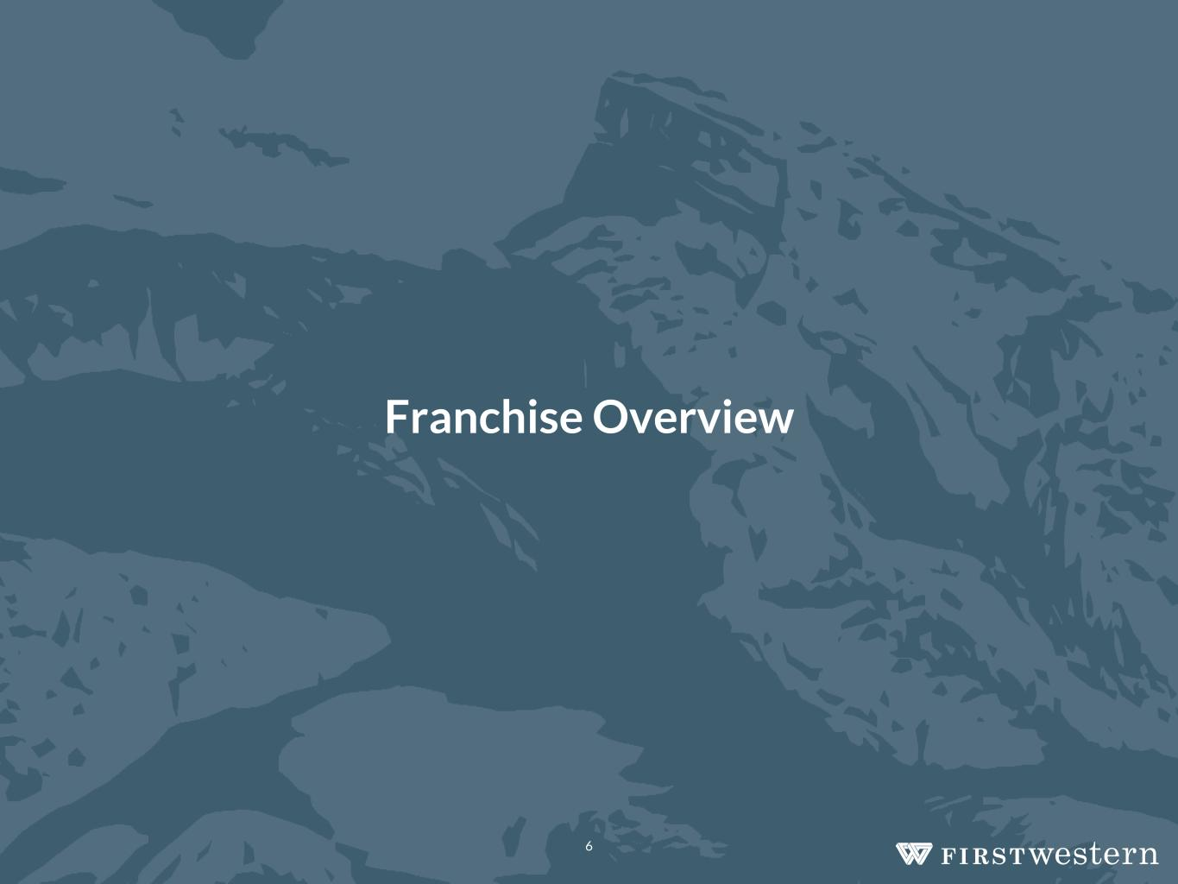
Franchise Overview 6

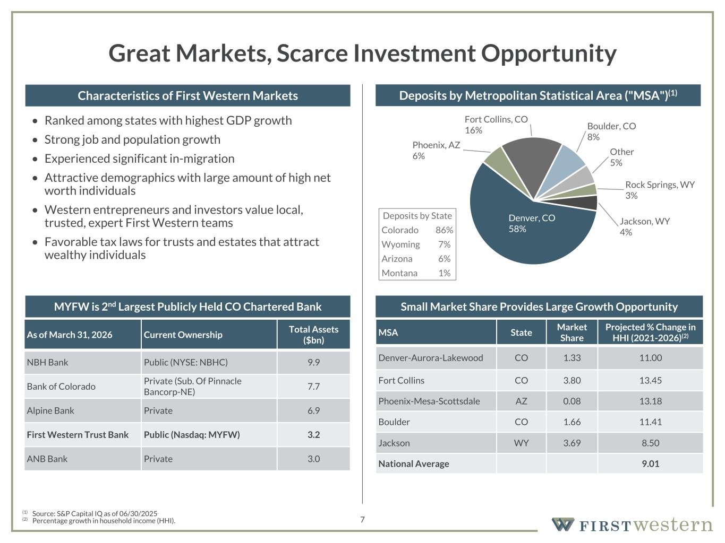
157 180 196 164 166 168 62 94 111 154 161 132 122 125 129 76 78 86 255 255 255 Chart color Table color Special Headlines Slide Headlines / Text on light background Primary Colors Secondary Colors Primary Background / Call Out Boxes / Text on dark background Chart color Table Color Tertiary Colors Chart color Table Color Chart Color Chart Color Approved Fonts AaBbCc 123 Lora (bold) Slide Headlines / Special Headlines AaBbCc 123 Lato (regular, bold, italics) Body Copy / Subheadings / Small Text Descriptions 7 Great Markets, Scarce Investment Opportunity • Ranked among states with highest GDP growth • Strong job and population growth • Experienced significant in-migration • Attractive demographics with large amount of high net worth individuals • Western entrepreneurs and investors value local, trusted, expert First Western teams • Favorable tax laws for trusts and estates that attract wealthy individuals MSA State Market Share Projected % Change in HHI (2021-2026)(2) Denver-Aurora-Lakewood CO 1.33 11.00 Fort Collins CO 3.80 13.45 Phoenix-Mesa-Scottsdale AZ 0.08 13.18 Boulder CO 1.66 11.41 Jackson WY 3.69 8.50 National Average 9.01 (1) Source: S&P Capital IQ as of 06/30/2025. (2) Percentage growth in household income (HHI). Characteristics of First Western Markets Deposits by Metropolitan Statistical Area ("MSA")(1) Small Market Share Provides Large Growth Opportunity As of March 31, 2026 Current Ownership Total Assets ($bn) NBH Bank Public (NYSE: NBHC) 9.9 Bank of Colorado Private (Sub. Of Pinnacle Bancorp-NE) 7.7 Alpine Bank Private 6.9 First Western Trust Bank Public (Nasdaq: MYFW) 3.2 ANB Bank Private 3.0 MYFW is 2nd Largest Publicly Held CO Chartered Bank Denver, CO 58% Phoenix, AZ 6% Fort Collins, CO 16% Boulder, CO 8% Other 5% Rock Springs, WY 3% Jackson, WY 4% Deposits by State Colorado 86% Wyoming 7% Arizona 6% Montana 1%

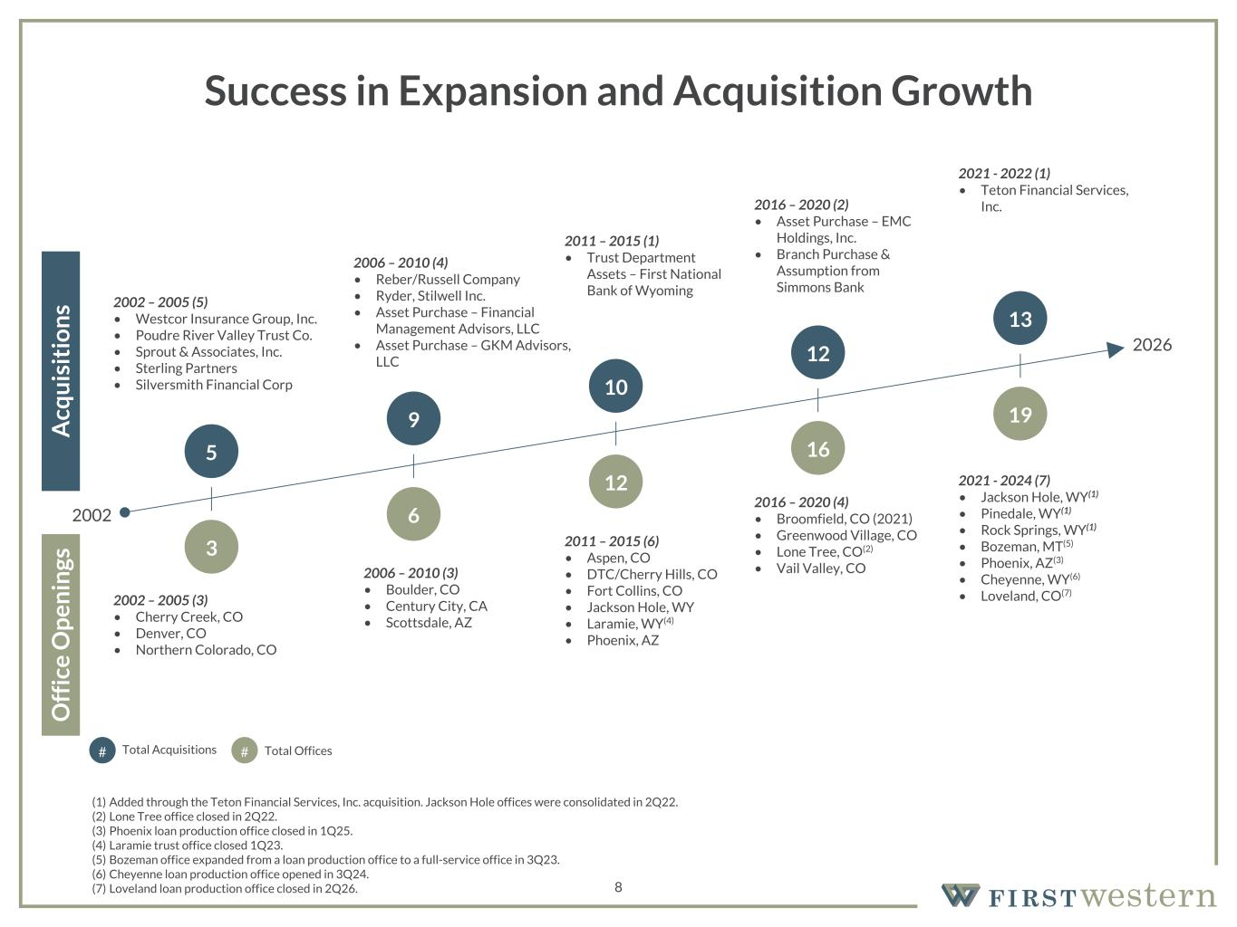
157 180 196 164 166 168 62 94 111 154 161 132 122 125 129 76 78 86 255 255 255 Chart color Table color Special Headlines Slide Headlines / Text on light background Primary Colors Secondary Colors Primary Background / Call Out Boxes / Text on dark background Chart color Table Color Tertiary Colors Chart color Table Color Chart Color Chart Color Approved Fonts AaBbCc 123 Lora (bold) Slide Headlines / Special Headlines AaBbCc 123 Lato (regular, bold, italics) Body Copy / Subheadings / Small Text Descriptions 8 Success in Expansion and Acquisition Growth 2006 – 2010 (3) • Boulder, CO • Century City, CA • Scottsdale, AZ 2011 – 2015 (6) • Aspen, CO • DTC/Cherry Hills, CO • Fort Collins, CO • Jackson Hole, WY • Laramie, WY(4) • Phoenix, AZ 2016 – 2020 (4) • Broomfield, CO (2021) • Greenwood Village, CO • Lone Tree, CO(2) • Vail Valley, CO 2002 – 2005 (3) • Cherry Creek, CO • Denver, CO • Northern Colorado, CO 2002 – 2005 (5) • Westcor Insurance Group, Inc. • Poudre River Valley Trust Co. • Sprout & Associates, Inc. • Sterling Partners • Silversmith Financial Corp 2006 – 2010 (4) • Reber/Russell Company • Ryder, Stilwell Inc. • Asset Purchase – Financial Management Advisors, LLC • Asset Purchase – GKM Advisors, LLC 2011 – 2015 (1) • Trust Department Assets – First National Bank of Wyoming 2016 – 2020 (2) • Asset Purchase – EMC Holdings, Inc. • Branch Purchase & Assumption from Simmons Bank O ff ic e O p en in gs A cq u is it io n s 2002 2026 3 5 6 9 12 10 16 12 # #Total Acquisitions Total Offices 19 13 2021 - 2022 (1) • Teton Financial Services, Inc. 2021 - 2024 (7) • Jackson Hole, WY(1) • Pinedale, WY(1) • Rock Springs, WY(1) • Bozeman, MT(5) • Phoenix, AZ(3) • Cheyenne, WY(6) • Loveland, CO(7) (1) Added through the Teton Financial Services, Inc. acquisition. Jackson Hole offices were consolidated in 2Q22. (2) Lone Tree office closed in 2Q22. (3) Phoenix loan production office closed in 1Q25. (4) Laramie trust office closed 1Q23. (5) Bozeman office expanded from a loan production office to a full-service office in 3Q23. (6) Cheyenne loan production office opened in 3Q24. (7) Loveland loan production office closed in 2Q26.

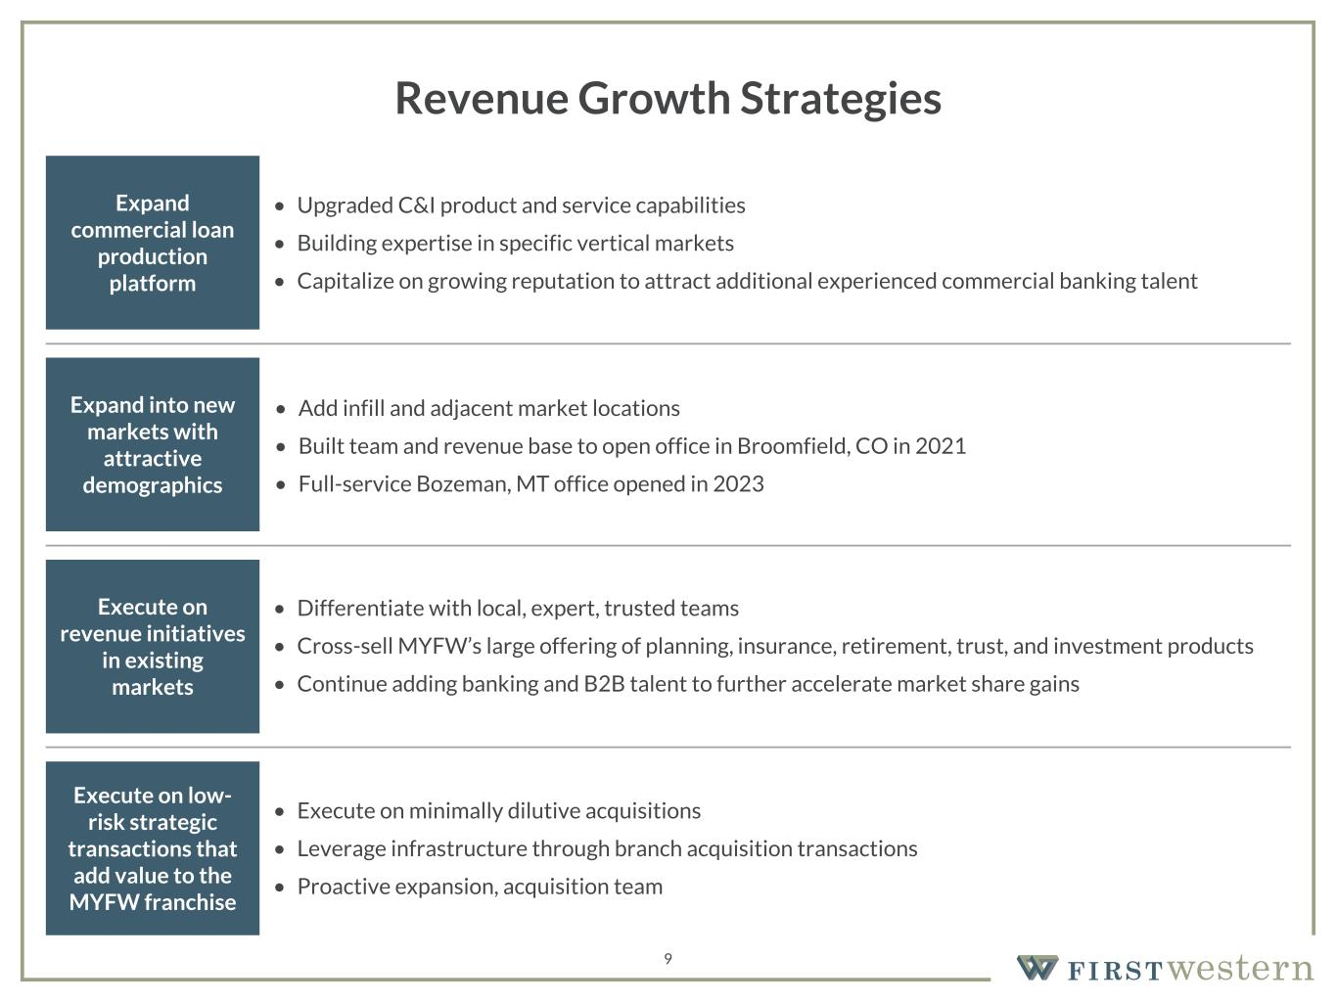
157 180 196 164 166 168 62 94 111 154 161 132 122 125 129 76 78 86 255 255 255 Chart color Table color Special Headlines Slide Headlines / Text on light background Primary Colors Secondary Colors Primary Background / Call Out Boxes / Text on dark background Chart color Table Color Tertiary Colors Chart color Table Color Chart Color Chart Color Approved Fonts AaBbCc 123 Lora (bold) Slide Headlines / Special Headlines AaBbCc 123 Lato (regular, bold, italics) Body Copy / Subheadings / Small Text Descriptions 9 Revenue Growth Strategies Expand commercial loan production platform • Upgraded C&I product and service capabilities • Building expertise in specific vertical markets • Capitalize on growing reputation to attract additional experienced commercial banking talent Expand into new markets with attractive demographics • Add infill and adjacent market locations • Built team and revenue base to open office in Broomfield, CO in 2021 • Full-service Bozeman, MT office opened in 2023 Execute on revenue initiatives in existing markets • Differentiate with local, expert, trusted teams • Cross-sell MYFW’s large offering of planning, insurance, retirement, trust, and investment products • Continue adding banking and B2B talent to further accelerate market share gains Execute on low- risk strategic transactions that add value to the MYFW franchise • Execute on minimally dilutive acquisitions • Leverage infrastructure through branch acquisition transactions • Proactive expansion, acquisition team

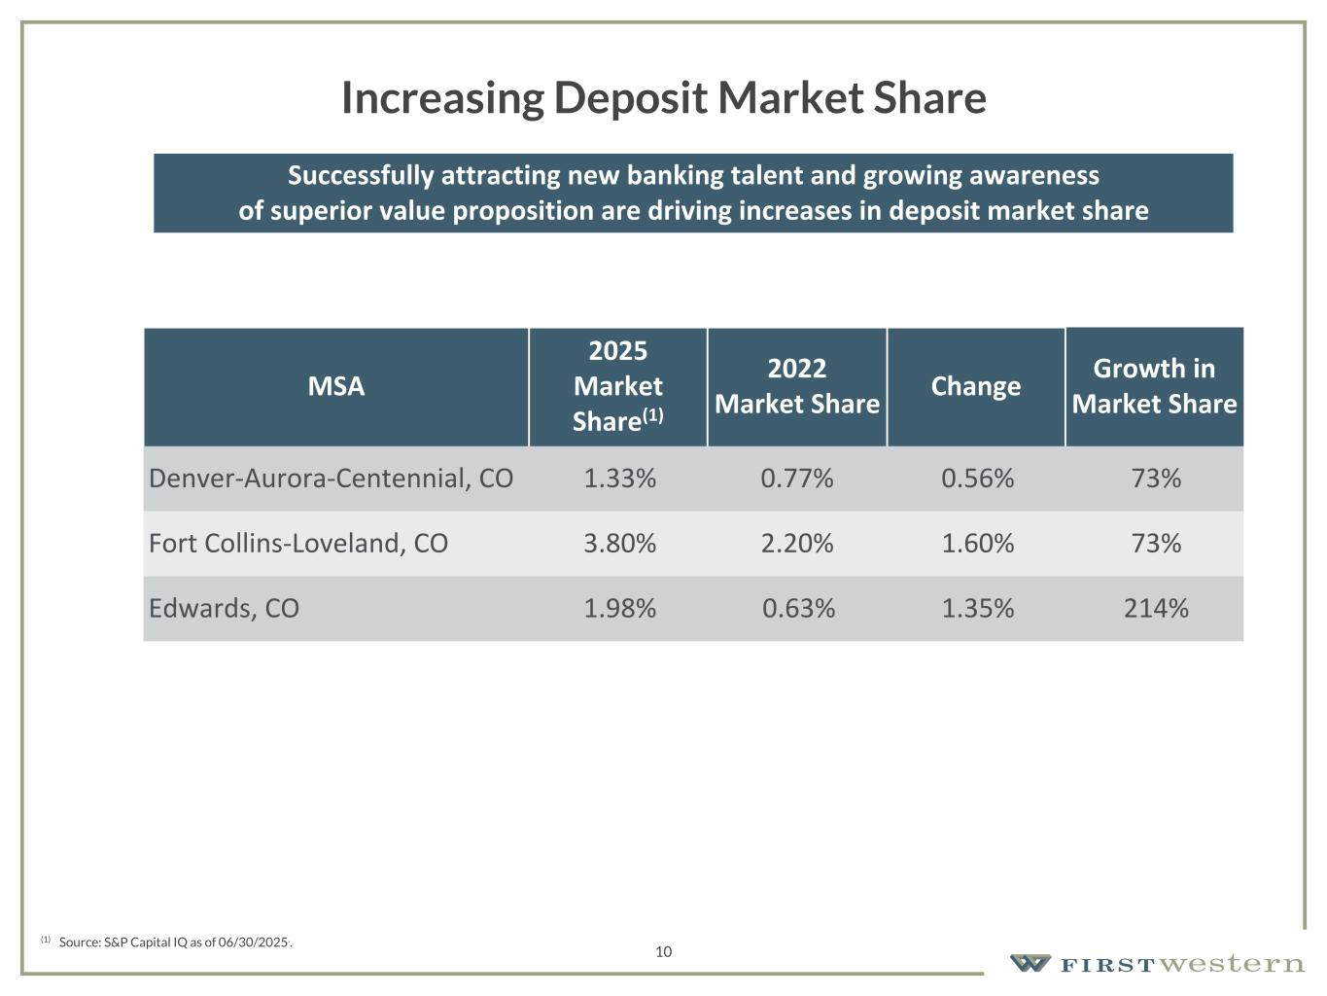
157 180 196 164 166 168 62 94 111 154 161 132 122 125 129 76 78 86 255 255 255 Chart color Table color Special Headlines Slide Headlines / Text on light background Primary Colors Secondary Colors Primary Background / Call Out Boxes / Text on dark background Chart color Table Color Tertiary Colors Chart color Table Color Chart Color Chart Color Approved Fonts AaBbCc 123 Lora (bold) Slide Headlines / Special Headlines AaBbCc 123 Lato(regular, bold, italics) Body Copy / Subheadings / Small Text Descriptions 10 Increasing Deposit Market Share Successfully attracting new banking talent and growing awareness of superior value proposition are driving increases in deposit market share MSA 2025 Market Share(1) 2022 Market Share Change Growth in Market Share Denver-Aurora-Centennial, CO 1.33% 0.77% 0.56% 73% Fort Collins-Loveland, CO 3.80% 2.20% 1.60% 73% Edwards, CO 1.98% 0.63% 1.35% 214% (1) Source: S&P Capital IQ as of 06/30/2025..


Unique Business Model 11

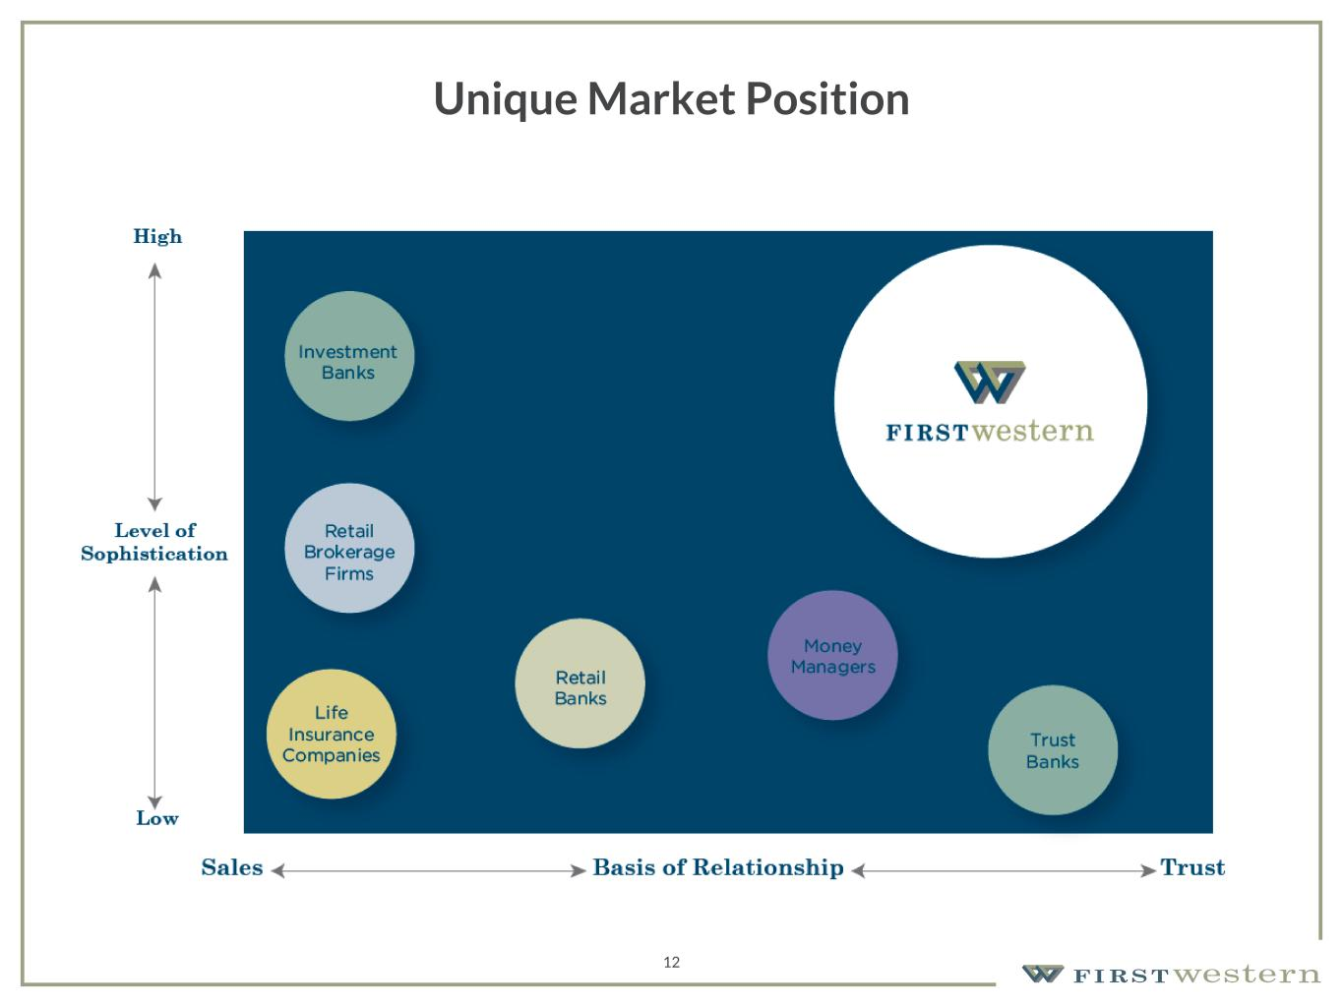
157 180 196 164 166 168 62 94 111 154 161 132 122 125 129 76 78 86 255 255 255 Chart color Table color Special Headlines Slide Headlines / Text on light background Primary Colors Secondary Colors Primary Background / Call Out Boxes / Text on dark background Chart color Table Color Tertiary Colors Chart color Table Color Chart Color Chart Color Approved Fonts AaBbCc 123 Lora (bold) Slide Headlines / Special Headlines AaBbCc 123 Lato(regular, bold, italics) Body Copy / Subheadings / Small Text Descriptions 12 Unique Market Position

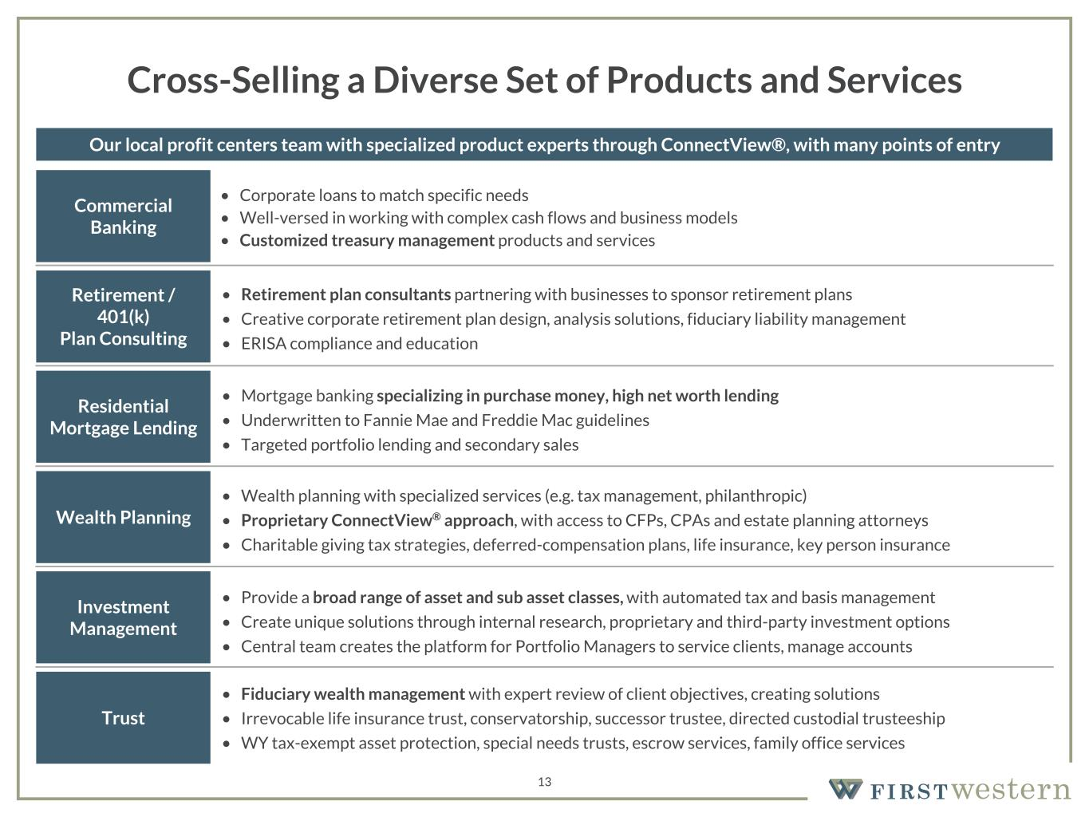
157 180 196 164 166 168 62 94 111 154 161 132 122 125 129 76 78 86 255 255 255 Chart color Table color Special Headlines Slide Headlines / Text on light background Primary Colors Secondary Colors Primary Background / Call Out Boxes / Text on dark background Chart color Table Color Tertiary Colors Chart color Table Color Chart Color Chart Color Approved Fonts AaBbCc 123 Lora (bold) Slide Headlines / Special Headlines AaBbCc 123 Lato (regular, bold, italics) Body Copy / Subheadings / Small Text Descriptions • Corporate loans to match specific needs • Well-versed in working with complex cash flows and business models • Customized treasury management products and services 13 Cross-Selling a Diverse Set of Products and Services Commercial Banking • Fiduciary wealth management with expert review of client objectives, creating solutions • Irrevocable life insurance trust, conservatorship, successor trustee, directed custodial trusteeship • WY tax-exempt asset protection, special needs trusts, escrow services, family office services • Provide a broad range of asset and sub asset classes, with automated tax and basis management • Create unique solutions through internal research, proprietary and third-party investment options • Central team creates the platform for Portfolio Managers to service clients, manage accounts • Wealth planning with specialized services (e.g. tax management, philanthropic) • Proprietary ConnectView® approach, with access to CFPs, CPAs and estate planning attorneys • Charitable giving tax strategies, deferred-compensation plans, life insurance, key person insurance • Mortgage banking specializing in purchase money, high net worth lending • Underwritten to Fannie Mae and Freddie Mac guidelines • Targeted portfolio lending and secondary sales • Retirement plan consultants partnering with businesses to sponsor retirement plans • Creative corporate retirement plan design, analysis solutions, fiduciary liability management • ERISA compliance and education Retirement / 401(k) Plan Consulting Residential Mortgage Lending Wealth Planning Investment Management Trust Our local profit centers team with specialized product experts through ConnectView®, with many points of entry

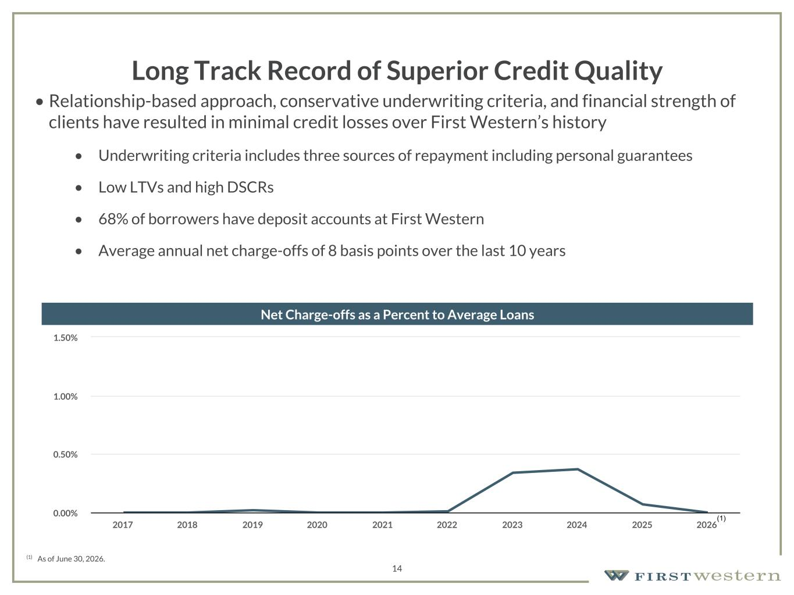
157 180 196 164 166 168 62 94 111 154 161 132 122 125 129 76 78 86 255 255 255 Chart color Table color Special Headlines Slide Headlines / Text on light background Primary Colors Secondary Colors Primary Background / Call Out Boxes / Text on dark background Chart color Table Color Tertiary Colors Chart color Table Color Chart Color Chart Color Approved Fonts AaBbCc 123 Lora (bold) Slide Headlines / Special Headlines AaBbCc 123 Lato(regular, bold, italics) Body Copy / Subheadings / Small Text Descriptions 14 Long Track Record of Superior Credit Quality • Relationship-based approach, conservative underwriting criteria, and financial strength of clients have resulted in minimal credit losses over First Western’s history • Underwriting criteria includes three sources of repayment including personal guarantees • Low LTVs and high DSCRs • 68% of borrowers have deposit accounts at First Western • Average annual net charge-offs of 8 basis points over the last 10 years Net Charge-offs as a Percent to Average Loans (1) (1) As of June 30, 2026. 2017 2018 2019 2020 2021 2022 2023 2024 2025 2026 0.00% 0.50% 1.00% 1.50%

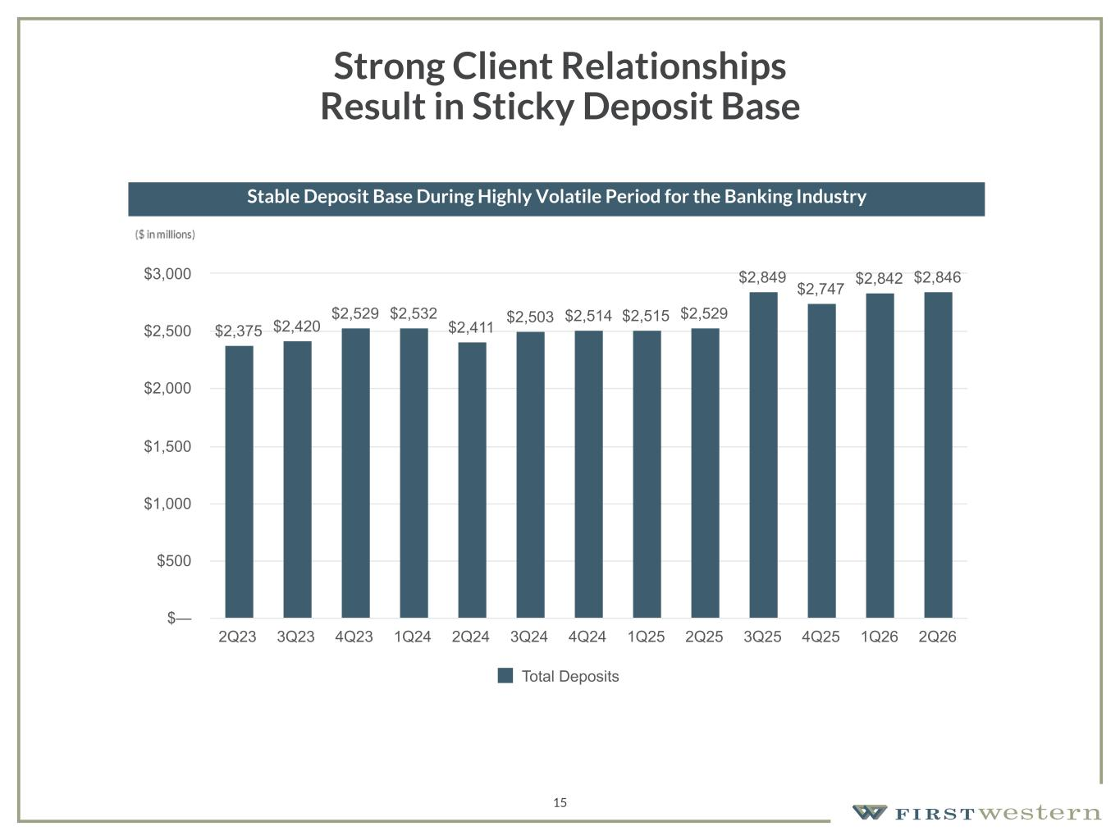
157 180 196 164 166 168 62 94 111 154 161 132 122 125 129 76 78 86 255 255 255 Chart color Table color Special Headlines Slide Headlines / Text on light background Primary Colors Secondary Colors Primary Background / Call Out Boxes / Text on dark background Chart color Table Color Tertiary Colors Chart color Table Color Chart Color Chart Color Approved Fonts AaBbCc 123 Lora (bold) Slide Headlines / Special Headlines AaBbCc 123 Lato(regular, bold, italics) Body Copy / Subheadings / Small Text Descriptions 15 Strong Client Relationships Result in Sticky Deposit Base Stable Deposit Base During Highly Volatile Period for the Banking Industry $2,375 $2,420 $2,529 $2,532 $2,411 $2,503 $2,514 $2,515 $2,529 $2,849 $2,747 $2,842 $2,846 Total Deposits 2Q23 3Q23 4Q23 1Q24 2Q24 3Q24 4Q24 1Q25 2Q25 3Q25 4Q25 1Q26 2Q26 $— $500 $1,000 $1,500 $2,000 $2,500 $3,000

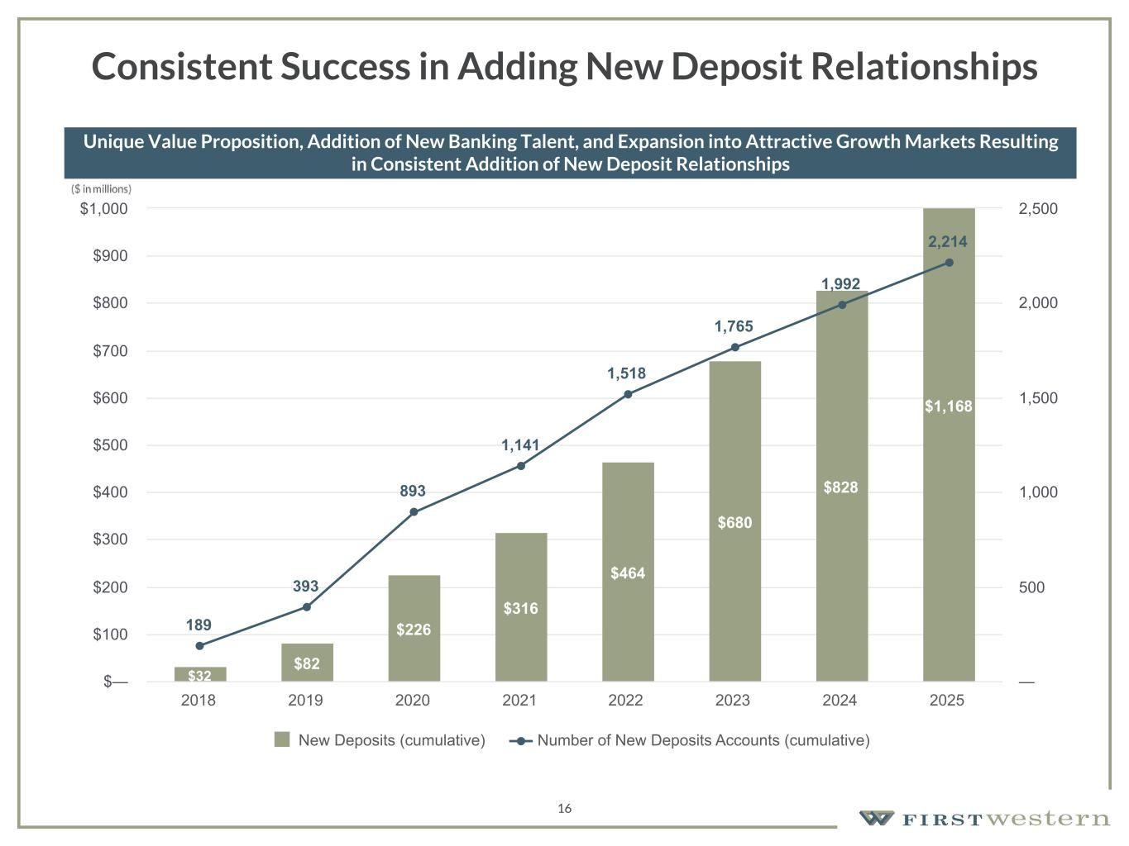
157 180 196 164 166 168 62 94 111 154 161 132 122 125 129 76 78 86 255 255 255 Chart color Table color Special Headlines Slide Headlines / Text on light background Primary Colors Secondary Colors Primary Background / Call Out Boxes / Text on dark background Chart color Table Color Tertiary Colors Chart color Table Color Chart Color Chart Color Approved Fonts AaBbCc 123 Lora (bold) Slide Headlines / Special Headlines AaBbCc 123 Lato(regular, bold, italics) Body Copy / Subheadings / Small Text Descriptions 16 Consistent Success in Adding New Deposit Relationships Unique Value Proposition, Addition of New Banking Talent, and Expansion into Attractive Growth Markets Resulting in Consistent Addition of New Deposit Relationships $32 $82 $226 $316 $464 $680 $828 $1,168 189 393 893 1,141 1,518 1,765 1,992 2,214 New Deposits (cumulative) Number of New Deposits Accounts (cumulative) 2018 2019 2020 2021 2022 2023 2024 2025 $— $100 $200 $300 $400 $500 $600 $700 $800 $900 $1,000 — 500 1,000 1,500 2,000 2,500


Transformation Underway 17

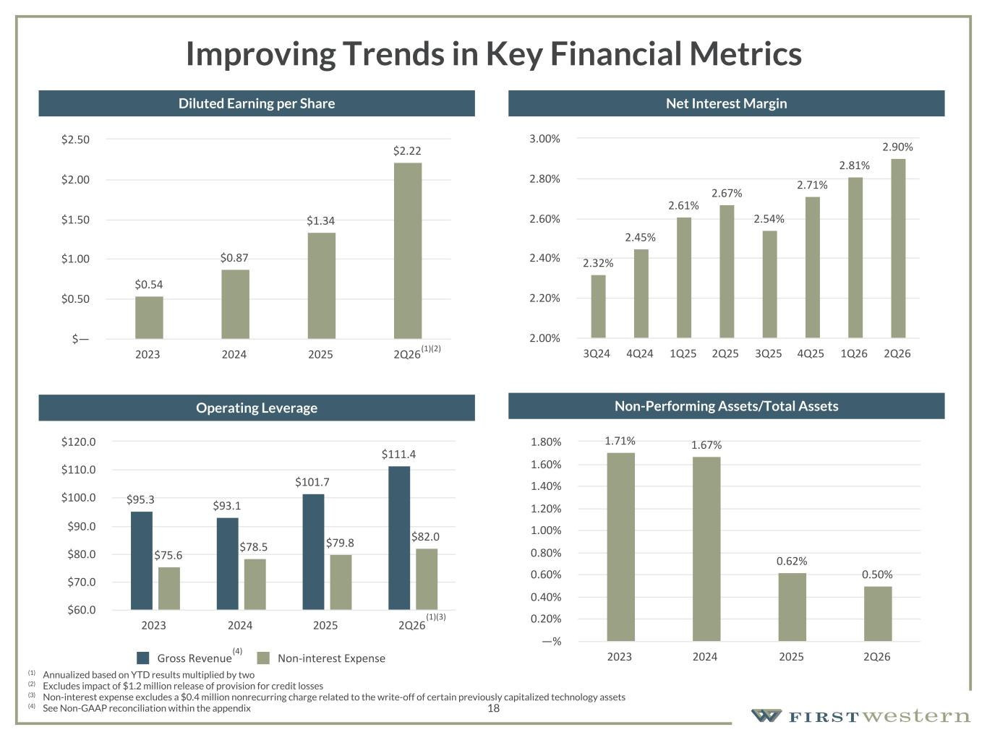
157 180 196 164 166 168 62 94 111 154 161 132 122 125 129 76 78 86 255 255 255 Chart color Table color Special Headlines Slide Headlines / Text on light background Primary Colors Secondary Colors Primary Background / Call Out Boxes / Text on dark background Chart color Table Color Tertiary Colors Chart color Table Color Chart Color Chart Color Approved Fonts AaBbCc 123 Lora (bold) Slide Headlines / Special Headlines AaBbCc 123 Lato(regular, bold, italics) Body Copy / Subheadings / Small Text Descriptions 18 Improving Trends in Key Financial Metrics (1) Annualized based on YTD results multiplied by two (2) Excludes impact of $1.2 million release of provision for credit losses (3) Non-interest expense excludes a $0.4 million nonrecurring charge related to the write-off of certain previously capitalized technology assets (4) See Non-GAAP reconciliation within the appendix Diluted Earning per Share $0.54 $0.87 $1.34 $2.22 2023 2024 2025 2Q26 $— $0.50 $1.00 $1.50 $2.00 $2.50 Net Interest Margin Operating Leverage Non-Performing Assets/Total Assets 2.32% 2.45% 2.61% 2.67% 2.54% 2.71% 2.81% 2.90% 3Q24 4Q24 1Q25 2Q25 3Q25 4Q25 1Q26 2Q26 2.00% 2.20% 2.40% 2.60% 2.80% 3.00% $95.3 $93.1 $101.7 $111.4 $75.6 $78.5 $79.8 $82.0 Gross Revenue Non-interest Expense 2023 2024 2025 2Q26 $60.0 $70.0 $80.0 $90.0 $100.0 $110.0 $120.0 1.71% 1.67% 0.62% 0.50% 2023 2024 2025 2Q26 —% 0.20% 0.40% 0.60% 0.80% 1.00% 1.20% 1.40% 1.60% 1.80% (1)(2) (1)(3) (4)

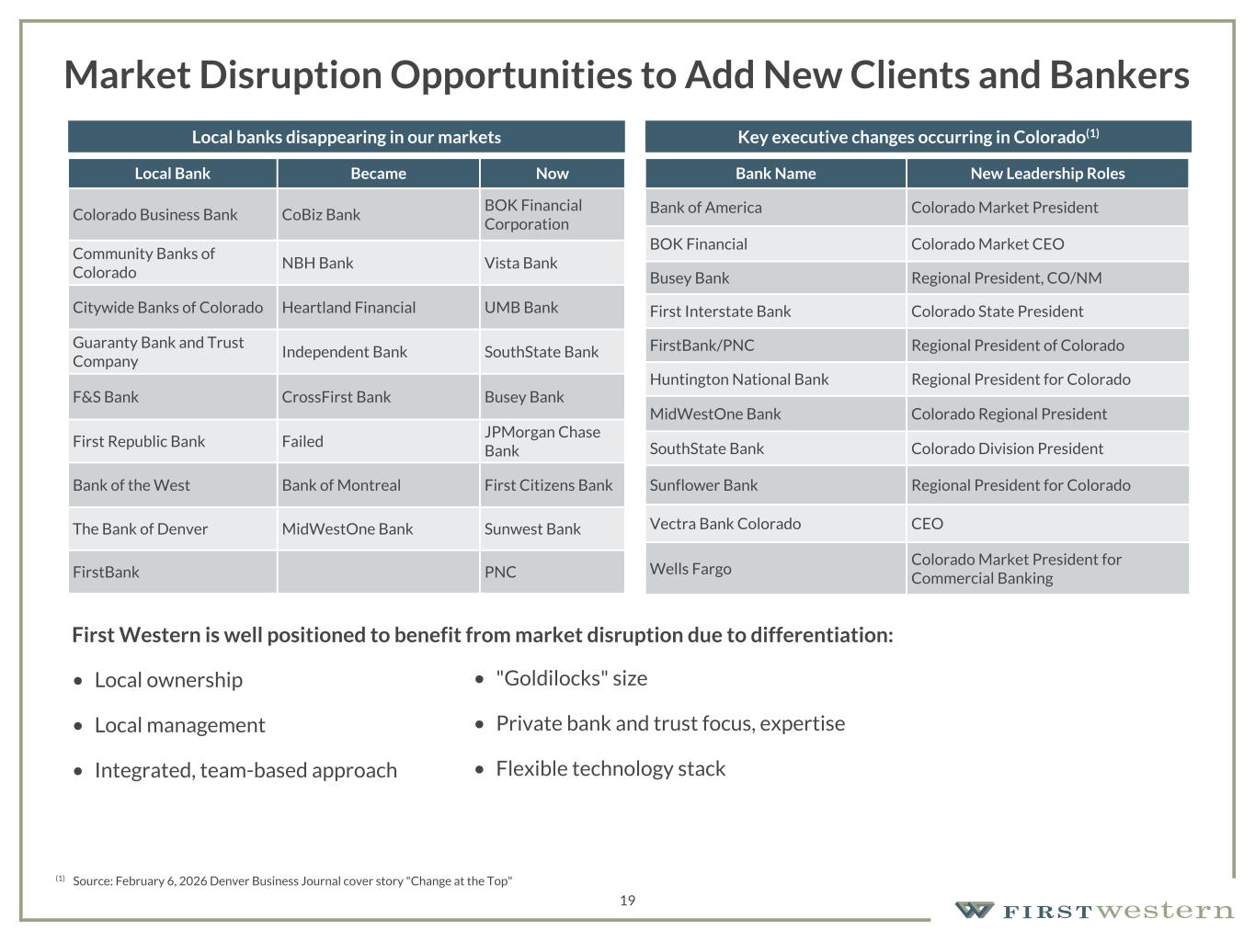
157 180 196 164 166 168 62 94 111 154 161 132 122 125 129 76 78 86 255 255 255 Chart color Table color Special Headlines Slide Headlines / Text on light background Primary Colors Secondary Colors Primary Background / Call Out Boxes / Text on dark background Chart color Table Color Tertiary Colors Chart color Table Color Chart Color Chart Color Approved Fonts AaBbCc 123 Lora (bold) Slide Headlines / Special Headlines AaBbCc 123 Lato (regular, bold, italics) Body Copy / Subheadings / Small Text Descriptions • "Goldilocks" size • Private bank and trust focus, expertise • Flexible technology stack 19 Market Disruption Opportunities to Add New Clients and Bankers Local Bank Became Now Colorado Business Bank CoBiz Bank BOK Financial Corporation Community Banks of Colorado NBH Bank Vista Bank Citywide Banks of Colorado Heartland Financial UMB Bank Guaranty Bank and Trust Company Independent Bank SouthState Bank F&S Bank CrossFirst Bank Busey Bank First Republic Bank Failed JPMorgan Chase Bank Bank of the West Bank of Montreal First Citizens Bank The Bank of Denver MidWestOne Bank Sunwest Bank FirstBank PNC Bank Name New Leadership Roles Bank of America Colorado Market President BOK Financial Colorado Market CEO Busey Bank Regional President, CO/NM First Interstate Bank Colorado State President FirstBank/PNC Regional President of Colorado Huntington National Bank Regional President for Colorado MidWestOne Bank Colorado Regional President SouthState Bank Colorado Division President Sunflower Bank Regional President for Colorado Vectra Bank Colorado CEO Wells Fargo Colorado Market President for Commercial Banking Local banks disappearing in our markets Key executive changes occurring in Colorado(1) (1) Source: February 6, 2026 Denver Business Journal cover story "Change at the Top" First Western is well positioned to benefit from market disruption due to differentiation: • Local ownership • Local management • Integrated, team-based approach

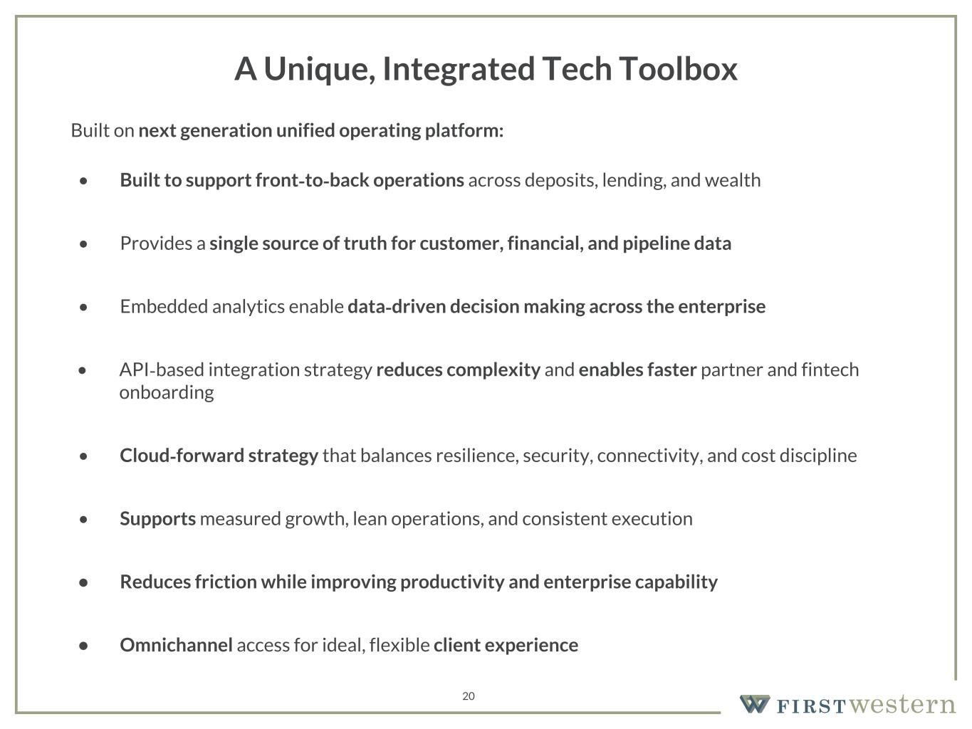
157 180 196 164 166 168 62 94 111 154 161 132 122 125 129 76 78 86 255 255 255 Chart color Table color Special Headlines Slide Headlines / Text on light background Primary Colors Secondary Colors Primary Background / Call Out Boxes / Text on dark background Chart color Table Color Tertiary Colors Chart color Table Color Chart Color Chart Color Approved Fonts AaBbCc 123 Lora (bold) Slide Headlines / Special Headlines AaBbCc 123 Lato(regular, bold, italics) Body Copy / Subheadings / Small Text Descriptions 20 A Unique, Integrated Tech Toolbox Built on next generation unified operating platform: • Built to support front-to-back operations across deposits, lending, and wealth • Provides a single source of truth for customer, financial, and pipeline data • Embedded analytics enable data-driven decision making across the enterprise • API-based integration strategy reduces complexity and enables faster partner and fintech onboarding • Cloud-forward strategy that balances resilience, security, connectivity, and cost discipline • Supports measured growth, lean operations, and consistent execution • Reduces friction while improving productivity and enterprise capability • Omnichannel access for ideal, flexible client experience

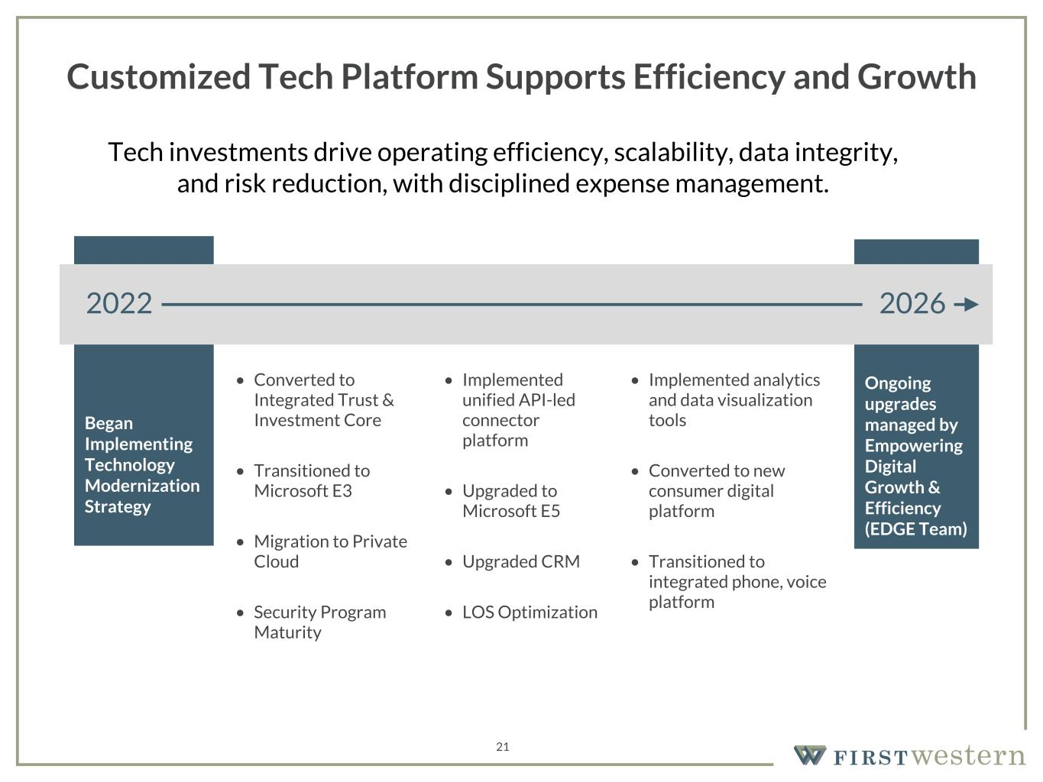
157 180 196 164 166 168 62 94 111 154 161 132 122 125 129 76 78 86 255 255 255 Chart color Table color Special Headlines Slide Headlines / Text on light background Primary Colors Secondary Colors Primary Background / Call Out Boxes / Text on dark background Chart color Table Color Tertiary Colors Chart color Table Color Chart Color Chart Color Approved Fonts AaBbCc 123 Lora (bold) Slide Headlines / Special Headlines AaBbCc 123 Lato(regular, bold, italics) Body Copy / Subheadings / Small Text Descriptions 21 Customized Tech Platform Supports Efficiency and Growth Tech investments drive operating efficiency, scalability, data integrity, and risk reduction, with disciplined expense management. Began Implementing Technology Modernization Strategy Ongoing upgrades managed by Empowering Digital Growth & Efficiency (EDGE Team) 2022 2026 • Converted to Integrated Trust & Investment Core • Transitioned to Microsoft E3 • Migration to Private Cloud • Security Program Maturity • Implemented unified API-led connector platform • Upgraded to Microsoft E5 • Upgraded CRM • LOS Optimization • Implemented analytics and data visualization tools • Converted to new consumer digital platform • Transitioned to integrated phone, voice platform

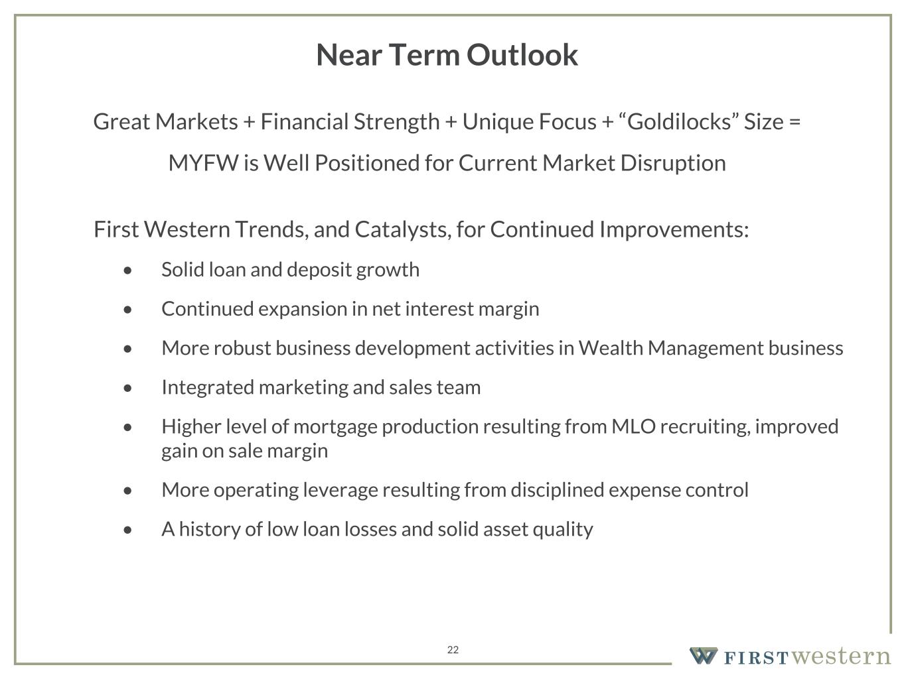
157 180 196 164 166 168 62 94 111 154 161 132 122 125 129 76 78 86 255 255 255 Chart color Table color Special Headlines Slide Headlines / Text on light background Primary Colors Secondary Colors Primary Background / Call Out Boxes / Text on dark background Chart color Table Color Tertiary Colors Chart color Table Color Chart Color Chart Color Approved Fonts AaBbCc 123 Lora (bold) Slide Headlines / Special Headlines AaBbCc 123 Lato (regular, bold, italics) Body Copy / Subheadings / Small Text Descriptions 22 Near Term Outlook Great Markets + Financial Strength + Unique Focus + “Goldilocks” Size = MYFW is Well Positioned for Current Market Disruption First Western Trends, and Catalysts, for Continued Improvements: • Solid loan and deposit growth • Continued expansion in net interest margin • More robust business development activities in Wealth Management business • Integrated marketing and sales team • Higher level of mortgage production resulting from MLO recruiting, improved gain on sale margin • More operating leverage resulting from disciplined expense control • A history of low loan losses and solid asset quality

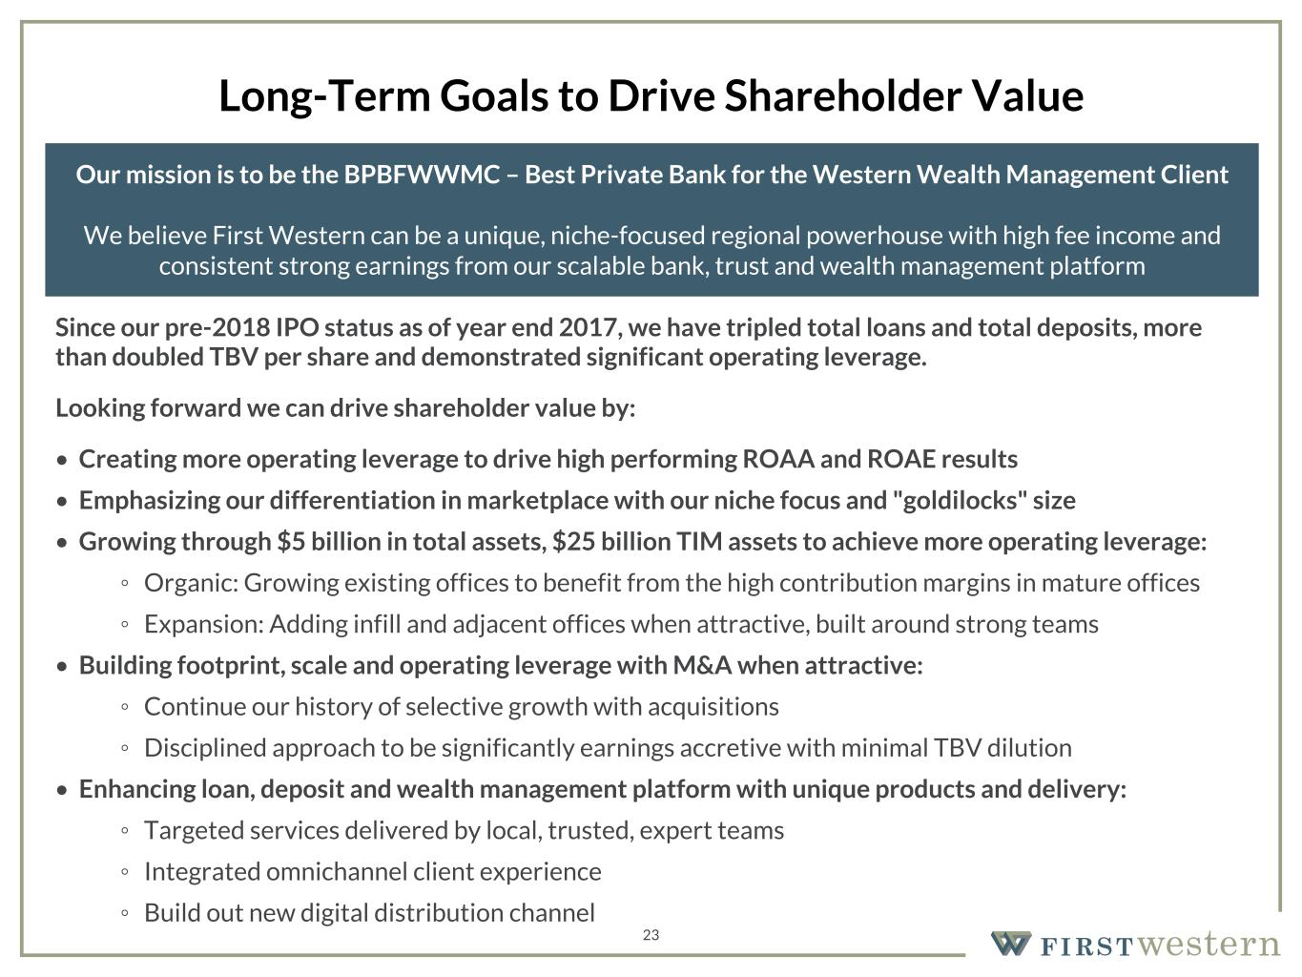
157 180 196 164 166 168 62 94 111 154 161 132 122 125 129 76 78 86 255 255 255 Chart color Table color Special Headlines Slide Headlines / Text on light background Primary Colors Secondary Colors Primary Background / Call Out Boxes / Text on dark background Chart color Table Color Tertiary Colors Chart color Table Color Chart Color Chart Color Approved Fonts AaBbCc 123 Lora (bold) Slide Headlines / Special Headlines AaBbCc 123 Lato (regular, bold, italics) Body Copy / Subheadings / Small Text Descriptions 23 Long-Term Goals to Drive Shareholder Value Since our pre-2018 IPO status as of year end 2017, we have tripled total loans and total deposits, more than doubled TBV per share and demonstrated significant operating leverage. Looking forward we can drive shareholder value by: • Creating more operating leverage to drive high performing ROAA and ROAE results • Emphasizing our differentiation in marketplace with our niche focus and "goldilocks" size • Growing through $5 billion in total assets, $25 billion TIM assets to achieve more operating leverage: ◦ Organic: Growing existing offices to benefit from the high contribution margins in mature offices ◦ Expansion: Adding infill and adjacent offices when attractive, built around strong teams • Building footprint, scale and operating leverage with M&A when attractive: ◦ Continue our history of selective growth with acquisitions ◦ Disciplined approach to be significantly earnings accretive with minimal TBV dilution • Enhancing loan, deposit and wealth management platform with unique products and delivery: ◦ Targeted services delivered by local, trusted, expert teams ◦ Integrated omnichannel client experience ◦ Build out new digital distribution channel Our mission is to be the BPBFWWMC – Best Private Bank for the Western Wealth Management Client We believe First Western can be a unique, niche-focused regional powerhouse with high fee income and consistent strong earnings from our scalable bank, trust and wealth management platform


Driving Profitable Growth 24

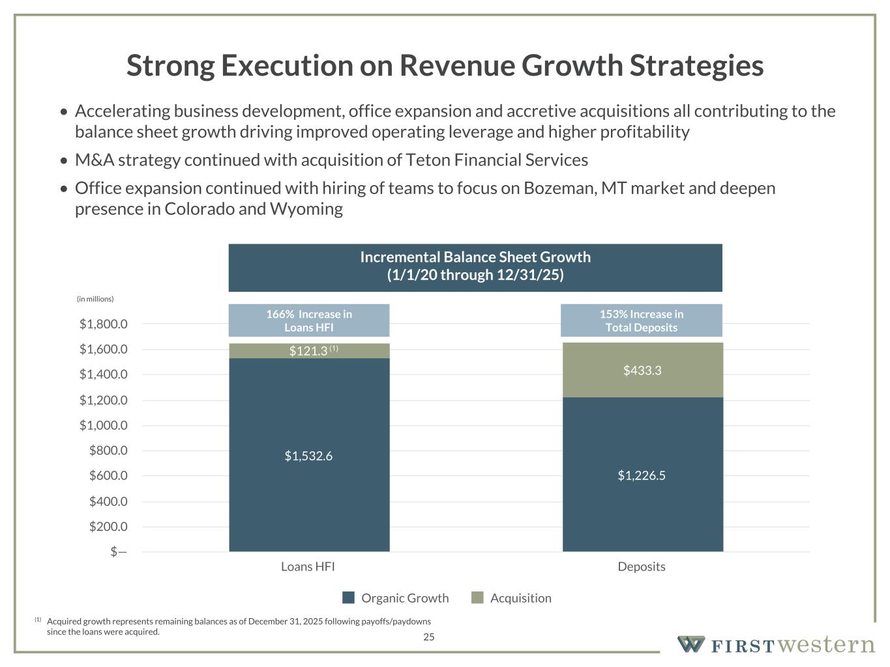
157 180 196 164 166 168 62 94 111 154 161 132 122 125 129 76 78 86 255 255 255 Chart color Table color Special Headlines Slide Headlines / Text on light background Primary Colors Secondary Colors Primary Background / Call Out Boxes / Text on dark background Chart color Table Color Tertiary Colors Chart color Table Color Chart Color Chart Color Approved Fonts AaBbCc 123 Lora (bold) Slide Headlines / Special Headlines AaBbCc 123 Lato(regular, bold, italics) Body Copy / Subheadings / Small Text Descriptions 25 Strong Execution on Revenue Growth Strategies • Accelerating business development, office expansion and accretive acquisitions all contributing to the balance sheet growth driving improved operating leverage and higher profitability • M&A strategy continued with acquisition of Teton Financial Services • Office expansion continued with hiring of teams to focus on Bozeman, MT market and deepen presence in Colorado and Wyoming (in millions) Incremental Balance Sheet Growth (1/1/20 through 12/31/25) (1) Acquired growth represents remaining balances as of December 31, 2025 following payoffs/paydowns since the loans were acquired. $1,532.6 $1,226.5 $121.3 $433.3 Organic Growth Acquisition Loans HFI Deposits $— $200.0 $400.0 $600.0 $800.0 $1,000.0 $1,200.0 $1,400.0 $1,600.0 $1,800.0 166% Increase in Loans HFI 153% Increase in Total Deposits (1)


Recent Financial Trends 26

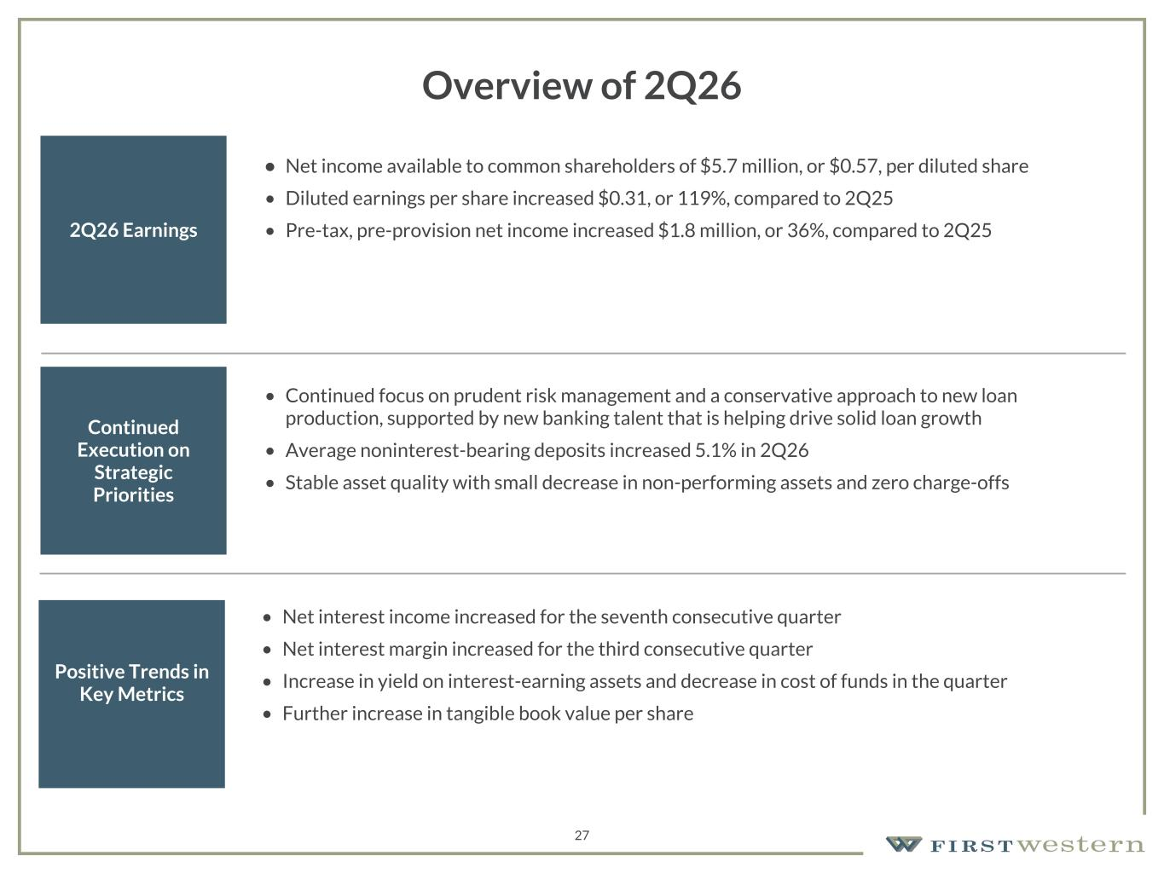
157 180 196 164 166 168 62 94 111 154 161 132 122 125 129 76 78 86 255 255 255 Chart color Table color Special Headlines Slide Headlines / Text on light background Primary Colors Secondary Colors Primary Background / Call Out Boxes / Text on dark background Chart color Table Color Tertiary Colors Chart color Table Color Chart Color Chart Color Approved Fonts AaBbCc 123 Lora (bold) Slide Headlines / Special Headlines AaBbCc 123 Lato(regular, bold, italics) Body Copy / Subheadings / Small Text Descriptions Overview of 2Q26 2Q26 Earnings • Net income available to common shareholders of $5.7 million, or $0.57, per diluted share • Diluted earnings per share increased $0.31, or 119%, compared to 2Q25 • Pre-tax, pre-provision net income increased $1.8 million, or 36%, compared to 2Q25 Continued Execution on Strategic Priorities • Continued focus on prudent risk management and a conservative approach to new loan production, supported by new banking talent that is helping drive solid loan growth • Average noninterest-bearing deposits increased 5.1% in 2Q26 • Stable asset quality with small decrease in non-performing assets and zero charge-offs Positive Trends in Key Metrics • Net interest income increased for the seventh consecutive quarter • Net interest margin increased for the third consecutive quarter • Increase in yield on interest-earning assets and decrease in cost of funds in the quarter • Further increase in tangible book value per share 27

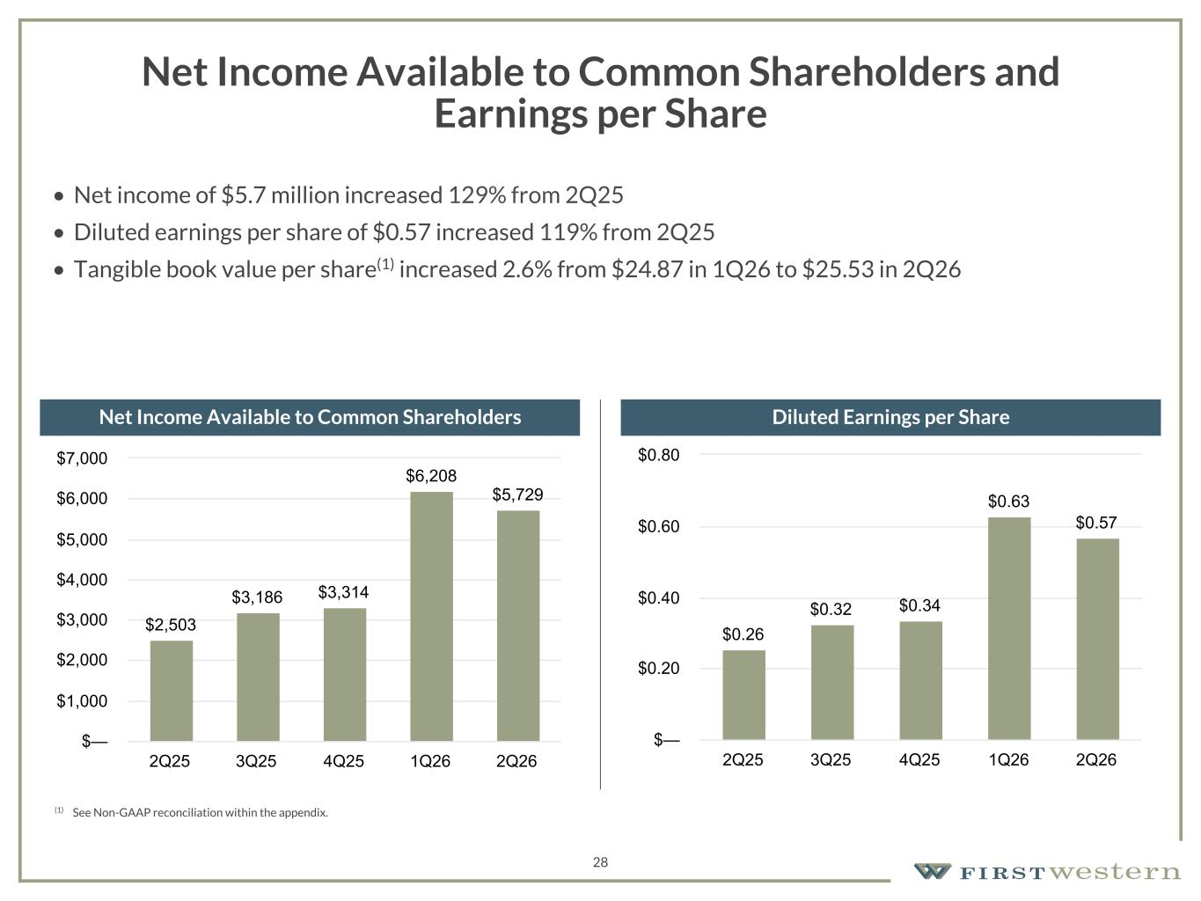
157 180 196 164 166 168 62 94 111 154 161 132 122 125 129 76 78 86 255 255 255 Chart color Table color Special Headlines Slide Headlines / Text on light background Primary Colors Secondary Colors Primary Background / Call Out Boxes / Text on dark background Chart color Table Color Tertiary Colors Chart color Table Color Chart Color Chart Color Approved Fonts AaBbCc 123 Lora (bold) Slide Headlines / Special Headlines AaBbCc 123 Lato(regular, bold, italics) Body Copy / Subheadings / Small Text Descriptions 28 Net Income Available to Common Shareholders and Earnings per Share • Net income of $5.7 million increased 129% from 2Q25 • Diluted earnings per share of $0.57 increased 119% from 2Q25 • Tangible book value per share(1) increased 2.6% from $24.87 in 1Q26 to $25.53 in 2Q26 Net Income Available to Common Shareholders Diluted Earnings per Share $2,503 $3,186 $3,314 $6,208 $5,729 2Q25 3Q25 4Q25 1Q26 2Q26 $— $1,000 $2,000 $3,000 $4,000 $5,000 $6,000 $7,000 $0.26 $0.32 $0.34 $0.63 $0.57 2Q25 3Q25 4Q25 1Q26 2Q26 $— $0.20 $0.40 $0.60 $0.80 (1) See Non-GAAP reconciliation within the appendix.

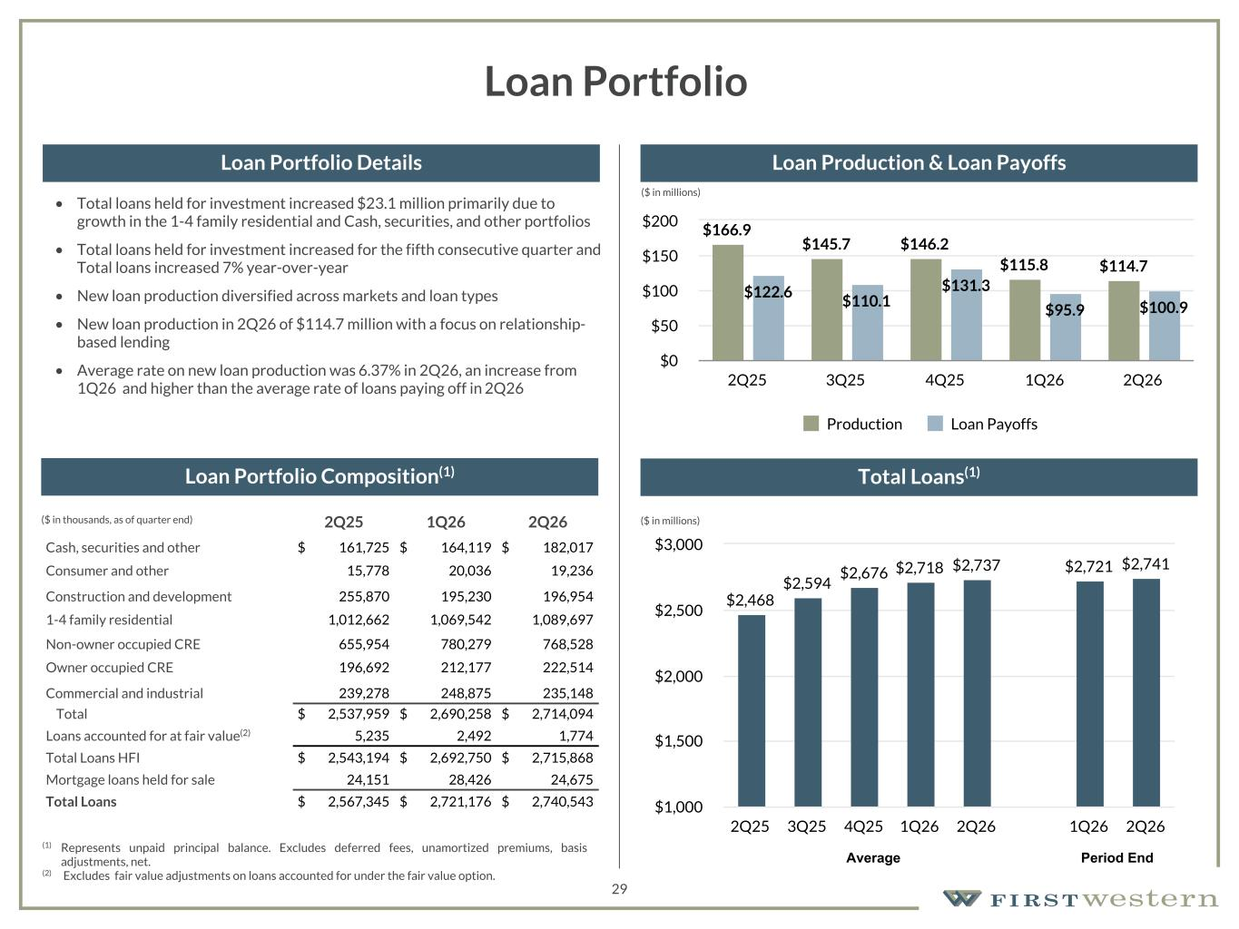
157 180 196 164 166 168 62 94 111 154 161 132 122 125 129 76 78 86 255 255 255 Chart color Table color Special Headlines Slide Headlines / Text on light background Primary Colors Secondary Colors Primary Background / Call Out Boxes / Text on dark background Chart color Table Color Tertiary Colors Chart color Table Color Chart Color Chart Color Approved Fonts AaBbCc 123 Lora (bold) Slide Headlines / Special Headlines AaBbCc 123 Lato(regular, bold, italics) Body Copy / Subheadings / Small Text Descriptions 29 Loan Portfolio • Total loans held for investment increased $23.1 million primarily due to growth in the 1-4 family residential and Cash, securities, and other portfolios • Total loans held for investment increased for the fifth consecutive quarter and Total loans increased 7% year-over-year • New loan production diversified across markets and loan types • New loan production in 2Q26 of $114.7 million with a focus on relationship- based lending • Average rate on new loan production was 6.37% in 2Q26, an increase from 1Q26 and higher than the average rate of loans paying off in 2Q26 2Q25 1Q26 2Q26 Cash, securities and other $ 161,725 $ 164,119 $ 182,017 Consumer and other 15,778 20,036 19,236 Construction and development 255,870 195,230 196,954 1-4 family residential 1,012,662 1,069,542 1,089,697 Non-owner occupied CRE 655,954 780,279 768,528 Owner occupied CRE 196,692 212,177 222,514 Commercial and industrial 239,278 248,875 235,148 Total $ 2,537,959 $ 2,690,258 $ 2,714,094 Loans accounted for at fair value(2) 5,235 2,492 1,774 Total Loans HFI $ 2,543,194 $ 2,692,750 $ 2,715,868 Mortgage loans held for sale 24,151 28,426 24,675 Total Loans $ 2,567,345 $ 2,721,176 $ 2,740,543 (1) Represents unpaid principal balance. Excludes deferred fees, unamortized premiums, basis adjustments, net. (2) Excludes fair value adjustments on loans accounted for under the fair value option. ($ in thousands, as of quarter end) Loan Portfolio Composition(1) Loan Portfolio Details Loan Production & Loan Payoffs Total Loans(1) $2,468 $2,594 $2,676 $2,718 $2,737 $2,721 $2,741 2Q25 3Q25 4Q25 1Q26 2Q26 1Q26 2Q26 $1,000 $1,500 $2,000 $2,500 $3,000 Average Period End $166.9 $145.7 $146.2 $115.8 $114.7 $122.6 $110.1 $131.3 $95.9 $100.9 Production Loan Payoffs 2Q25 3Q25 4Q25 1Q26 2Q26 $0 $50 $100 $150 $200 ($ in millions) ($ in millions)

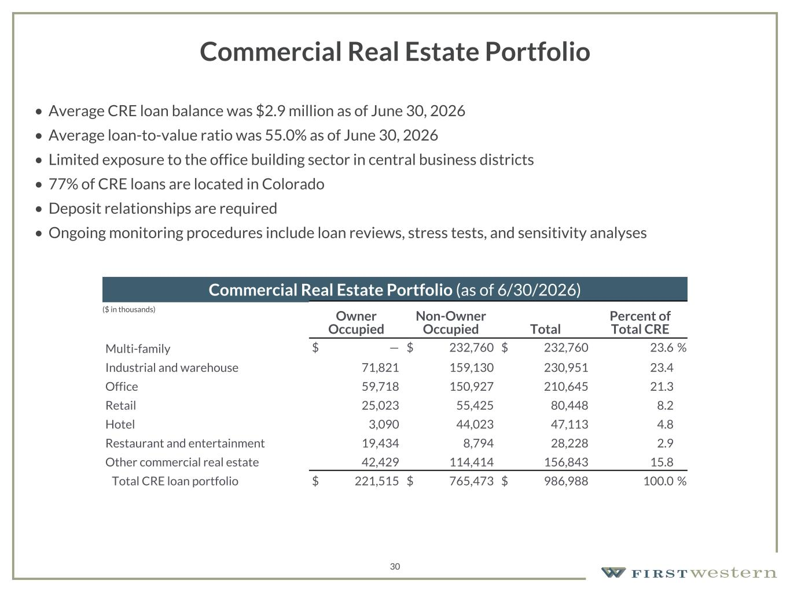
157 180 196 164 166 168 62 94 111 154 161 132 122 125 129 76 78 86 255 255 255 Chart color Table color Special Headlines Slide Headlines / Text on light background Primary Colors Secondary Colors Primary Background / Call Out Boxes / Text on dark background Chart color Table Color Tertiary Colors Chart color Table Color Chart Color Chart Color Approved Fonts AaBbCc 123 Lora (bold) Slide Headlines / Special Headlines AaBbCc 123 Lato(regular, bold, italics) Body Copy / Subheadings / Small Text Descriptions 30 Commercial Real Estate Portfolio • Average CRE loan balance was $2.9 million as of June 30, 2026 • Average loan-to-value ratio was 55.0% as of June 30, 2026 • Limited exposure to the office building sector in central business districts • 77% of CRE loans are located in Colorado • Deposit relationships are required • Ongoing monitoring procedures include loan reviews, stress tests, and sensitivity analyses Commercial Real Estate Portfolio (as of 6/30/2026) Owner Occupied Non-Owner Occupied Total Percent of Total CRE Multi-family $ — $ 232,760 $ 232,760 23.6 % Industrial and warehouse 71,821 159,130 230,951 23.4 Office 59,718 150,927 210,645 21.3 Retail 25,023 55,425 80,448 8.2 Hotel 3,090 44,023 47,113 4.8 Restaurant and entertainment 19,434 8,794 28,228 2.9 Other commercial real estate 42,429 114,414 156,843 15.8 Total CRE loan portfolio $ 221,515 $ 765,473 $ 986,988 100.0 % ($ in thousands)

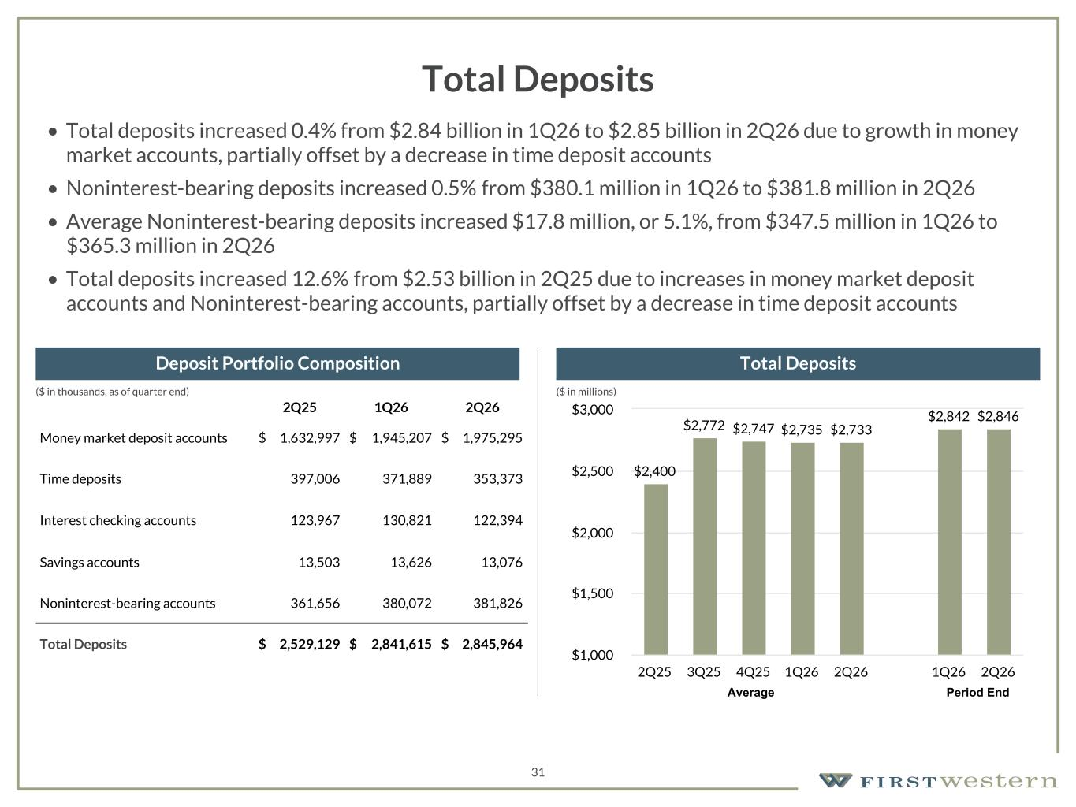
157 180 196 164 166 168 62 94 111 154 161 132 122 125 129 76 78 86 255 255 255 Chart color Table color Special Headlines Slide Headlines / Text on light background Primary Colors Secondary Colors Primary Background / Call Out Boxes / Text on dark background Chart color Table Color Tertiary Colors Chart color Table Color Chart Color Chart Color Approved Fonts AaBbCc 123 Lora (bold) Slide Headlines / Special Headlines AaBbCc 123 Lato(regular, bold, italics) Body Copy / Subheadings / Small Text Descriptions 31 Total Deposits • Total deposits increased 0.4% from $2.84 billion in 1Q26 to $2.85 billion in 2Q26 due to growth in money market accounts, partially offset by a decrease in time deposit accounts • Noninterest-bearing deposits increased 0.5% from $380.1 million in 1Q26 to $381.8 million in 2Q26 • Average Noninterest-bearing deposits increased $17.8 million, or 5.1%, from $347.5 million in 1Q26 to $365.3 million in 2Q26 • Total deposits increased 12.6% from $2.53 billion in 2Q25 due to increases in money market deposit accounts and Noninterest-bearing accounts, partially offset by a decrease in time deposit accounts 2Q25 1Q26 2Q26 Money market deposit accounts $ 1,632,997 $ 1,945,207 $ 1,975,295 Time deposits 397,006 371,889 353,373 Interest checking accounts 123,967 130,821 122,394 Savings accounts 13,503 13,626 13,076 Noninterest-bearing accounts 361,656 380,072 381,826 Total Deposits $ 2,529,129 $ 2,841,615 $ 2,845,964 Deposit Portfolio Composition Total Deposits $2,400 $2,772 $2,747 $2,735 $2,733 $2,842 $2,846 2Q25 3Q25 4Q25 1Q26 2Q26 1Q26 2Q26 $1,000 $1,500 $2,000 $2,500 $3,000 Average Period End ($ in millions)($ in thousands, as of quarter end)

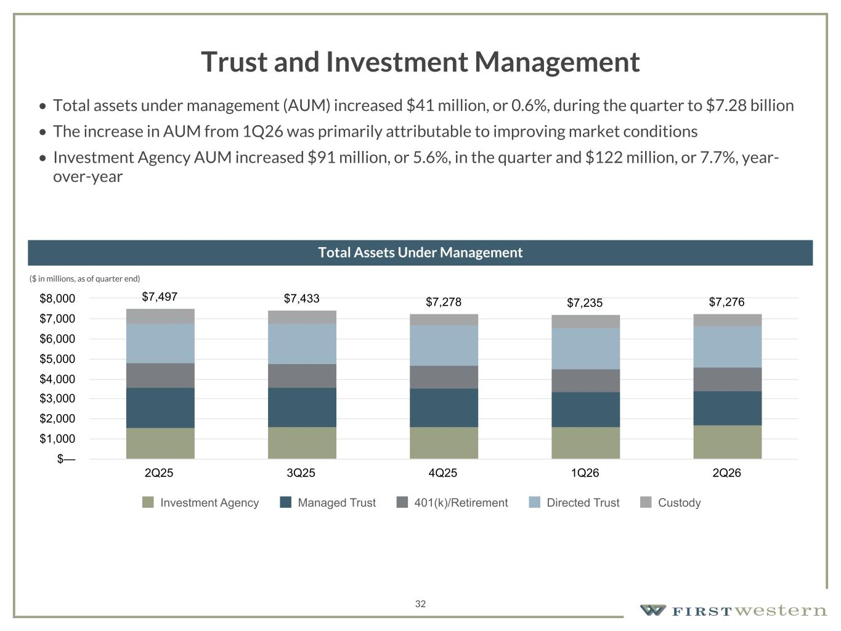
157 180 196 164 166 168 62 94 111 154 161 132 122 125 129 76 78 86 255 255 255 Chart color Table color Special Headlines Slide Headlines / Text on light background Primary Colors Secondary Colors Primary Background / Call Out Boxes / Text on dark background Chart color Table Color Tertiary Colors Chart color Table Color Chart Color Chart Color Approved Fonts AaBbCc 123 Lora (bold) Slide Headlines / Special Headlines AaBbCc 123 Lato(regular, bold, italics) Body Copy / Subheadings / Small Text Descriptions 32 Trust and Investment Management • Total assets under management (AUM) increased $41 million, or 0.6%, during the quarter to $7.28 billion • The increase in AUM from 1Q26 was primarily attributable to improving market conditions • Investment Agency AUM increased $91 million, or 5.6%, in the quarter and $122 million, or 7.7%, year- over-year ($ in millions, as of quarter end) Total Assets Under Management $7,497 $7,433 $7,278 $7,235 $7,276 Investment Agency Managed Trust 401(k)/Retirement Directed Trust Custody 2Q25 3Q25 4Q25 1Q26 2Q26 $— $1,000 $2,000 $3,000 $4,000 $5,000 $6,000 $7,000 $8,000

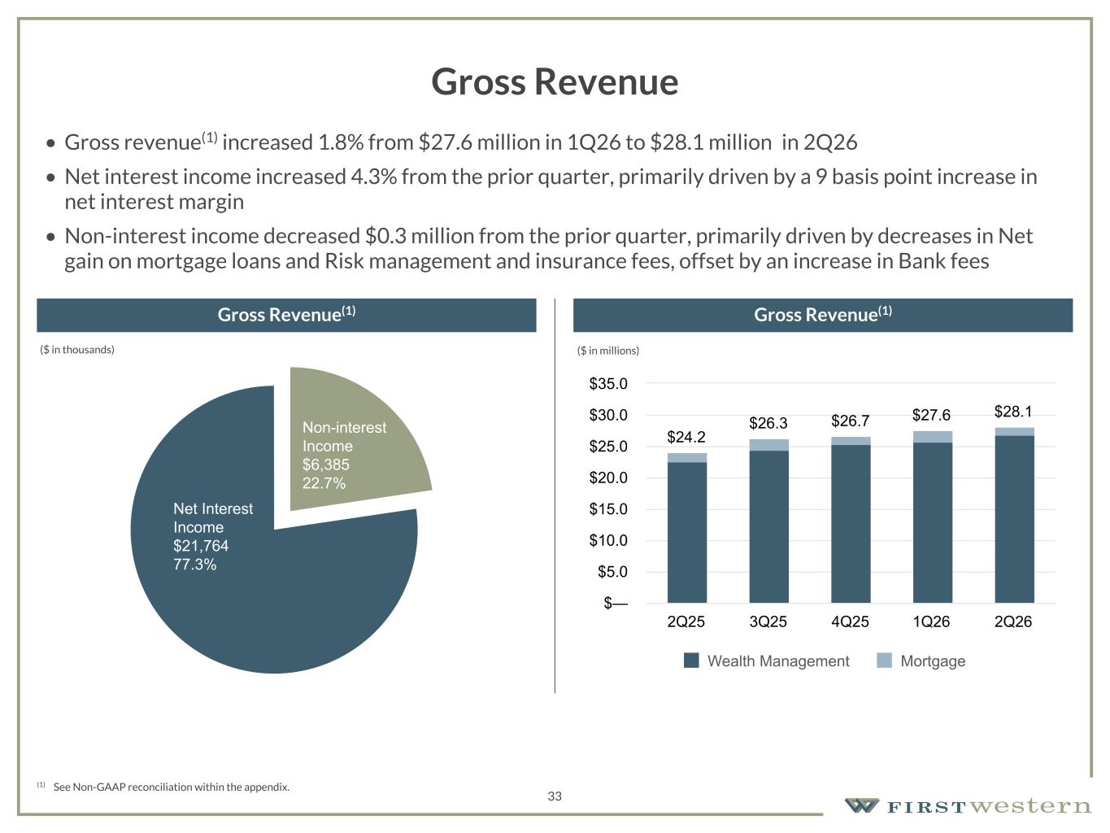
157 180 196 164 166 168 62 94 111 154 161 132 122 125 129 76 78 86 255 255 255 Chart color Table color Special Headlines Slide Headlines / Text on light background Primary Colors Secondary Colors Primary Background / Call Out Boxes / Text on dark background Chart color Table Color Tertiary Colors Chart color Table Color Chart Color Chart Color Approved Fonts AaBbCc 123 Lora (bold) Slide Headlines / Special Headlines AaBbCc 123 Lato(regular, bold, italics) Body Copy / Subheadings / Small Text Descriptions (1) See Non-GAAP reconciliation within the appendix. Gross Revenue Gross Revenue(1) Gross Revenue(1) 33 $24.2 $26.3 $26.7 $27.6 $28.1 Wealth Management Mortgage 2Q25 3Q25 4Q25 1Q26 2Q26 $— $5.0 $10.0 $15.0 $20.0 $25.0 $30.0 $35.0 • Gross revenue(1) increased 1.8% from $27.6 million in 1Q26 to $28.1 million in 2Q26 • Net interest income increased 4.3% from the prior quarter, primarily driven by a 9 basis point increase in net interest margin • Non-interest income decreased $0.3 million from the prior quarter, primarily driven by decreases in Net gain on mortgage loans and Risk management and insurance fees, offset by an increase in Bank fees Non-interest Income $6,385 22.7% Net Interest Income $21,764 77.3% ($ in thousands) ($ in millions)

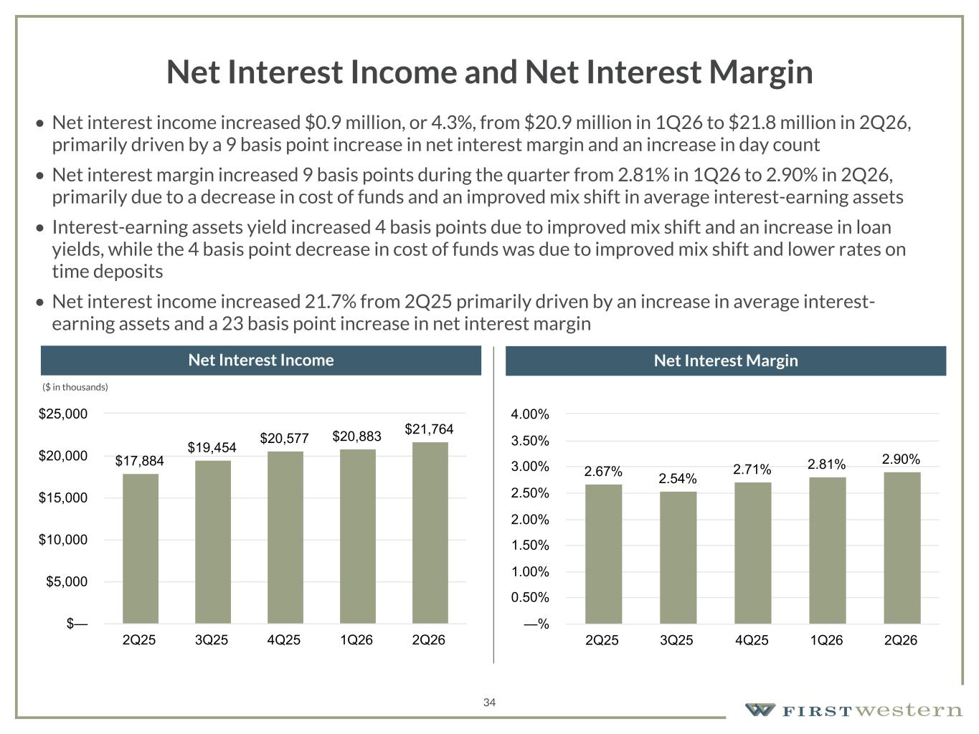
157 180 196 164 166 168 62 94 111 154 161 132 122 125 129 76 78 86 255 255 255 Chart color Table color Special Headlines Slide Headlines / Text on light background Primary Colors Secondary Colors Primary Background / Call Out Boxes / Text on dark background Chart color Table Color Tertiary Colors Chart color Table Color Chart Color Chart Color Approved Fonts AaBbCc 123 Lora (bold) Slide Headlines / Special Headlines AaBbCc 123 Lato(regular, bold, italics) Body Copy / Subheadings / Small Text Descriptions 34 Net Interest Income and Net Interest Margin • Net interest income increased $0.9 million, or 4.3%, from $20.9 million in 1Q26 to $21.8 million in 2Q26, primarily driven by a 9 basis point increase in net interest margin and an increase in day count • Net interest margin increased 9 basis points during the quarter from 2.81% in 1Q26 to 2.90% in 2Q26, primarily due to a decrease in cost of funds and an improved mix shift in average interest-earning assets • Interest-earning assets yield increased 4 basis points due to improved mix shift and an increase in loan yields, while the 4 basis point decrease in cost of funds was due to improved mix shift and lower rates on time deposits • Net interest income increased 21.7% from 2Q25 primarily driven by an increase in average interest- earning assets and a 23 basis point increase in net interest margin Net Interest Income Net Interest Margin $17,884 $19,454 $20,577 $20,883 $21,764 2Q25 3Q25 4Q25 1Q26 2Q26 $— $5,000 $10,000 $15,000 $20,000 $25,000 2.67% 2.54% 2.71% 2.81% 2.90% 2Q25 3Q25 4Q25 1Q26 2Q26 —% 0.50% 1.00% 1.50% 2.00% 2.50% 3.00% 3.50% 4.00% ($ in thousands)

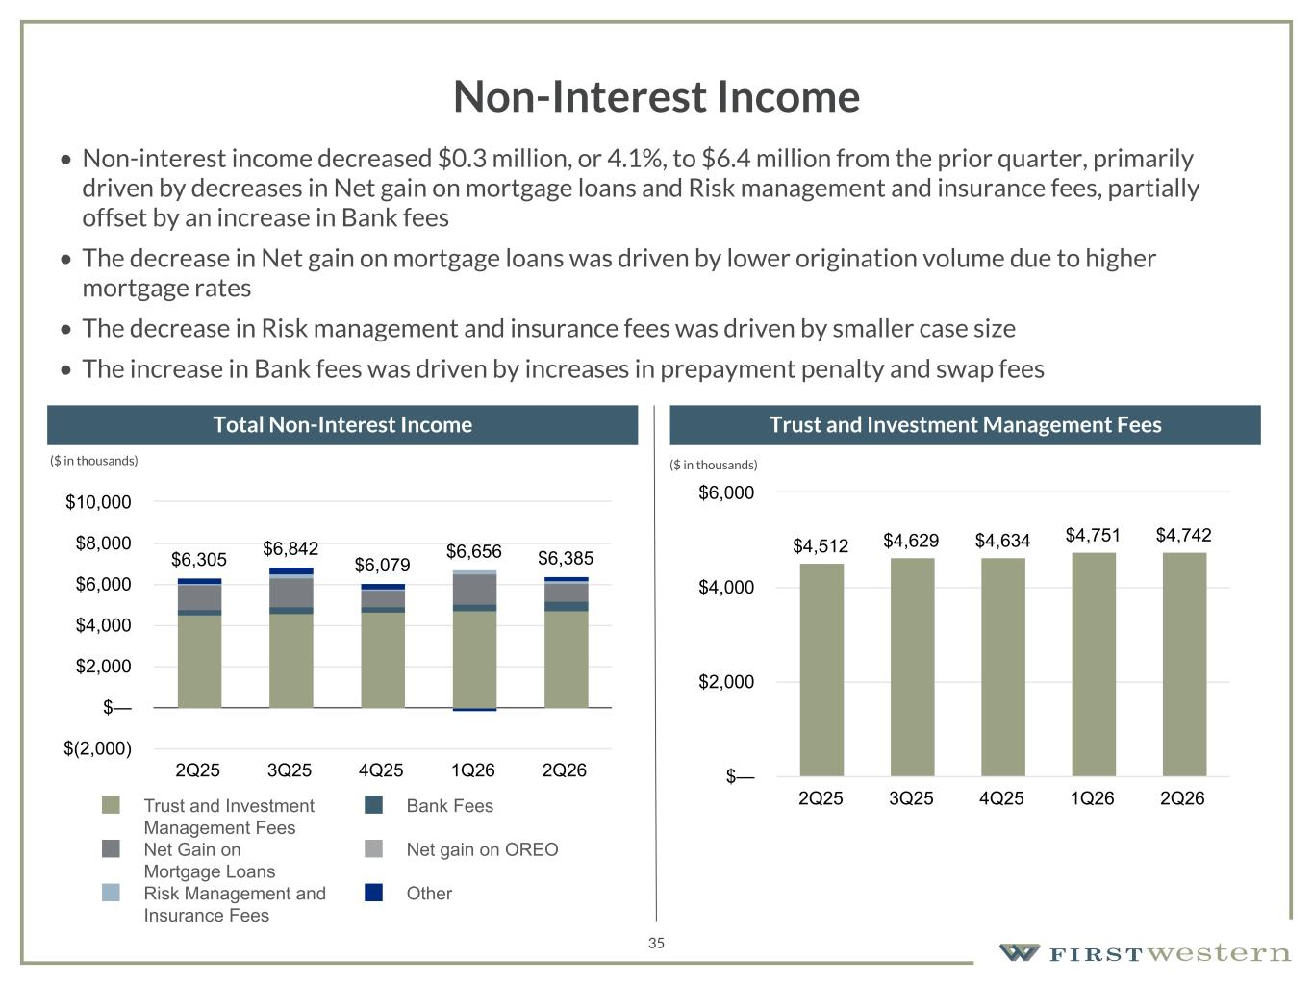
157 180 196 164 166 168 62 94 111 154 161 132 122 125 129 76 78 86 255 255 255 Chart color Table color Special Headlines Slide Headlines / Text on light background Primary Colors Secondary Colors Primary Background / Call Out Boxes / Text on dark background Chart color Table Color Tertiary Colors Chart color Table Color Chart Color Chart Color Approved Fonts AaBbCc 123 Lora (bold) Slide Headlines / Special Headlines AaBbCc 123 Lato(regular, bold, italics) Body Copy / Subheadings / Small Text Descriptions 35 Non-Interest Income • Non-interest income decreased $0.3 million, or 4.1%, to $6.4 million from the prior quarter, primarily driven by decreases in Net gain on mortgage loans and Risk management and insurance fees, partially offset by an increase in Bank fees • The decrease in Net gain on mortgage loans was driven by lower origination volume due to higher mortgage rates • The decrease in Risk management and insurance fees was driven by smaller case size • The increase in Bank fees was driven by increases in prepayment penalty and swap fees Total Non-Interest Income Trust and Investment Management Fees $6,305 $6,842 $6,079 $6,656 $6,385 Trust and Investment Management Fees Bank Fees Net Gain on Mortgage Loans Net gain on OREO Risk Management and Insurance Fees Other 2Q25 3Q25 4Q25 1Q26 2Q26 $(2,000) $— $2,000 $4,000 $6,000 $8,000 $10,000 $4,512 $4,629 $4,634 $4,751 $4,742 2Q25 3Q25 4Q25 1Q26 2Q26 $— $2,000 $4,000 $6,000 ($ in thousands) ($ in thousands)

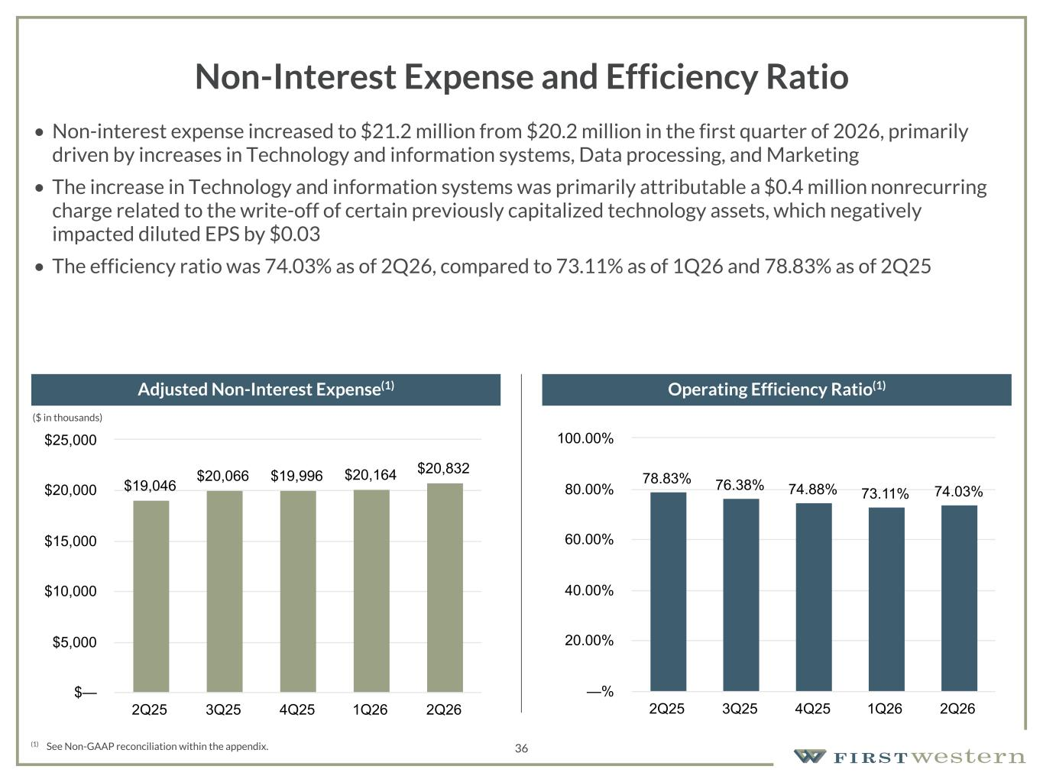
157 180 196 164 166 168 62 94 111 154 161 132 122 125 129 76 78 86 255 255 255 Chart color Table color Special Headlines Slide Headlines / Text on light background Primary Colors Secondary Colors Primary Background / Call Out Boxes / Text on dark background Chart color Table Color Tertiary Colors Chart color Table Color Chart Color Chart Color Approved Fonts AaBbCc 123 Lora (bold) Slide Headlines / Special Headlines AaBbCc 123 Lato(regular, bold, italics) Body Copy / Subheadings / Small Text Descriptions 36 Non-Interest Expense and Efficiency Ratio • Non-interest expense increased to $21.2 million from $20.2 million in the first quarter of 2026, primarily driven by increases in Technology and information systems, Data processing, and Marketing • The increase in Technology and information systems was primarily attributable a $0.4 million nonrecurring charge related to the write-off of certain previously capitalized technology assets, which negatively impacted diluted EPS by $0.03 • The efficiency ratio was 74.03% as of 2Q26, compared to 73.11% as of 1Q26 and 78.83% as of 2Q25 (1) See Non-GAAP reconciliation within the appendix. Adjusted Non-Interest Expense(1) Operating Efficiency Ratio(1) (1) (1) (1) $19,046 $20,066 $19,996 $20,164 $20,832 2Q25 3Q25 4Q25 1Q26 2Q26 $— $5,000 $10,000 $15,000 $20,000 $25,000 78.83% 76.38% 74.88% 73.11% 74.03% 2Q25 3Q25 4Q25 1Q26 2Q26 —% 20.00% 40.00% 60.00% 80.00% 100.00% ($ in thousands)

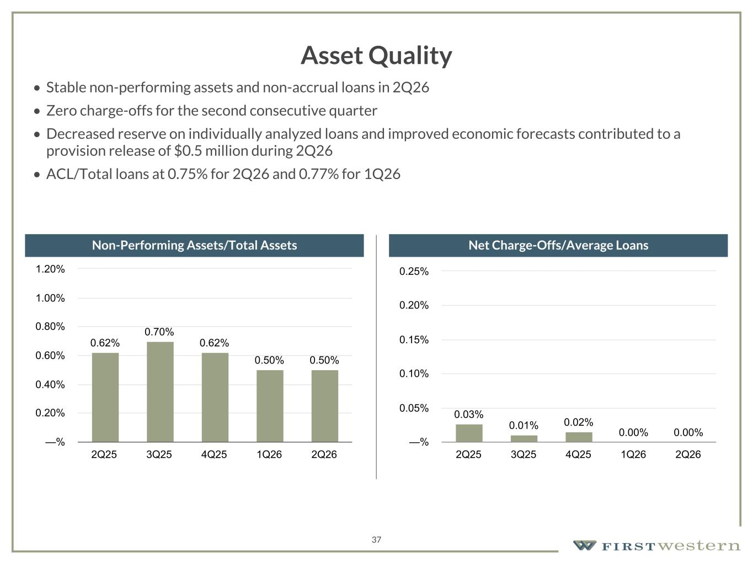
157 180 196 164 166 168 62 94 111 154 161 132 122 125 129 76 78 86 255 255 255 Chart color Table color Special Headlines Slide Headlines / Text on light background Primary Colors Secondary Colors Primary Background / Call Out Boxes / Text on dark background Chart color Table Color Tertiary Colors Chart color Table Color Chart Color Chart Color Approved Fonts AaBbCc 123 Lora (bold) Slide Headlines / Special Headlines AaBbCc 123 Lato(regular, bold, italics) Body Copy / Subheadings / Small Text Descriptions 37 Asset Quality • Stable non-performing assets and non-accrual loans in 2Q26 • Zero charge-offs for the second consecutive quarter • Decreased reserve on individually analyzed loans and improved economic forecasts contributed to a provision release of $0.5 million during 2Q26 • ACL/Total loans at 0.75% for 2Q26 and 0.77% for 1Q26 Non-Performing Assets/Total Assets Net Charge-Offs/Average Loans 0.62% 0.70% 0.62% 0.50% 0.50% 2Q25 3Q25 4Q25 1Q26 2Q26 —% 0.20% 0.40% 0.60% 0.80% 1.00% 1.20% 0.03% 0.01% 0.02% 0.00% 0.00% 2Q25 3Q25 4Q25 1Q26 2Q26 —% 0.05% 0.10% 0.15% 0.20% 0.25%

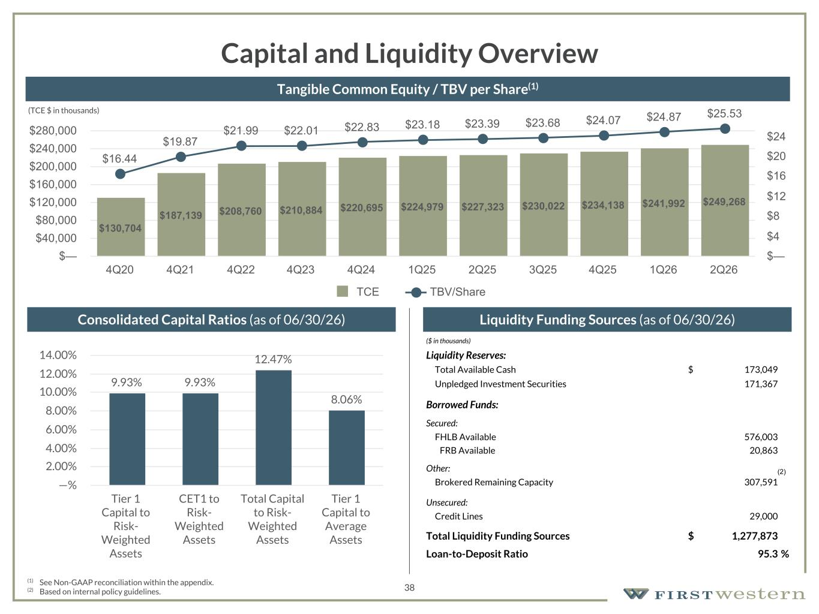
157 180 196 164 166 168 62 94 111 154 161 132 122 125 129 76 78 86 255 255 255 Chart color Table color Special Headlines Slide Headlines / Text on light background Primary Colors Secondary Colors Primary Background / Call Out Boxes / Text on dark background Chart color Table Color Tertiary Colors Chart color Table Color Chart Color Chart Color Approved Fonts AaBbCc 123 Lora (bold) Slide Headlines / Special Headlines AaBbCc 123 Lato (regular, bold, italics) Body Copy / Subheadings / Small Text Descriptions 38 Capital and Liquidity Overview Liquidity Funding Sources (as of 06/30/26) (1) See Non-GAAP reconciliation within the appendix. (2) Based on internal policy guidelines. Consolidated Capital Ratios (as of 06/30/26) Tangible Common Equity / TBV per Share(1) ($ in thousands) Liquidity Reserves: Total Available Cash $ 173,049 Unpledged Investment Securities 171,367 Borrowed Funds: Secured: FHLB Available 576,003 FRB Available 20,863 Other: Brokered Remaining Capacity 307,591 Unsecured: Credit Lines 29,000 Total Liquidity Funding Sources $ 1,277,873 Loan-to-Deposit Ratio 95.3 % 9.93% 9.93% 12.47% 8.06% Tier 1 Capital to Risk- Weighted Assets CET1 to Risk- Weighted Assets Total Capital to Risk- Weighted Assets Tier 1 Capital to Average Assets —% 2.00% 4.00% 6.00% 8.00% 10.00% 12.00% 14.00% (2) (TCE $ in thousands) $130,704 $187,139 $208,760 $210,884 $220,695 $224,979 $227,323 $230,022 $234,138 $241,992 $249,268 $16.44 $19.87 $21.99 $22.01 $22.83 $23.18 $23.39 $23.68 $24.07 $24.87 $25.53 TCE TBV/Share 4Q20 4Q21 4Q22 4Q23 4Q24 1Q25 2Q25 3Q25 4Q25 1Q26 2Q26 $— $40,000 $80,000 $120,000 $160,000 $200,000 $240,000 $280,000 $— $4 $8 $12 $16 $20 $24

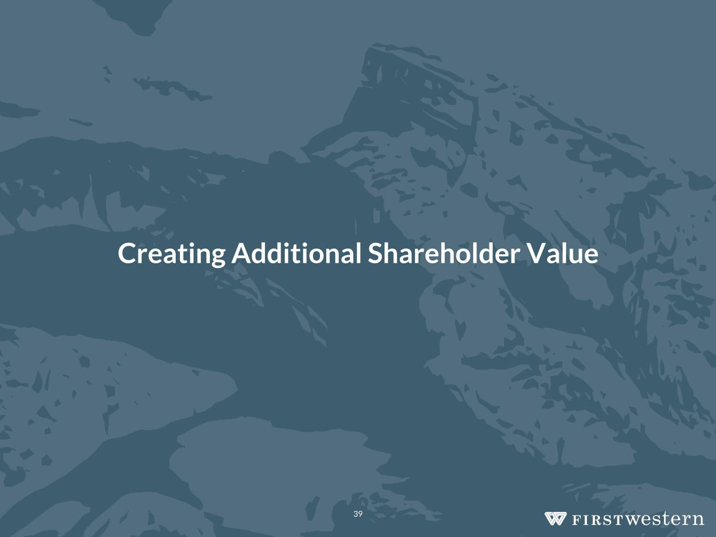
Creating Additional Shareholder Value 39

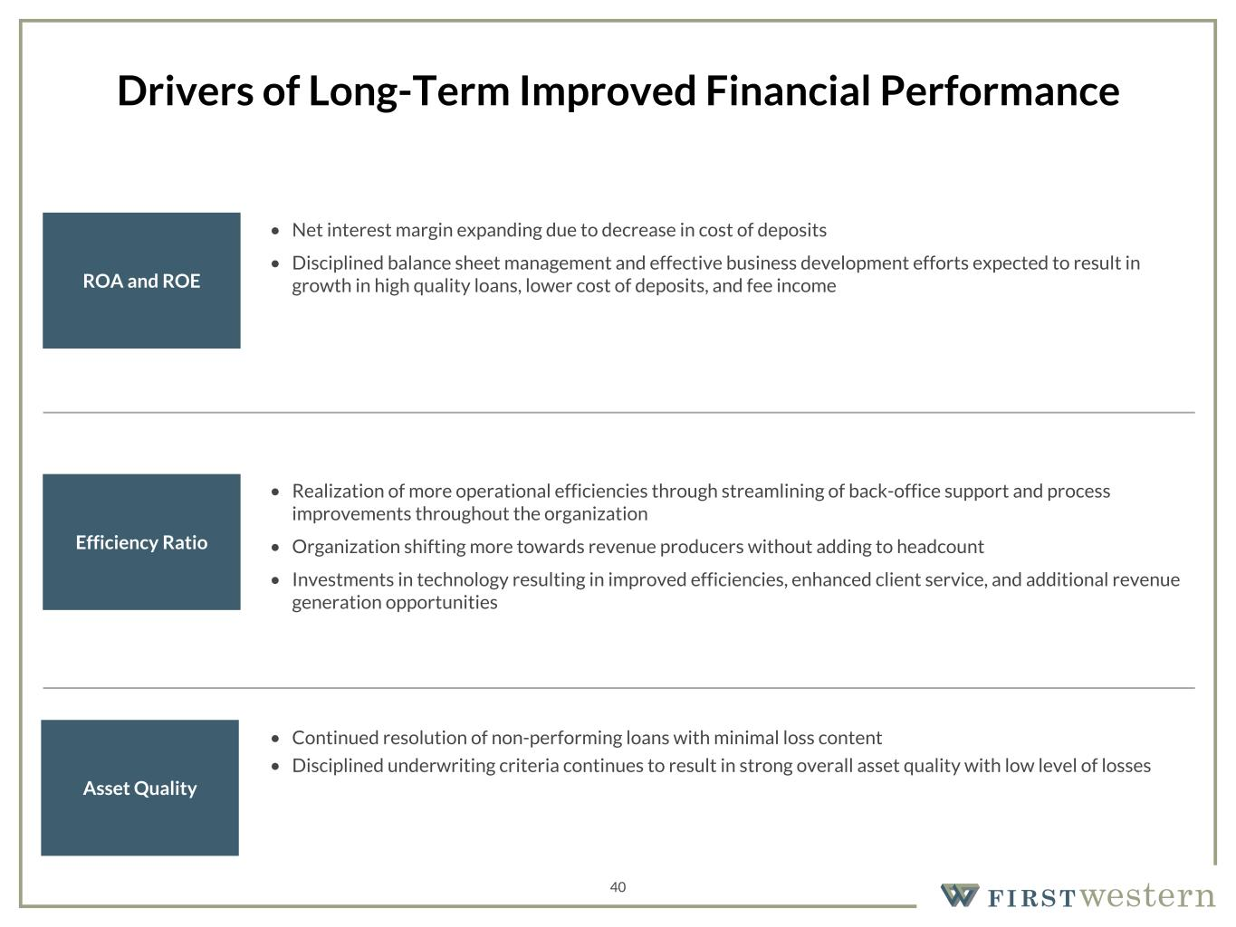
157 180 196 164 166 168 62 94 111 154 161 132 122 125 129 76 78 86 255 255 255 Chart color Table color Special Headlines Slide Headlines / Text on light background Primary Colors Secondary Colors Primary Background / Call Out Boxes / Text on dark background Chart color Table Color Tertiary Colors Chart color Table Color Chart Color Chart Color Approved Fonts AaBbCc 123 Lora (bold) Slide Headlines / Special Headlines AaBbCc 123 Lato (regular, bold, italics) Body Copy / Subheadings / Small Text Descriptions 40 Drivers of Long-Term Improved Financial Performance Efficiency Ratio Asset Quality ROA and ROE • Net interest margin expanding due to decrease in cost of deposits • Disciplined balance sheet management and effective business development efforts expected to result in growth in high quality loans, lower cost of deposits, and fee income • Realization of more operational efficiencies through streamlining of back-office support and process improvements throughout the organization • Organization shifting more towards revenue producers without adding to headcount • Investments in technology resulting in improved efficiencies, enhanced client service, and additional revenue generation opportunities • Continued resolution of non-performing loans with minimal loss content • Disciplined underwriting criteria continues to result in strong overall asset quality with low level of losses

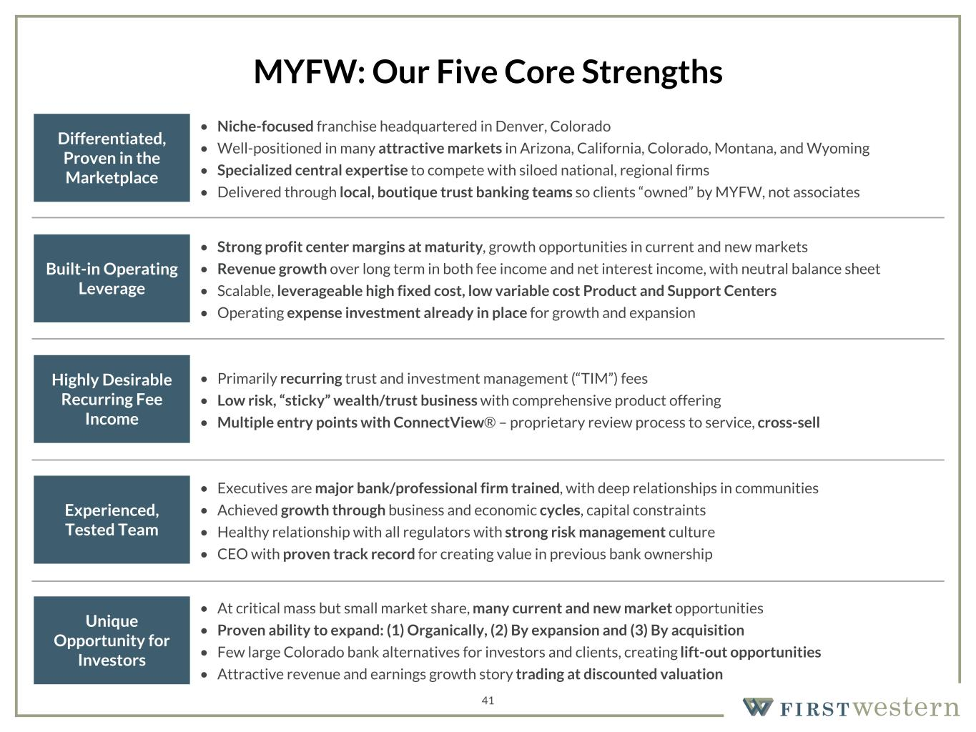
157 180 196 164 166 168 62 94 111 154 161 132 122 125 129 76 78 86 255 255 255 Chart color Table color Special Headlines Slide Headlines / Text on light background Primary Colors Secondary Colors Primary Background / Call Out Boxes / Text on dark background Chart color Table Color Tertiary Colors Chart color Table Color Chart Color Chart Color Approved Fonts AaBbCc 123 Lora (bold) Slide Headlines / Special Headlines AaBbCc 123 Lato (regular, bold, italics) Body Copy / Subheadings / Small Text Descriptions 41 MYFW: Our Five Core Strengths Differentiated, Proven in the Marketplace Built-in Operating Leverage Highly Desirable Recurring Fee Income Experienced, Tested Team Unique Opportunity for Investors • Niche-focused franchise headquartered in Denver, Colorado • Well-positioned in many attractive markets in Arizona, California, Colorado, Montana, and Wyoming • Specialized central expertise to compete with siloed national, regional firms • Delivered through local, boutique trust banking teams so clients “owned” by MYFW, not associates • Strong profit center margins at maturity, growth opportunities in current and new markets • Revenue growth over long term in both fee income and net interest income, with neutral balance sheet • Scalable, leverageable high fixed cost, low variable cost Product and Support Centers • Operating expense investment already in place for growth and expansion • Primarily recurring trust and investment management (“TIM”) fees • Low risk, “sticky” wealth/trust business with comprehensive product offering • Multiple entry points with ConnectView® – proprietary review process to service, cross-sell • At critical mass but small market share, many current and new market opportunities • Proven ability to expand: (1) Organically, (2) By expansion and (3) By acquisition • Few large Colorado bank alternatives for investors and clients, creating lift-out opportunities • Attractive revenue and earnings growth story trading at discounted valuation • Executives are major bank/professional firm trained, with deep relationships in communities • Achieved growth through business and economic cycles, capital constraints • Healthy relationship with all regulators with strong risk management culture • CEO with proven track record for creating value in previous bank ownership

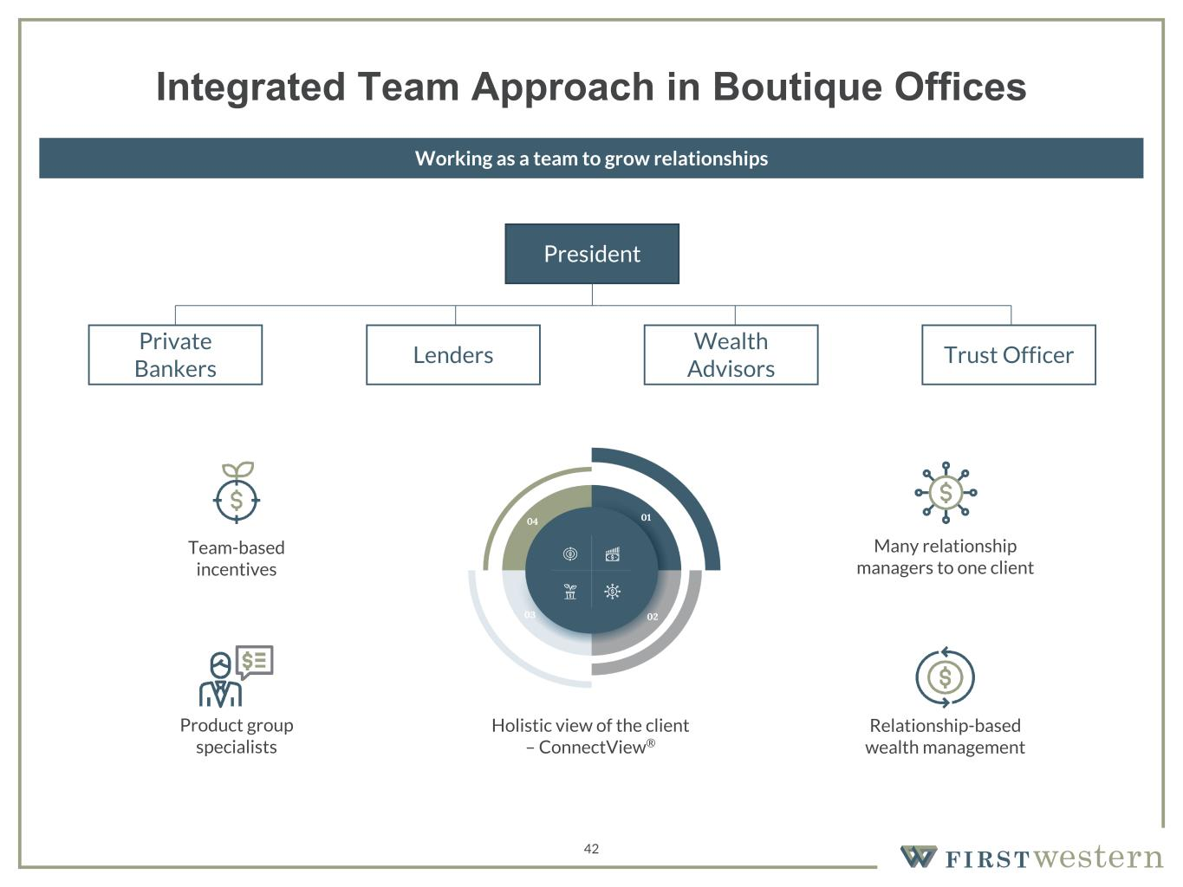
157 180 196 164 166 168 62 94 111 154 161 132 122 125 129 76 78 86 255 255 255 Chart color Table color Special Headlines Slide Headlines / Text on light background Primary Colors Secondary Colors Primary Background / Call Out Boxes / Text on dark background Chart color Table Color Tertiary Colors Chart color Table Color Chart Color Chart Color Approved Fonts AaBbCc 123 Lora (bold) Slide Headlines / Special Headlines AaBbCc 123 Lato (regular, bold, italics) Body Copy / Subheadings / Small Text Descriptions 42 President Private Bankers Lenders Wealth Advisors Trust Officer Team-based incentives Relationship-based wealth management Many relationship managers to one client Product group specialists Holistic view of the client – ConnectView® Integrated Team Approach in Boutique Offices Working as a team to grow relationships

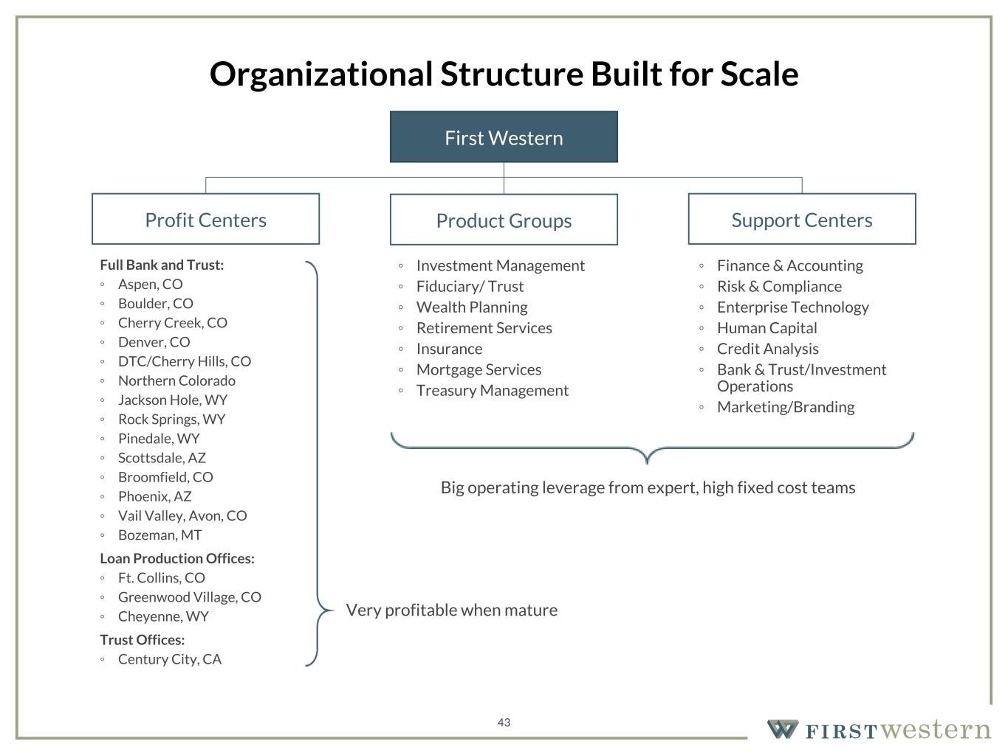
157 180 196 164 166 168 62 94 111 154 161 132 122 125 129 76 78 86 255 255 255 Chart color Table color Special Headlines Slide Headlines / Text on light background Primary Colors Secondary Colors Primary Background / Call Out Boxes / Text on dark background Chart color Table Color Tertiary Colors Chart color Table Color Chart Color Chart Color Approved Fonts AaBbCc 123 Lora (bold) Slide Headlines / Special Headlines AaBbCc 123 Lato (regular, bold, italics) Body Copy / Subheadings / Small Text Descriptions 43 Organizational Structure Built for Scale Full Bank and Trust: ◦ Aspen, CO ◦ Boulder, CO ◦ Cherry Creek, CO ◦ Denver, CO ◦ DTC/Cherry Hills, CO ◦ Northern Colorado ◦ Jackson Hole, WY ◦ Rock Springs, WY ◦ Pinedale, WY ◦ Scottsdale, AZ ◦ Broomfield, CO ◦ Phoenix, AZ ◦ Vail Valley, Avon, CO ◦ Bozeman, MT Loan Production Offices: ◦ Ft. Collins, CO ◦ Greenwood Village, CO ◦ Cheyenne, WY Trust Offices: ◦ Century City, CA ◦ Investment Management ◦ Fiduciary/ Trust ◦ Wealth Planning ◦ Retirement Services ◦ Insurance ◦ Mortgage Services ◦ Treasury Management First Western Profit Centers Product Groups Support Centers ◦ Finance & Accounting ◦ Risk & Compliance ◦ Enterprise Technology ◦ Human Capital ◦ Credit Analysis ◦ Bank & Trust/Investment Operations ◦ Marketing/Branding Big operating leverage from expert, high fixed cost teams Very profitable when mature

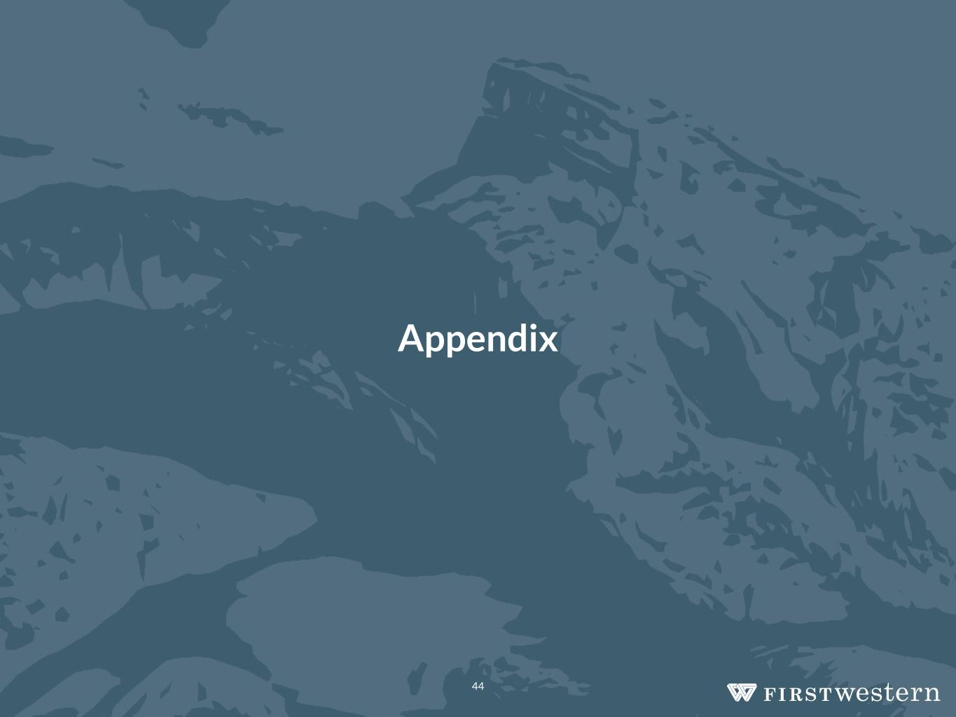
Appendix 44


Organizational Overview 45

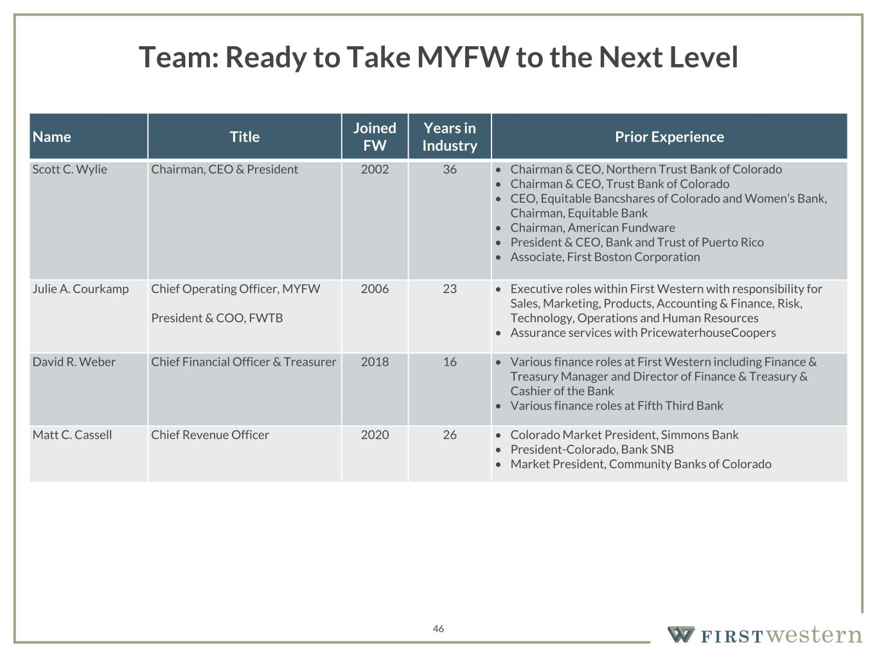
157 180 196 164 166 168 62 94 111 154 161 132 122 125 129 76 78 86 255 255 255 Chart color Table color Special Headlines Slide Headlines / Text on light background Primary Colors Secondary Colors Primary Background / Call Out Boxes / Text on dark background Chart color Table Color Tertiary Colors Chart color Table Color Chart Color Chart Color Approved Fonts AaBbCc 123 Lora (bold) Slide Headlines / Special Headlines AaBbCc 123 Lato (regular, bold, italics) Body Copy / Subheadings / Small Text Descriptions Name Title Joined FW Years in Industry Prior Experience Scott C. Wylie Chairman, CEO & President 2002 36 • Chairman & CEO, Northern Trust Bank of Colorado • Chairman & CEO, Trust Bank of Colorado • CEO, Equitable Bancshares of Colorado and Women’s Bank, Chairman, Equitable Bank • Chairman, American Fundware • President & CEO, Bank and Trust of Puerto Rico • Associate, First Boston Corporation Julie A. Courkamp Chief Operating Officer, MYFW President & COO, FWTB 2006 23 • Executive roles within First Western with responsibility for Sales, Marketing, Products, Accounting & Finance, Risk, Technology, Operations and Human Resources • Assurance services with PricewaterhouseCoopers David R. Weber Chief Financial Officer & Treasurer 2018 16 • Various finance roles at First Western including Finance & Treasury Manager and Director of Finance & Treasury & Cashier of the Bank • Various finance roles at Fifth Third Bank Matt C. Cassell Chief Revenue Officer 2020 26 • Colorado Market President, Simmons Bank • President-Colorado, Bank SNB • Market President, Community Banks of Colorado 46 Team: Ready to Take MYFW to the Next Level

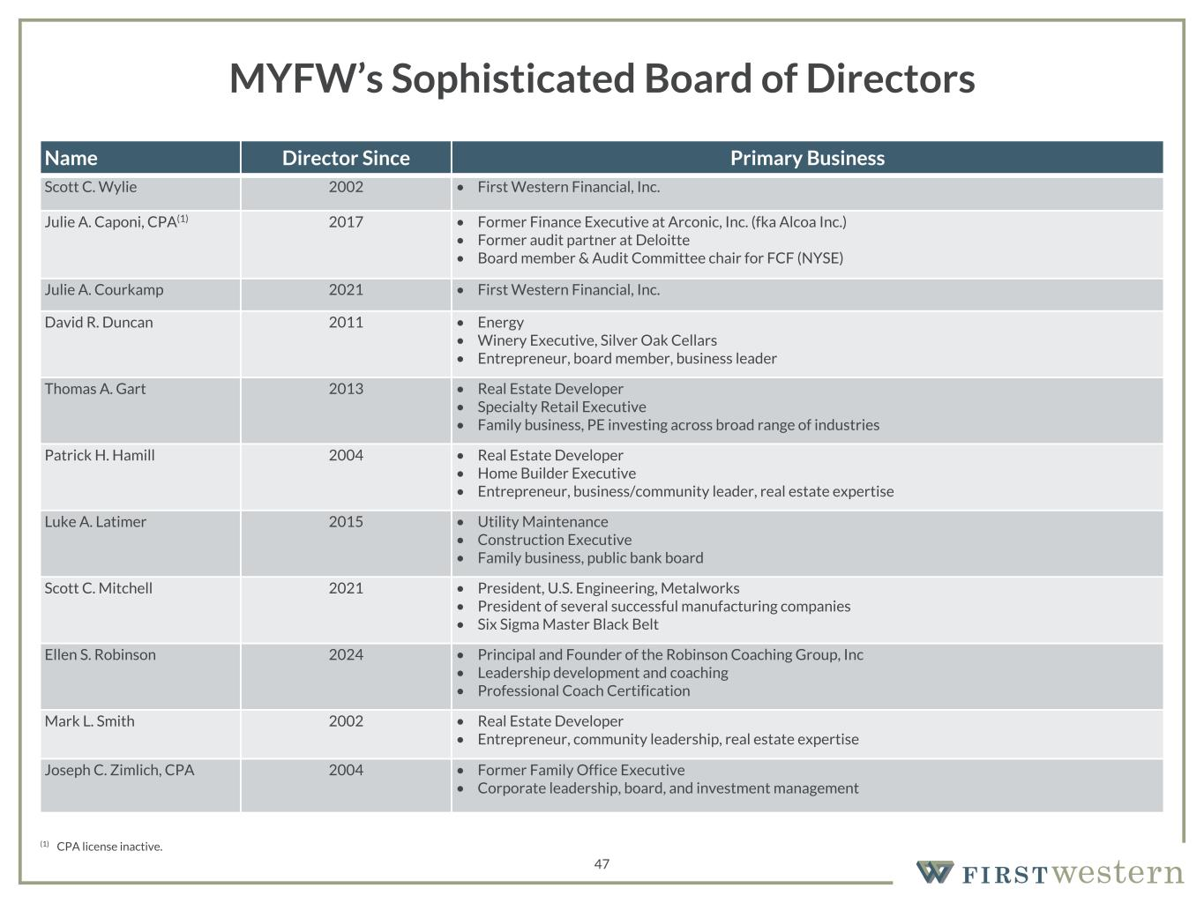
157 180 196 164 166 168 62 94 111 154 161 132 122 125 129 76 78 86 255 255 255 Chart color Table color Special Headlines Slide Headlines / Text on light background Primary Colors Secondary Colors Primary Background / Call Out Boxes / Text on dark background Chart color Table Color Tertiary Colors Chart color Table Color Chart Color Chart Color Approved Fonts AaBbCc 123 Lora (bold) Slide Headlines / Special Headlines AaBbCc 123 Lato (regular, bold, italics) Body Copy / Subheadings / Small Text Descriptions Name Director Since Primary Business Scott C. Wylie 2002 • First Western Financial, Inc. Julie A. Caponi, CPA(1) 2017 • Former Finance Executive at Arconic, Inc. (fka Alcoa Inc.) • Former audit partner at Deloitte • Board member & Audit Committee chair for FCF (NYSE) Julie A. Courkamp 2021 • First Western Financial, Inc. David R. Duncan 2011 • Energy • Winery Executive, Silver Oak Cellars • Entrepreneur, board member, business leader Thomas A. Gart 2013 • Real Estate Developer • Specialty Retail Executive • Family business, PE investing across broad range of industries Patrick H. Hamill 2004 • Real Estate Developer • Home Builder Executive • Entrepreneur, business/community leader, real estate expertise Luke A. Latimer 2015 • Utility Maintenance • Construction Executive • Family business, public bank board Scott C. Mitchell 2021 • President, U.S. Engineering, Metalworks • President of several successful manufacturing companies • Six Sigma Master Black Belt Ellen S. Robinson 2024 • Principal and Founder of the Robinson Coaching Group, Inc • Leadership development and coaching • Professional Coach Certification Mark L. Smith 2002 • Real Estate Developer • Entrepreneur, community leadership, real estate expertise Joseph C. Zimlich, CPA 2004 • Former Family Office Executive • Corporate leadership, board, and investment management 47 MYFW’s Sophisticated Board of Directors (1) CPA license inactive.

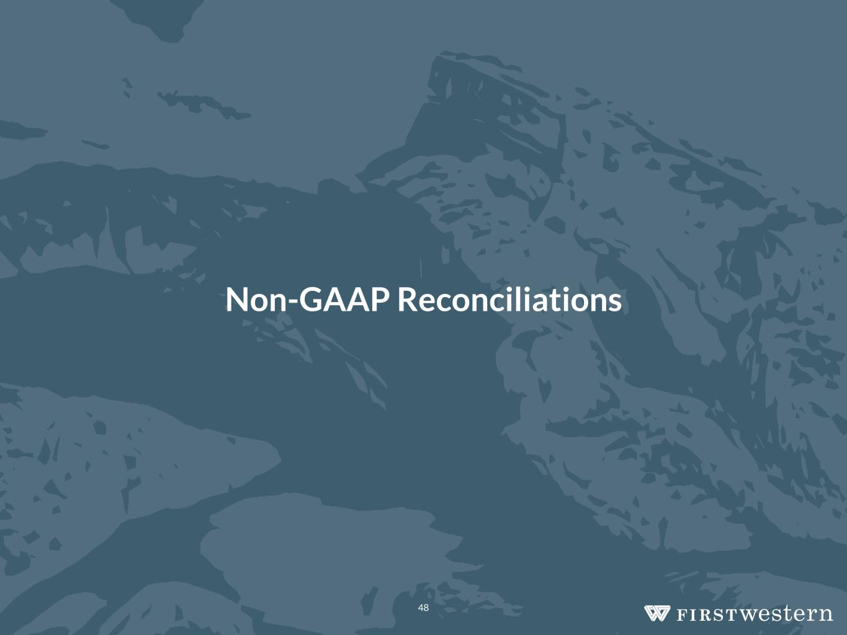
Non-GAAP Reconciliations 48

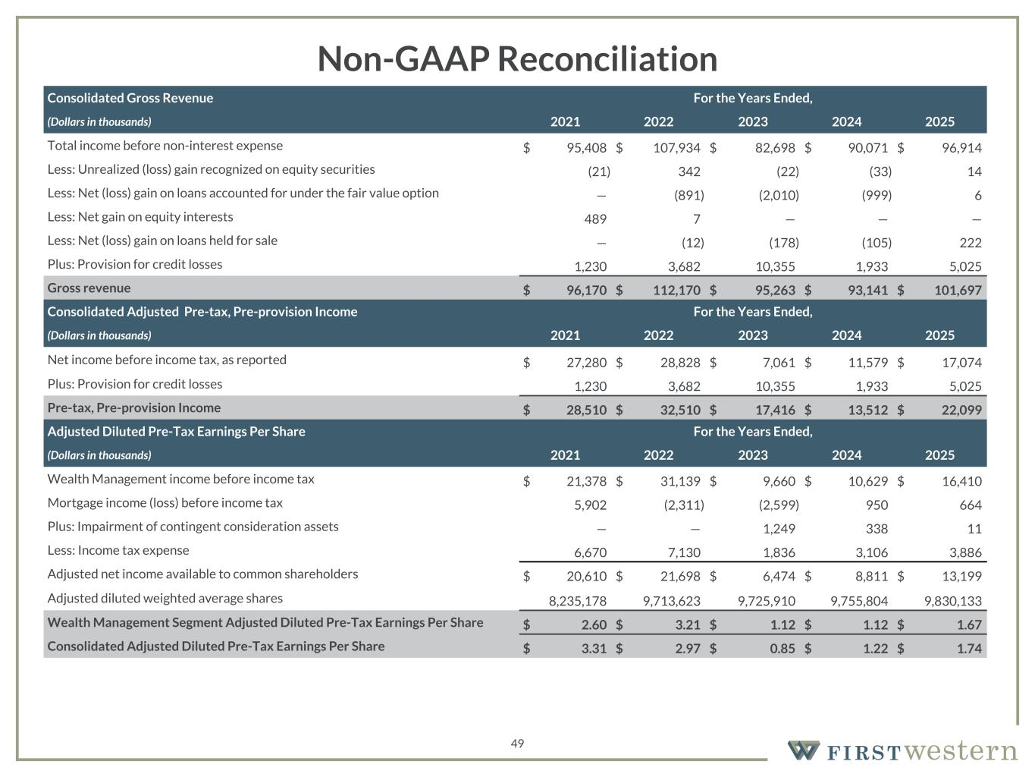
157 180 196 164 166 168 62 94 111 154 161 132 122 125 129 76 78 86 255 255 255 Chart color Table color Special Headlines Slide Headlines / Text on light background Primary Colors Secondary Colors Primary Background / Call Out Boxes / Text on dark background Chart color Table Color Tertiary Colors Chart color Table Color Chart Color Chart Color Approved Fonts AaBbCc 123 Lora (bold) Slide Headlines / Special Headlines AaBbCc 123 Lato (regular, bold, italics) Body Copy / Subheadings / Small Text Descriptions 49 Non-GAAP Reconciliation Consolidated Gross Revenue For the Years Ended, (Dollars in thousands) 2021 2022 2023 2024 2025 Total income before non-interest expense $ 95,408 $ 107,934 $ 82,698 $ 90,071 $ 96,914 Less: Unrealized (loss) gain recognized on equity securities (21) 342 (22) (33) 14 Less: Net (loss) gain on loans accounted for under the fair value option — (891) (2,010) (999) 6 Less: Net gain on equity interests 489 7 — — — Less: Net (loss) gain on loans held for sale — (12) (178) (105) 222 Plus: Provision for credit losses 1,230 3,682 10,355 1,933 5,025 Gross revenue $ 96,170 $ 112,170 $ 95,263 $ 93,141 $ 101,697 Consolidated Adjusted Pre-tax, Pre-provision Income For the Years Ended, (Dollars in thousands) 2021 2022 2023 2024 2025 Net income before income tax, as reported $ 27,280 $ 28,828 $ 7,061 $ 11,579 $ 17,074 Plus: Provision for credit losses 1,230 3,682 10,355 1,933 5,025 Pre-tax, Pre-provision Income $ 28,510 $ 32,510 $ 17,416 $ 13,512 $ 22,099 Adjusted Diluted Pre-Tax Earnings Per Share For the Years Ended, (Dollars in thousands) 2021 2022 2023 2024 2025 Wealth Management income before income tax $ 21,378 $ 31,139 $ 9,660 $ 10,629 $ 16,410 Mortgage income (loss) before income tax 5,902 (2,311) (2,599) 950 664 Plus: Impairment of contingent consideration assets — — 1,249 338 11 Less: Income tax expense 6,670 7,130 1,836 3,106 3,886 Adjusted net income available to common shareholders $ 20,610 $ 21,698 $ 6,474 $ 8,811 $ 13,199 Adjusted diluted weighted average shares 8,235,178 9,713,623 9,725,910 9,755,804 9,830,133 Wealth Management Segment Adjusted Diluted Pre-Tax Earnings Per Share $ 2.60 $ 3.21 $ 1.12 $ 1.12 $ 1.67 Consolidated Adjusted Diluted Pre-Tax Earnings Per Share $ 3.31 $ 2.97 $ 0.85 $ 1.22 $ 1.74

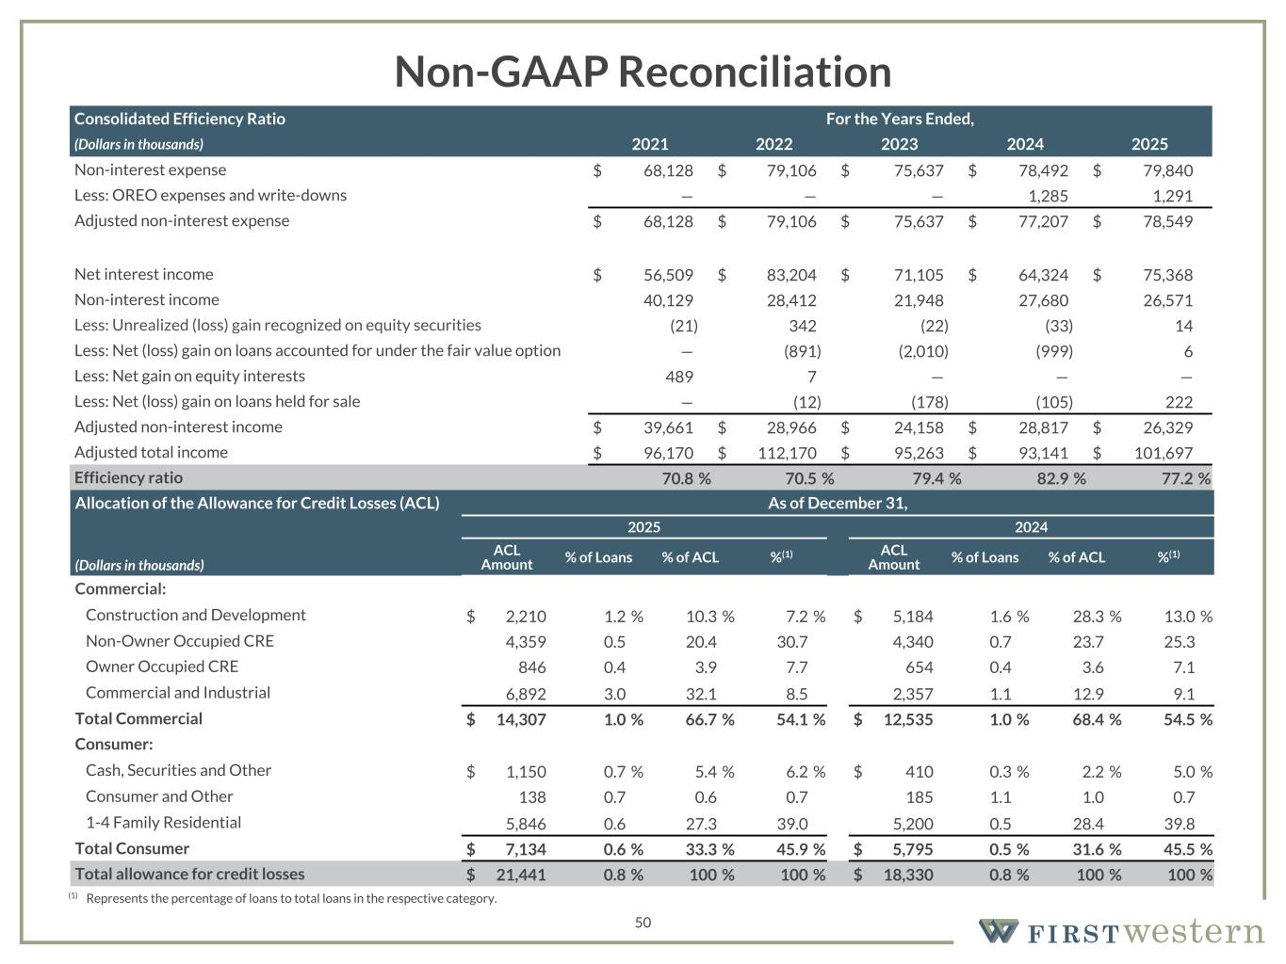
157 180 196 164 166 168 62 94 111 154 161 132 122 125 129 76 78 86 255 255 255 Chart color Table color Special Headlines Slide Headlines / Text on light background Primary Colors Secondary Colors Primary Background / Call Out Boxes / Text on dark background Chart color Table Color Tertiary Colors Chart color Table Color Chart Color Chart Color Approved Fonts AaBbCc 123 Lora (bold) Slide Headlines / Special Headlines AaBbCc 123 Lato (regular, bold, italics) Body Copy / Subheadings / Small Text Descriptions 50 Non-GAAP Reconciliation (1) Represents the percentage of loans to total loans in the respective category. Consolidated Efficiency Ratio For the Years Ended, (Dollars in thousands) 2021 2022 2023 2024 2025 Non-interest expense $ 68,128 $ 79,106 $ 75,637 $ 78,492 $ 79,840 Less: OREO expenses and write-downs — — — 1,285 1,291 Adjusted non-interest expense $ 68,128 $ 79,106 $ 75,637 $ 77,207 $ 78,549 Net interest income $ 56,509 $ 83,204 $ 71,105 $ 64,324 $ 75,368 Non-interest income 40,129 28,412 21,948 27,680 26,571 Less: Unrealized (loss) gain recognized on equity securities (21) 342 (22) (33) 14 Less: Net (loss) gain on loans accounted for under the fair value option — (891) (2,010) (999) 6 Less: Net gain on equity interests 489 7 — — — Less: Net (loss) gain on loans held for sale — (12) (178) (105) 222 Adjusted non-interest income $ 39,661 $ 28,966 $ 24,158 $ 28,817 $ 26,329 Adjusted total income $ 96,170 $ 112,170 $ 95,263 $ 93,141 $ 101,697 Efficiency ratio 70.8 % 70.5 % 79.4 % 82.9 % 77.2 % Allocation of the Allowance for Credit Losses (ACL) As of December 31, 2025 2024 (Dollars in thousands) ACL Amount % of Loans % of ACL %(1) ACL Amount % of Loans % of ACL %(1) Commercial: Construction and Development $ 2,210 1.2 % 10.3 % 7.2 % $ 5,184 1.6 % 28.3 % 13.0 % Non-Owner Occupied CRE 4,359 0.5 20.4 30.7 4,340 0.7 23.7 25.3 Owner Occupied CRE 846 0.4 3.9 7.7 654 0.4 3.6 7.1 Commercial and Industrial 6,892 3.0 32.1 8.5 2,357 1.1 12.9 9.1 Total Commercial $ 14,307 1.0 % 66.7 % 54.1 % $ 12,535 1.0 % 68.4 % 54.5 % Consumer: Cash, Securities and Other $ 1,150 0.7 % 5.4 % 6.2 % $ 410 0.3 % 2.2 % 5.0 % Consumer and Other 138 0.7 0.6 0.7 185 1.1 1.0 0.7 1-4 Family Residential 5,846 0.6 27.3 39.0 5,200 0.5 28.4 39.8 Total Consumer $ 7,134 0.6 % 33.3 % 45.9 % $ 5,795 0.5 % 31.6 % 45.5 % Total allowance for credit losses $ 21,441 0.8 % 100 % 100 % $ 18,330 0.8 % 100 % 100 %

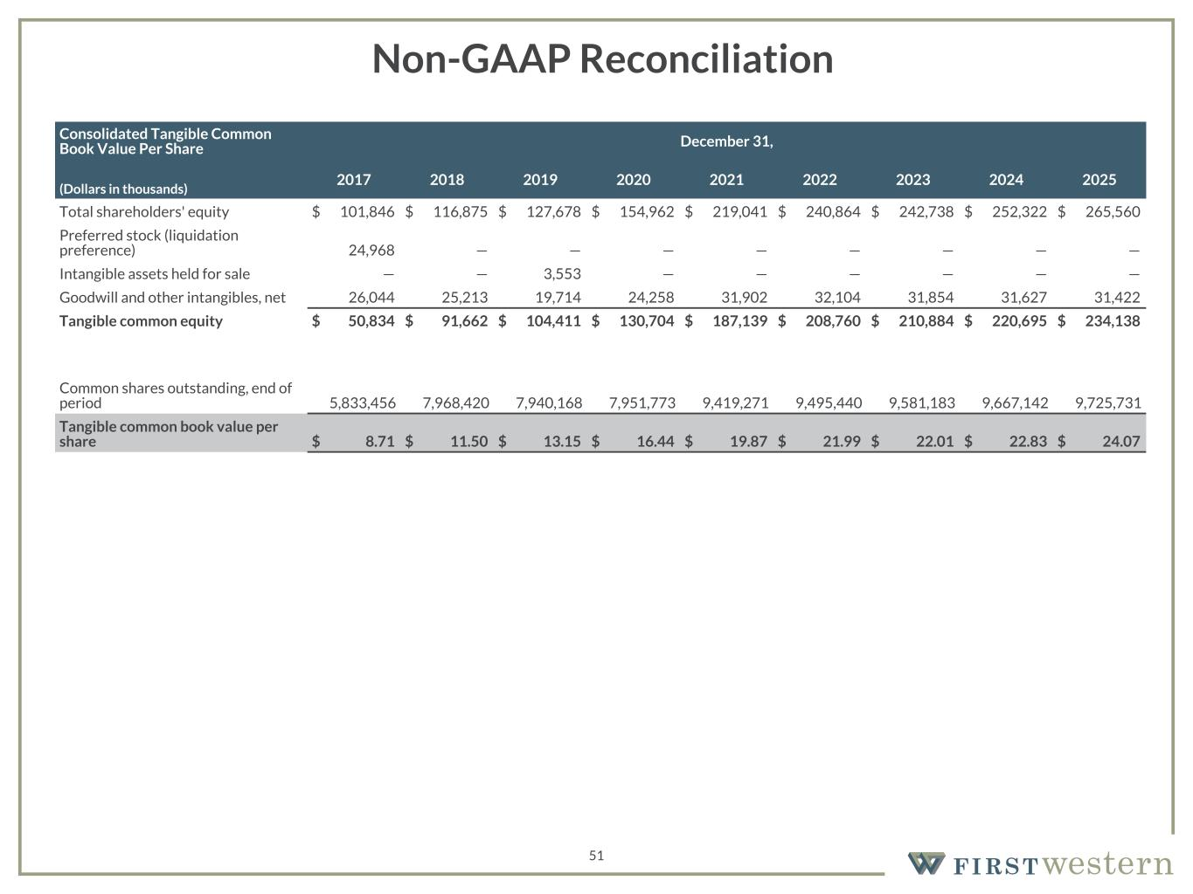
157 180 196 164 166 168 62 94 111 154 161 132 122 125 129 76 78 86 255 255 255 Chart color Table color Special Headlines Slide Headlines / Text on light background Primary Colors Secondary Colors Primary Background / Call Out Boxes / Text on dark background Chart color Table Color Tertiary Colors Chart color Table Color Chart Color Chart Color Approved Fonts AaBbCc 123 Lora (bold) Slide Headlines / Special Headlines AaBbCc 123 Lato(regular, bold, italics) Body Copy / Subheadings / Small Text Descriptions 51 Non-GAAP Reconciliation Consolidated Tangible Common Book Value Per Share December 31, (Dollars in thousands) 2017 2018 2019 2020 2021 2022 2023 2024 2025 Total shareholders' equity $ 101,846 $ 116,875 $ 127,678 $ 154,962 $ 219,041 $ 240,864 $ 242,738 $ 252,322 $ 265,560 Preferred stock (liquidation preference) 24,968 — — — — — — — — Intangible assets held for sale — — 3,553 — — — — — — Goodwill and other intangibles, net 26,044 25,213 19,714 24,258 31,902 32,104 31,854 31,627 31,422 Tangible common equity $ 50,834 $ 91,662 $ 104,411 $ 130,704 $ 187,139 $ 208,760 $ 210,884 $ 220,695 $ 234,138 Common shares outstanding, end of period 5,833,456 7,968,420 7,940,168 7,951,773 9,419,271 9,495,440 9,581,183 9,667,142 9,725,731 Tangible common book value per share $ 8.71 $ 11.50 $ 13.15 $ 16.44 $ 19.87 $ 21.99 $ 22.01 $ 22.83 $ 24.07

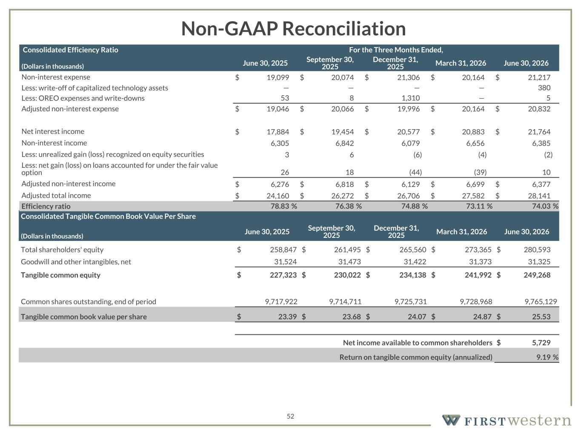
157 180 196 164 166 168 62 94 111 154 161 132 122 125 129 76 78 86 255 255 255 Chart color Table color Special Headlines Slide Headlines / Text on light background Primary Colors Secondary Colors Primary Background / Call Out Boxes / Text on dark background Chart color Table Color Tertiary Colors Chart color Table Color Chart Color Chart Color Approved Fonts AaBbCc 123 Lora (bold) Slide Headlines / Special Headlines AaBbCc 123 Lato(regular, bold, italics) Body Copy / Subheadings / Small Text Descriptions 52 Non-GAAP Reconciliation Consolidated Tangible Common Book Value Per Share (Dollars in thousands) June 30, 2025 September 30, 2025 December 31, 2025 March 31, 2026 June 30, 2026 Total shareholders' equity $ 258,847 $ 261,495 $ 265,560 $ 273,365 $ 280,593 Goodwill and other intangibles, net 31,524 31,473 31,422 31,373 31,325 Tangible common equity $ 227,323 $ 230,022 $ 234,138 $ 241,992 $ 249,268 Common shares outstanding, end of period 9,717,922 9,714,711 9,725,731 9,728,968 9,765,129 Tangible common book value per share $ 23.39 $ 23.68 $ 24.07 $ 24.87 $ 25.53 Net income available to common shareholders $ 5,729 Return on tangible common equity (annualized) 9.19 % Consolidated Efficiency Ratio For the Three Months Ended, (Dollars in thousands) June 30, 2025 September 30, 2025 December 31, 2025 March 31, 2026 June 30, 2026 Non-interest expense $ 19,099 $ 20,074 $ 21,306 $ 20,164 $ 21,217 Less: write-off of capitalized technology assets — — — — 380 Less: OREO expenses and write-downs 53 8 1,310 — 5 Adjusted non-interest expense $ 19,046 $ 20,066 $ 19,996 $ 20,164 $ 20,832 Net interest income $ 17,884 $ 19,454 $ 20,577 $ 20,883 $ 21,764 Non-interest income 6,305 6,842 6,079 6,656 6,385 Less: unrealized gain (loss) recognized on equity securities 3 6 (6) (4) (2) Less: net gain (loss) on loans accounted for under the fair value option 26 18 (44) (39) 10 Adjusted non-interest income $ 6,276 $ 6,818 $ 6,129 $ 6,699 $ 6,377 Adjusted total income $ 24,160 $ 26,272 $ 26,706 $ 27,582 $ 28,141 Efficiency ratio 78.83 % 76.38 % 74.88 % 73.11 % 74.03 %

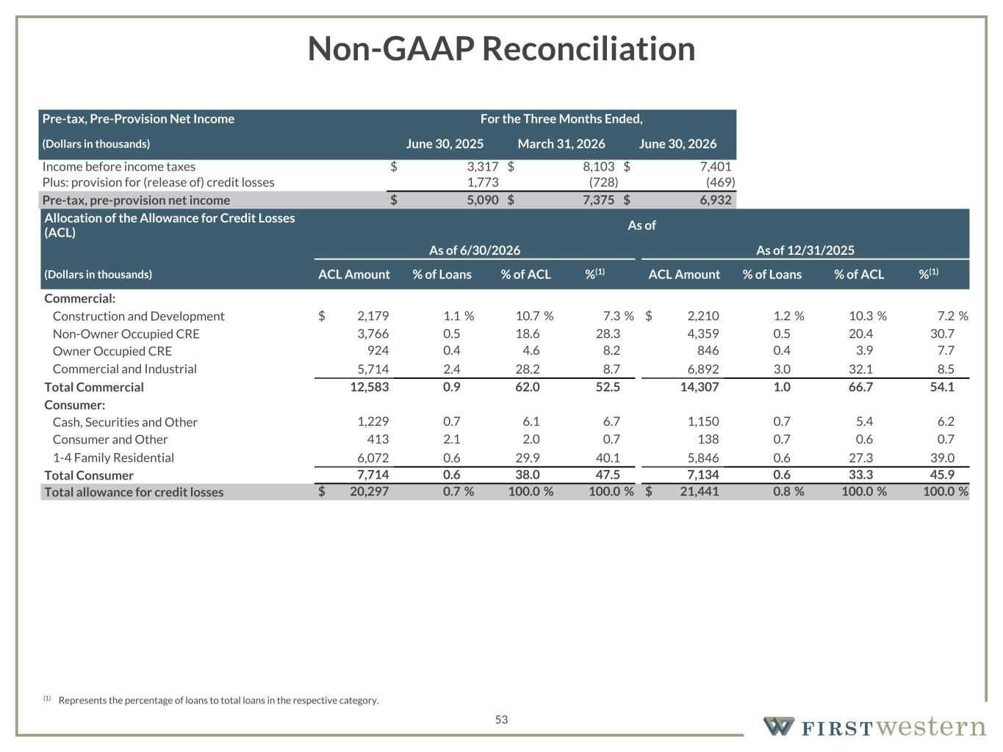
157 180 196 164 166 168 62 94 111 154 161 132 122 125 129 76 78 86 255 255 255 Chart color Table color Special Headlines Slide Headlines / Text on light background Primary Colors Secondary Colors Primary Background / Call Out Boxes / Text on dark background Chart color Table Color Tertiary Colors Chart color Table Color Chart Color Chart Color Approved Fonts AaBbCc 123 Lora (bold) Slide Headlines / Special Headlines AaBbCc 123 Lato(regular, bold, italics) Body Copy / Subheadings / Small Text Descriptions 53 Non-GAAP Reconciliation Pre-tax, Pre-Provision Net Income For the Three Months Ended, (Dollars in thousands) June 30, 2025 March 31, 2026 June 30, 2026 Income before income taxes $ 3,317 $ 8,103 $ 7,401 Plus: provision for (release of) credit losses 1,773 (728) (469) Pre-tax, pre-provision net income $ 5,090 $ 7,375 $ 6,932 Allocation of the Allowance for Credit Losses (ACL) As of As of 6/30/2026 As of 12/31/2025 (Dollars in thousands) ACL Amount % of Loans % of ACL %(1) ACL Amount % of Loans % of ACL %(1) Commercial: Construction and Development $ 2,179 1.1 % 10.7 % 7.3 % $ 2,210 1.2 % 10.3 % 7.2 % Non-Owner Occupied CRE 3,766 0.5 18.6 28.3 4,359 0.5 20.4 30.7 Owner Occupied CRE 924 0.4 4.6 8.2 846 0.4 3.9 7.7 Commercial and Industrial 5,714 2.4 28.2 8.7 6,892 3.0 32.1 8.5 Total Commercial 12,583 0.9 62.0 52.5 14,307 1.0 66.7 54.1 Consumer: Cash, Securities and Other 1,229 0.7 6.1 6.7 1,150 0.7 5.4 6.2 Consumer and Other 413 2.1 2.0 0.7 138 0.7 0.6 0.7 1-4 Family Residential 6,072 0.6 29.9 40.1 5,846 0.6 27.3 39.0 Total Consumer 7,714 0.6 38.0 47.5 7,134 0.6 33.3 45.9 Total allowance for credit losses $ 20,297 0.7 % 100.0 % 100.0 % $ 21,441 0.8 % 100.0 % 100.0 % (1) Represents the percentage of loans to total loans in the respective category.

