UNITED STATES
SECURITIES AND EXCHANGE COMMISSION
Washington, D.C. 20549
FORM 8-K
CURRENT REPORT
Pursuant to Section 13 or 15(d) of The Securities Exchange Act of 1934
Date of Report (Date of earliest event reported): October 22, 2026
FIRST WESTERN FINANCIAL, INC.
(Exact name of registrant as specified in its charter)
Colorado |  |  | 001-38595 |  |  | 37-1442266
(State or other jurisdiction of  incorporation or organization) |  |  | (Commission  File Number) |  |  | (I.R.S. Employer  Identification No.)
1900 16th Street, Suite 1200  Denver, Colorado |  |  |  |  |  | 80202
(Address of principal executive offices) |  |  |  |  |  | (Zip Code)
Registrant’s telephone number, including area code: 303.531.8100
Former name or former address, if changed since last report: Not Applicable
Check the appropriate box below if the Form 8-K filing is intended to simultaneously satisfy the filing obligation of the registrant under any of the following provisions:
o |  |  | Written communications pursuant to Rule 425 under the Securities Act (17 CFR 230.425)
o |  |  | Soliciting material pursuant to Rule 14a-12 under the Exchange Act (17 CFR 240.14a-12)
o |  |  | Pre-commencement communications pursuant to Rule 14d-2(b) under the Exchange Act (17 CFR 240.14d-2(b))
o |  |  | Pre-commencement communications pursuant to Rule 13e-4(c) under the Exchange Act (17 CFR 240.13e-4(c))
Indicate by check mark whether the registrant is an emerging growth company as defined in Rule 405 of the Securities Act of 1933 (§230.405 of this chapter) or Rule 12b-2 of the Securities Exchange Act of 1934 (§240.12b-2 of this chapter).
o |  |  | Emerging growth company
o |  |  | If an emerging growth company, indicate by check mark if the registrant has elected not to use the extended transition period for complying with any new or revised financial accounting standards provided pursuant to Section 13(a) of the Exchange Act.
Securities registered pursuant to Section 12(b) of the Act:
Title of each class |  |  | Trading Symbol |  |  | Name of each exchange on which registered
Common Stock, no par value |  |  | MYFW |  |  | NASDAQ Stock Market LLC

Item 2.02 Results of Operations and Financial Condition.
On October 22, 2026, First Western Financial, Inc. (the “Company”) issued a press release announcing its financial results for the third quarter ended September 30, 2026. A copy of the press release is furnished as Exhibit 99.1 and is incorporated by reference herein.
The information in this Item 2.02, including Exhibit 99.1, is being furnished pursuant to Item 2.02 of Form 8-K and shall not be deemed “filed” for purposes of Section 18 of the Securities Exchange Act of 1934, as amended (the “Exchange Act”), or otherwise subject to liabilities of that section, nor shall it be deemed incorporated by reference into any filing under the Securities Act of 1933, as amended (the “Securities Act”), or the Exchange Act, unless specifically identified therein as being incorporated therein by reference.

Item 7.01 Regulation FD Disclosure.
The Company intends to hold an investor call and webcast to discuss its financial results for the third quarter ended September 30, 2026 on Friday, October 23, 2026, at 10:00 a.m. Mountain Time. The Company’s presentation to analysts and investors contains additional information about the Company’s financial results for the third quarter ended September 30, 2026 and is furnished as Exhibit 99.2 and is incorporated by reference herein.
The information in this Item 7.01, including Exhibit 99.2, is being furnished pursuant to Item 7.01 of Form 8-K and shall not be deemed “filed” for purposes of Section 18 of the Exchange Act, or otherwise subject to liabilities of that section, nor shall it be deemed incorporated by reference into any filing under the Securities Act or the Exchange Act, unless specifically identified therein as being incorporated therein by reference.

Item 9.01 Financial Statements and Exhibits.
(d) Exhibits.
Exhibit  Number |  |  |  |  |  | Description
99.1 |  |  |  |  |  | Press Release issued by First Western Financial, Inc. dated October 22, 2026
99.2 |  |  |  |  |  | First Western Financial, Inc. Earnings Presentation
104 |  |  |  |  |  | Cover Page Interactive Data File (the cover page XBRL tags are embedded in the Inline XBRL document)

2

SIGNATURES
Pursuant to the requirements of the Securities Exchange Act of 1934, the registrant has duly caused this report to be signed on its behalf by the undersigned, thereunto duly authorized.
 |  |  |  |  |  | FIRST WESTERN FINANCIAL, INC.
Date: October 22, 2026 |  |  |  |  |  | By: /s/ Scott C. Wylie
 |  |  |  |  |  | Scott C. Wylie
 |  |  |  |  |  | Chairman, Chief Executive Officer and President

3

Exhibit 99.1

First Western Reports Third Quarter 2026 Financial Results
Third Quarter 2026 Summary
•Net income available to common shareholders of $6.0 million, or $0.60 per diluted share, in Q3 2026, compared to $5.7 million, or $0.57 per diluted share, in Q2 2026
•Pre-tax, pre-provision net income increased 14.5% from $6.9 million in Q2 2026 to $7.9 million in Q3 2026
•Net interest margin increased 5 basis points from 2.90% in Q2 2026 to 2.95% in Q3 2026
•Net interest income increased $1.2 million, or 5.5%, from $21.8 million in Q2 2026 to $23.0 million in Q3 2026
•Total loans held for investment increased $95.0 million, or 3.5%, from $2.72 billion in Q2 2026 to $2.81 billion in Q3 2026
•Total deposits increased $70.0 million, or 2.5%, from $2.85 billion in Q2 2026 to $2.92 billion in Q3 2026

Denver, Colo., October 22, 2026 – First Western Financial, Inc. (“First Western” or the “Company”) (NASDAQ: MYFW), today reported financial results for the third quarter ended September 30, 2026.
Net income available to common shareholders was $6.0 million, or $0.60 per diluted share, for the third quarter of 2026. This compares to net income of $5.7 million, or $0.57 per diluted share, for the second quarter of 2026, and net income of $3.2 million, or $0.32 per diluted share, for the third quarter of 2025.
Scott C. Wylie, CEO of First Western, commented, “Our third quarter results demonstrate continued execution and progress across our business, underscored by strong loan and deposit growth, accelerating loan production, further expansion in our net interest margin and disciplined expense management. Healthy client demand in our markets drove robust loan growth during the quarter, while continued growth in noninterest-bearing deposits reflects the strength of our relationship-based banking model and our ongoing focus on improving our funding mix. Together, these trends contributed to strong growth in net interest income and pre-provision net revenue, while asset quality remained stable.

“We remain encouraged by the strength of our loan pipeline and the opportunities we see across our markets. With continued momentum in our core banking franchise, disciplined expense management and a strong balance sheet, we believe we are well positioned to continue improving profitability and creating long-term value for our shareholders,” said Mr. Wylie.

 |  |  | For the Three Months Ended
 |  |  | September 30, |  |  |  |  |  | June 30, |  |  |  |  |  | September 30,
(Dollars in thousands, except per share data) |  |  | 2026 |  |  |  |  |  | 2026 |  |  |  |  |  | 2025
Earnings Summary
Net interest income |  |  | $ | 22,960 |  |  |  |  | $ | 21,764 |  |  |  |  | $ | 19,454
Provision for (release of) credit losses |  |  | 647 |  |  |  |  |  | (469) |  |  |  |  |  | 2,257
Total non-interest income |  |  | 5,806 |  |  |  |  |  | 6,385 |  |  |  |  |  | 6,842
Total non-interest expense |  |  | 20,840 |  |  |  |  |  | 21,217 |  |  |  |  |  | 20,074
Income before income taxes |  |  | 7,279 |  |  |  |  |  | 7,401 |  |  |  |  |  | 3,965
Income tax expense |  |  | 1,298 |  |  |  |  |  | 1,672 |  |  |  |  |  | 779
Net income available to common shareholders |  |  | 5,981 |  |  |  |  |  | 5,729 |  |  |  |  |  | 3,186
Basic earnings per common share |  |  | 0.61 |  |  |  |  |  | 0.59 |  |  |  |  |  | 0.33
Diluted earnings per common share |  |  | 0.60 |  |  |  |  |  | 0.57 |  |  |  |  |  | 0.32
Return on average assets (annualized) |  |  | 0.74 |  | % |  |  |  | 0.73 |  | % |  |  |  | 0.40 |  | %
Return on average shareholders' equity (annualized) |  |  | 8.39 |  |  |  |  |  | 8.28 |  |  |  |  |  | 4.92
Return on tangible common equity (annualized)(1) |  |  | 9.31 |  |  |  |  |  | 9.19 |  |  |  |  |  | 5.54
Net interest margin |  |  | 2.95 |  |  |  |  |  | 2.90 |  |  |  |  |  | 2.54
Efficiency ratio(1) |  |  | 72.20 |  |  |  |  |  | 74.03 |  |  |  |  |  | 76.38
____________________
(1) Represents a Non-GAAP financial measure. See “Reconciliations of Non-GAAP Financial Measures” for a reconciliation of our Non-GAAP measures to the most directly comparable GAAP financial measure.
Operating Results for the Third Quarter 2026
Revenue
Total income before non-interest expense was $28.1 million for the third quarter of 2026, a decrease of 1.7% from $28.6 million for the second quarter of 2026. Gross revenue(1) was $28.9 million for the third quarter of 2026, an increase of 2.8% from $28.1 million for the second quarter of 2026. Relative to the second quarter of 2026, the decrease in Total income before non-interest expense was primarily driven by an increase in Provision for credit losses and a decrease in Non-interest income, partially offset by an increase in Net interest income. Relative to the third quarter of 2025, Total income before non-interest expense increased 17.1% from $24.0 million and Gross revenue increased 9.9% from $26.3 million. Relative to the third quarter of 2025, the increase in Total income before non-interest expense was primarily driven by an increase in Net interest income and a decrease in Provision for credit losses.
(1) Represents a Non-GAAP financial measure. See “Reconciliations of Non-GAAP Financial Measures” for a reconciliation of our Non-GAAP measures to the most directly comparable GAAP financial measure.
Net Interest Margin
Net interest margin for the third quarter of 2026 increased 5 basis points to 2.95% from 2.90% reported in the second quarter of 2026, primarily due to an increase in yield on average interest-earning assets, partially offset by an increase in cost of funds. The yield on interest-earning assets increased 7 basis points to 5.65% from 5.58% reported in the second quarter of 2026, while the cost of funds increased 2 basis points to 2.88% from 2.86% reported in the second quarter of 2026. The increase in yield on interest-earning assets was primarily driven by an increase in loan yields. The increase in cost of funds was primarily driven by higher cost of deposits as a result of higher rates on money market accounts.
Relative to the third quarter of 2025, net interest margin increased 41 basis points from 2.54% due to a 35 basis point decrease in cost of funds as a result of the lower interest rate environment and an increase in yield on average interest-earning assets.
2
Net Interest Income
Net interest income for the third quarter of 2026 was $23.0 million, an increase of 5.5% from $21.8 million for the second quarter of 2026. The increase was primarily driven by a 5 basis point increase in net interest margin and an $81.1 million increase in average interest-earning assets. Relative to the third quarter of 2025, Net interest income increased 17.9% from $19.5 million. The increase compared to the third quarter of 2025 was primarily driven by a 41 basis point increase in net interest margin and an increase in average interest-earning assets.
Non-interest Income
Non-interest income for the third quarter of 2026 was $5.8 million, a decrease of 9.4% from $6.4 million in the second quarter of 2026. The decrease was primarily driven by decreases in Net gain on mortgage loans and Bank fees, partially offset by an increase in Trust and investment management fees. The decrease in Net gain on mortgage loans was primarily driven by lower origination volume. The decrease in Bank fees was primarily driven by lower prepayment penalty and swap income.
Relative to the third quarter of 2025, Non-interest income decreased $1.0 million, primarily driven by a decrease in Net gain on mortgage loans primarily driven by lower origination volume.
Non-interest Expense
Non-interest expense for the third quarter of 2026 was $20.8 million, a decrease of 1.9% from $21.2 million in the second quarter of 2026. The decrease was primarily driven by reduced Salaries and employee benefits and Technology and information systems, partially offset by an increase in Occupancy and equipment. The decrease in Salaries and employee benefits was primarily driven by reduced employer payroll taxes. The decrease in Technology and information systems was primarily attributable to a $0.4 million nonrecurring charge related to the write-off of certain previously capitalized technology assets recorded in the second quarter of 2026. The increase in Occupancy and equipment was driven by an increase in variable lease costs.
Relative to the third quarter of 2025, Non-interest expense increased 3.5% from $20.1 million, primarily driven by an increase in Salaries and employee benefits due to an increase in headcount, partially offset by a decrease in bonus accruals.
The Company’s efficiency ratio(1) was 72.2% in the third quarter of 2026, compared to 74.0% in the second quarter of 2026 and 76.4% in the third quarter of 2025.
(1) Represents a Non-GAAP financial measure. See “Reconciliations of Non-GAAP Financial Measures” for a reconciliation of our Non-GAAP measures to the most directly comparable GAAP financial measure.
Income Taxes
The Company recorded Income tax expense of $1.3 million for the third quarter of 2026, compared to $1.7 million for the second quarter of 2026, and $0.8 million for the third quarter of 2025. Relative to the second quarter of 2026, tax expense decreased $0.4 million primarily due to a $0.4 million benefit from a clean fuel tax credit purchased during the third quarter of 2026.
Loans
Total loans held for investment were $2.81 billion as of September 30, 2026, an increase of $95.0 million, or 3.5%, from $2.72 billion as of June 30, 2026. Changes in the quarter included growth in the 1-4 family residential and Commercial and industrial portfolios. Relative to the third quarter of 2025, total loans held for investment increased 8.4% from $2.59 billion as of September 30, 2025, primarily driven by growth in 1-4 family residential, Commercial and industrial, Owner occupied commercial real estate and Non-owner occupied commercial real estate portfolio.
3
Deposits
Total deposits were $2.92 billion as of September 30, 2026, an increase of 2.5%, from $2.85 billion as of June 30, 2026. Relative to the third quarter of 2025, Total deposits increased 2.5% from $2.85 billion. The increase over both periods was primarily driven by increases in Noninterest-bearing accounts and money market deposit accounts.
Borrowings
Federal Home Loan Bank (“FHLB”) borrowings were $150.9 million as of September 30, 2026, an increase of $114.5 million from $36.4 million as of June 30, 2026. The increase when compared to June 30, 2026 was primarily driven by interest-earning asset growth. Relative to the third quarter of 2025, borrowings increased $100.0 million from $50.9 million, driven by interest-earning asset growth.
Subordinated notes were $34.9 million as of September 30, 2026, compared to $44.8 million as of June 30, 2026. Subordinated notes decreased $9.8 million from $44.7 million as of September 30, 2025. Relative to the second quarter of 2026 and third quarter of 2025, the decrease was due to the redemption of $10.0 million of subordinated notes.
Assets Under Management
Assets Under Management (“AUM”) was $7.21 billion as of September 30, 2026, a decrease of $61 million, or 0.8%, from $7.28 billion as of June 30, 2026. The decrease in AUM during the quarter was primarily attributable to lower market values in low fee account types. Compared to September 30, 2025, total AUM decreased 2.9% from $7.43 billion due to lower market values in low fee account types, partially offset by increased net contributions.
Credit Quality
Non-performing assets totaled $13.3 million, or 0.39%, of Total assets as of September 30, 2026, compared to $16.3 million, or 0.50%, of Total assets, as of June 30, 2026. As of September 30, 2025, non-performing assets totaled $22.7 million, or 0.70%, of Total assets. Relative to the second quarter of 2026, the decrease in non-performing assets was driven by paydowns and a charge-off. Relative to the third quarter of 2025, the decrease in non-performing assets was driven by the sale of an OREO property in the first quarter of 2026 and paydowns.
Non-accrual loans totaled $13.3 million as of September 30, 2026, compared to $16.3 million as of June 30, 2026. As of September 30, 2025, non-accrual loans totaled $18.3 million. Relative to the second quarter of 2026 and the third quarter of 2025, the decrease was driven primarily by paydowns.
During the third quarter of 2026, the Company recorded a provision expense of $0.6 million, compared to a provision release of $0.5 million in the second quarter of 2026, and provision expense of $2.3 million in the third quarter of 2025. The expense of $0.6 million in the third quarter of 2026 was primarily driven by loan growth. As of September 30, 2026 and June 30, 2026, the Allowance for credit losses as a percentage of Total loans was 74 basis points and 75 basis points, respectively.
4
Capital
As of September 30, 2026, First Western (“Consolidated”) and First Western Trust Bank (“Bank”) exceeded the minimum capital levels required by their respective regulators. As of September 30, 2026, the Bank was classified as “well capitalized,” as summarized in the following table:
 |  |  | September 30,
 |  |  | 2026
Consolidated Capital
Tier 1 capital to risk-weighted assets |  |  | 9.76 |  | %
CET1 to risk-weighted assets |  |  | 9.76
Total capital to risk-weighted assets |  |  | 11.80
Tier 1 capital to average assets |  |  | 8.08
Bank Capital
Tier 1 capital to risk-weighted assets |  |  | 10.79 |  | %
CET1 to risk-weighted assets |  |  | 10.79
Total capital to risk-weighted assets |  |  | 11.60
Tier 1 capital to average assets |  |  | 8.92
Book value per common share increased 2.6% from $28.73 as of June 30, 2026 to $29.48 as of September 30, 2026. Book value per common share increased 9.5% from $26.92 as of September 30, 2025.
Tangible book value per common share(1) increased 2.9% from $25.53 as of June 30, 2026 to $26.28 as of September 30, 2026. Tangible book value per common share increased 11.0% from $23.68 as of September 30, 2025.
(1) Represents a Non-GAAP financial measure. See “Reconciliations of Non-GAAP Financial Measures” for a reconciliation of our Non-GAAP measures to the most directly comparable GAAP financial measure.
Conference Call, Webcast and Slide Presentation
The Company will host a conference call and webcast at 10:00 a.m. MT / 12:00 p.m. ET on Friday, October 23, 2026. Telephone access: https://register-conf.media-server.com/register/BI8c00cfaf86874909b3e5150dcea82eff

A slide presentation relating to the third quarter 2026 results will be accessible prior to the scheduled conference call. The slide presentation and webcast of the conference call can be accessed on the Events and Presentations page of the Company’s investor relations website at https://myfw.gcs-web.com.
About First Western
First Western is a financial services holding company headquartered in Denver, Colorado, with operations in Colorado, Arizona, Wyoming, California, and Montana. First Western and its subsidiaries provide a fully integrated suite of wealth management services on a private trust bank platform, which includes a comprehensive selection of deposit, loan, trust, wealth planning and investment management products and services. First Western’s common stock is traded on the Nasdaq Global Select Market under the symbol “MYFW.” For more information, please visit www.myfw.com.
5
Non-GAAP Financial Measures
Some of the financial measures included in this press release are not measures of financial performance recognized in accordance with generally accepted accounting principles in the United States (“GAAP”). These non-GAAP financial measures include “Tangible Common Equity,” “Tangible Common Book Value per Share,” “Return on Tangible Common Equity,” “Efficiency Ratio,” and “Gross Revenue”. The Company believes these non-GAAP financial measures provide both management and investors a more complete understanding of the Company’s financial position and performance. These non-GAAP financial measures are supplemental and are not a substitute for any analysis based on GAAP financial measures. Not all companies use the same calculation of these measures; therefore, this presentation may not be comparable to other similarly titled measures as presented by other companies. Reconciliation of non-GAAP financial measures to GAAP financial measures are provided at the end of this press release.

6
Forward-Looking Statements
Statements in this news release regarding our expectations and beliefs about our future financial performance and financial condition, as well as trends in our business and markets are “forward-looking statements” as defined in the Private Securities Litigation Reform Act of 1995. Forward-looking statements often include words such as “believe,” “expect,” “anticipate,” “intend,” “plan,” “estimate,” “project,” “position,” “outlook,” or words of similar meaning, or future or conditional verbs such as “will,” “would,” “should,” “could,” or “may.” The forward-looking statements in this news release are based on current information and on assumptions that we make about future events and circumstances that are subject to a number of risks and uncertainties that are often difficult to predict and beyond our control. As a result of those risks and uncertainties, our actual financial results in the future could differ, possibly materially, from those expressed in or implied by the forward-looking statements contained in this news release and could cause us to make changes to our future plans. Those risks and uncertainties include, without limitation, the risk of geographic concentration in Colorado, Arizona, Wyoming, California, and Montana; the risk of changes in the economy affecting real estate values and liquidity; the risk in our ability to continue to originate residential real estate loans and sell such loans; risks specific to commercial loans and borrowers; the risk of claims and litigation pertaining to our fiduciary responsibilities; the risk of changes in interest rates could reduce our net interest margins and Net interest income; increased credit risk, including as a result of deterioration in economic conditions, could require us to increase our allowance for credit losses and could have a material adverse effect on our results of operations and financial condition; the risk in our ability to maintain a strong core deposit base or other low-cost funding sources. Additional information regarding these and other risks and uncertainties to which our business and future financial performance are subject is contained in our Annual Report on Form 10-K filed with the U.S. Securities and Exchange Commission (“SEC”) on February 27, 2026 (“Form 10-K”), and other documents we file with the SEC from time to time. We urge readers of this news release to review the “Risk Factors” section our Form 10-K and any updates to those risk factors set forth in our subsequent Quarterly Reports on Form 10-Q, Current Reports on Form 8-K, and our other filings with the SEC. Also, our actual financial results in the future may differ from those currently expected due to additional risks and uncertainties of which we are not currently aware or which we do not currently view as, but in the future may become, material to our business or operating results. Due to these and other possible uncertainties and risks, readers are cautioned not to place undue reliance on the forward-looking statements contained in this news release, which speak only as of today’s date, or to make predictions based solely on historical financial performance. Any forward-looking statement speaks only as of the date on which it is made, and we do not undertake any obligation to update or review any forward-looking statement, whether as a result of new information, future developments or otherwise, except as required by law.
Contacts:
Financial Profiles, Inc.
Lisa Fortuna
310-622-8251
MYFW@finprofiles.com
IR@myfw.com

7
First Western Financial, Inc.
Condensed Consolidated Statements of Income (unaudited)
 |  |  | Three Months Ended
 |  |  | September 30, |  |  |  |  |  | June 30, |  |  |  |  |  | September 30,
(dollars in thousands, except per share amounts) |  |  | 2026 |  |  |  |  |  | 2026 |  |  |  |  |  | 2025
Interest and dividend income:
Loans, including fees |  |  | $ | 40,153 |  |  |  |  | $ | 38,967 |  |  |  |  | $ | 37,701
Loans accounted for under the fair value option |  |  | 35 |  |  |  |  |  | 23 |  |  |  |  |  | 64
Investment securities |  |  | 2,819 |  |  |  |  |  | 1,845 |  |  |  |  |  | 1,387
Interest-bearing deposits in other financial institutions |  |  | 834 |  |  |  |  |  | 876 |  |  |  |  |  | 3,468
Dividends, restricted stock |  |  | 113 |  |  |  |  |  | 142 |  |  |  |  |  | 154
Total interest and dividend income |  |  | 43,954 |  |  |  |  |  | 41,853 |  |  |  |  |  | 42,774
Interest expense:
Deposits |  |  | 20,136 |  |  |  |  |  | 18,980 |  |  |  |  |  | 22,177
Other borrowed funds |  |  | 858 |  |  |  |  |  | 1,109 |  |  |  |  |  | 1,143
Total interest expense |  |  | 20,994 |  |  |  |  |  | 20,089 |  |  |  |  |  | 23,320
Net interest income |  |  | 22,960 |  |  |  |  |  | 21,764 |  |  |  |  |  | 19,454
Less: Provision for (release of) credit losses |  |  | 647 |  |  |  |  |  | (469) |  |  |  |  |  | 2,257
Net interest income, after provision for credit losses |  |  | 22,313 |  |  |  |  |  | 22,233 |  |  |  |  |  | 17,197
Non-interest income:
Trust and investment management fees |  |  | 4,865 |  |  |  |  |  | 4,742 |  |  |  |  |  | 4,629
Net gain on mortgage loans |  |  | 483 |  |  |  |  |  | 906 |  |  |  |  |  | 1,394
Bank fees |  |  | 329 |  |  |  |  |  | 429 |  |  |  |  |  | 312
Risk management and insurance fees |  |  | 26 |  |  |  |  |  | 112 |  |  |  |  |  | 193
Income on company-owned life insurance |  |  | 121 |  |  |  |  |  | 119 |  |  |  |  |  | 116
Net (loss) gain on loans accounted for under the fair value option |  |  | (76) |  |  |  |  |  | 10 |  |  |  |  |  | 18
Unrealized (loss) gain recognized on equity securities |  |  | (24) |  |  |  |  |  | (2) |  |  |  |  |  | 6
Other |  |  | 82 |  |  |  |  |  | 69 |  |  |  |  |  | 174
Total non-interest income |  |  | 5,806 |  |  |  |  |  | 6,385 |  |  |  |  |  | 6,842
Total income before non-interest expense |  |  | 28,119 |  |  |  |  |  | 28,618 |  |  |  |  |  | 24,039
Non-interest expense:
Salaries and employee benefits |  |  | 12,704 |  |  |  |  |  | 13,034 |  |  |  |  |  | 11,884
Occupancy and equipment |  |  | 2,087 |  |  |  |  |  | 1,983 |  |  |  |  |  | 2,188
Professional services |  |  | 1,560 |  |  |  |  |  | 1,490 |  |  |  |  |  | 1,894
Technology and information systems |  |  | 1,187 |  |  |  |  |  | 1,478 |  |  |  |  |  | 951
Data processing |  |  | 1,308 |  |  |  |  |  | 1,359 |  |  |  |  |  | 1,251
Marketing |  |  | 419 |  |  |  |  |  | 358 |  |  |  |  |  | 351
Amortization of other intangible assets |  |  | 48 |  |  |  |  |  | 48 |  |  |  |  |  | 51
Other |  |  | 1,527 |  |  |  |  |  | 1,467 |  |  |  |  |  | 1,504
Total non-interest expense |  |  | 20,840 |  |  |  |  |  | 21,217 |  |  |  |  |  | 20,074
Income before income taxes |  |  | 7,279 |  |  |  |  |  | 7,401 |  |  |  |  |  | 3,965
Income tax expense |  |  | 1,298 |  |  |  |  |  | 1,672 |  |  |  |  |  | 779
Net income available to common shareholders |  |  | $ | 5,981 |  |  |  |  | $ | 5,729 |  |  |  |  | $ | 3,186
Earnings per common share:
Basic |  |  | $ | 0.61 |  |  |  |  | $ | 0.59 |  |  |  |  | $ | 0.33
Diluted |  |  | 0.60 |  |  |  |  |  | 0.57 |  |  |  |  |  | 0.32
8
First Western Financial, Inc.
Condensed Consolidated Balance Sheets (unaudited)
 |  |  | September 30, |  |  |  |  |  | June 30, |  |  |  |  |  | September 30,
(dollars in thousands) |  |  | 2026 |  |  |  |  |  | 2026 |  |  |  |  |  | 2025
Assets
Cash and cash equivalents:
Cash and due from banks |  |  | $ | 11,067 |  |  |  |  | $ | 14,310 |  |  |  |  | $ | 13,889
Interest-bearing deposits in other financial institutions |  |  | 155,181 |  |  |  |  |  | 160,576 |  |  |  |  |  | 341,750
Total cash and cash equivalents |  |  | 166,248 |  |  |  |  |  | 174,886 |  |  |  |  |  | 355,639
Available-for-sale debt securities, at fair value (amortized cost of $154,271, $89,745, and $49,407, respectively) |  |  | 152,544 |  |  |  |  |  | 89,615 |  |  |  |  |  | 49,177
Held-to-maturity debt securities (fair value of $134,582, $112,617 and $93,589, respectively), net of allowance for credit losses of $189, $151, and $71, respectively |  |  | 141,852 |  |  |  |  |  | 116,766 |  |  |  |  |  | 98,205
Correspondent bank stock, at cost |  |  | 10,853 |  |  |  |  |  | 5,695 |  |  |  |  |  | 6,481
Mortgage loans held for sale, at fair value |  |  | 18,989 |  |  |  |  |  | 24,675 |  |  |  |  |  | 21,806
Loans (includes $1,146, $1,758, and $4,208 measured at fair value, respectively) |  |  | 2,806,245 |  |  |  |  |  | 2,711,803 |  |  |  |  |  | 2,590,846
Allowance for credit losses |  |  | (20,785) |  |  |  |  |  | (20,297) |  |  |  |  |  | (20,967)
Loans, net |  |  | 2,785,460 |  |  |  |  |  | 2,691,506 |  |  |  |  |  | 2,569,879
Premises and equipment, net |  |  | 25,462 |  |  |  |  |  | 25,641 |  |  |  |  |  | 24,963
Accrued interest receivable |  |  | 12,515 |  |  |  |  |  | 11,338 |  |  |  |  |  | 11,907
Accounts receivable |  |  | 5,343 |  |  |  |  |  | 4,781 |  |  |  |  |  | 4,687
Other receivables |  |  | 106 |  |  |  |  |  | 171 |  |  |  |  |  | 3,736
Other real estate owned, net |  |  | — |  |  |  |  |  | — |  |  |  |  |  | 4,389
Goodwill and other intangible assets, net |  |  | 31,277 |  |  |  |  |  | 31,325 |  |  |  |  |  | 31,473
Deferred tax assets, net |  |  | 5,572 |  |  |  |  |  | 2,679 |  |  |  |  |  | 3,500
Company-owned life insurance |  |  | 17,772 |  |  |  |  |  | 17,651 |  |  |  |  |  | 17,299
Other assets |  |  | 46,849 |  |  |  |  |  | 41,277 |  |  |  |  |  | 37,283
Total assets |  |  | $ | 3,420,842 |  |  |  |  | $ | 3,238,006 |  |  |  |  | $ | 3,240,424
Liabilities
Deposits:
Noninterest-bearing |  |  | $ | 420,566 |  |  |  |  | $ | 381,826 |  |  |  |  | $ | 375,708
Interest-bearing |  |  | 2,495,647 |  |  |  |  |  | 2,464,138 |  |  |  |  |  | 2,473,203
Total deposits |  |  | 2,916,213 |  |  |  |  |  | 2,845,964 |  |  |  |  |  | 2,848,911
Borrowings:
Federal Home Loan Bank and Federal Reserve borrowings |  |  | 150,926 |  |  |  |  |  | 36,431 |  |  |  |  |  | 50,867
Subordinated notes |  |  | 34,883 |  |  |  |  |  | 44,849 |  |  |  |  |  | 44,724
Accrued interest payable |  |  | 1,586 |  |  |  |  |  | 1,243 |  |  |  |  |  | 1,689
Other liabilities |  |  | 29,119 |  |  |  |  |  | 28,926 |  |  |  |  |  | 32,738
Total liabilities |  |  | 3,132,727 |  |  |  |  |  | 2,957,413 |  |  |  |  |  | 2,978,929
Shareholders’ Equity
Total shareholders’ equity |  |  | 288,115 |  |  |  |  |  | 280,593 |  |  |  |  |  | 261,495
Total liabilities and shareholders’ equity |  |  | $ | 3,420,842 |  |  |  |  | $ | 3,238,006 |  |  |  |  | $ | 3,240,424
9
First Western Financial, Inc.
Consolidated Financial Summary (unaudited)
 |  |  | September 30, |  |  |  |  |  | June 30, |  |  |  |  |  | September 30,
(dollars in thousands) |  |  | 2026 |  |  |  |  |  | 2026 |  |  |  |  |  | 2025
Loan Portfolio
Cash, securities, and other |  |  | $ | 177,437 |  |  |  |  | $ | 182,017 |  |  |  |  | $ | 159,204
Consumer and other |  |  | 19,003 |  |  |  |  |  | 19,236 |  |  |  |  |  | 12,254
Construction and development |  |  | 213,256 |  |  |  |  |  | 196,954 |  |  |  |  |  | 230,600
1-4 family residential |  |  | 1,133,089 |  |  |  |  |  | 1,089,697 |  |  |  |  |  | 1,041,990
Non-owner occupied CRE |  |  | 762,884 |  |  |  |  |  | 768,528 |  |  |  |  |  | 728,039
Owner occupied CRE |  |  | 231,988 |  |  |  |  |  | 222,514 |  |  |  |  |  | 191,239
Commercial and industrial |  |  | 272,044 |  |  |  |  |  | 235,148 |  |  |  |  |  | 225,919
Total |  |  | 2,809,701 |  |  |  |  |  | 2,714,094 |  |  |  |  |  | 2,589,245
Loans accounted for under the fair value option |  |  | 1,157 |  |  |  |  |  | 1,774 |  |  |  |  |  | 4,319
Total loans held for investment |  |  | 2,810,858 |  |  |  |  |  | 2,715,868 |  |  |  |  |  | 2,593,564
Deferred fees, unamortized premiums, basis adjustments, net(1)(2) |  |  | (4,612) |  |  |  |  |  | (4,065) |  |  |  |  |  | (2,718)
Loans (includes $1,146, $1,758, and $4,208 measured at fair value, respectively) |  |  | $ | 2,806,246 |  |  |  |  | $ | 2,711,803 |  |  |  |  | $ | 2,590,846
Mortgage loans held for sale |  |  | 18,989 |  |  |  |  |  | 24,675 |  |  |  |  |  | 21,806
Deposit Portfolio
Money market deposit accounts |  |  | $ | 2,004,098 |  |  |  |  | $ | 1,975,295 |  |  |  |  | $ | 1,988,336
Time deposits |  |  | 354,407 |  |  |  |  |  | 353,373 |  |  |  |  |  | 349,533
Interest checking accounts |  |  | 124,677 |  |  |  |  |  | 122,394 |  |  |  |  |  | 121,901
Savings accounts |  |  | 12,465 |  |  |  |  |  | 13,076 |  |  |  |  |  | 13,433
Total interest-bearing deposits |  |  | 2,495,647 |  |  |  |  |  | 2,464,138 |  |  |  |  |  | 2,473,203
Noninterest-bearing accounts |  |  | 420,566 |  |  |  |  |  | 381,826 |  |  |  |  |  | 375,708
Total deposits |  |  | $ | 2,916,213 |  |  |  |  | $ | 2,845,964 |  |  |  |  | $ | 2,848,911
____________________
(1) Includes fair value adjustments on loans held for investment accounted for under the fair value option.
(2) Includes basis adjustments related to the hedged portfolio accounted for under the portfolio layer method.

10
First Western Financial, Inc.
Consolidated Financial Summary (unaudited) (continued)
 |  |  | As of or for the Three Months Ended
 |  |  | September 30, |  |  |  |  |  | June 30, |  |  |  |  |  | September 30,
(dollars in thousands) |  |  | 2026 |  |  |  |  |  | 2026 |  |  |  |  |  | 2025
Average Balance Sheets
Assets
Interest-earning assets:
Interest-bearing deposits in other financial institutions |  |  | $ | 88,229 |  |  |  |  | $ | 94,533 |  |  |  |  | $ | 307,979
Debt securities |  |  | 240,811 |  |  |  |  |  | 167,993 |  |  |  |  |  | 127,154
Correspondent bank stock |  |  | 5,672 |  |  |  |  |  | 7,369 |  |  |  |  |  | 7,500
Gross loans |  |  | 2,735,212 |  |  |  |  |  | 2,712,366 |  |  |  |  |  | 2,562,960
Mortgage loans held for sale |  |  | 16,938 |  |  |  |  |  | 22,800 |  |  |  |  |  | 26,037
Loans held at fair value |  |  | 1,508 |  |  |  |  |  | 2,249 |  |  |  |  |  | 4,809
Total interest-earning assets |  |  | 3,088,370 |  |  |  |  |  | 3,007,310 |  |  |  |  |  | 3,036,439
Noninterest-earning assets |  |  | 125,658 |  |  |  |  |  | 121,384 |  |  |  |  |  | 124,457
Total assets |  |  | $ | 3,214,028 |  |  |  |  | $ | 3,128,694 |  |  |  |  | $ | 3,160,896
Liabilities and Shareholders’ Equity
Interest-bearing liabilities:
Interest-bearing deposits |  |  | $ | 2,456,221 |  |  |  |  | $ | 2,367,442 |  |  |  |  | $ | 2,422,177
FHLB and Federal Reserve borrowings |  |  | 18,091 |  |  |  |  |  | 41,409 |  |  |  |  |  | 51,065
Subordinated notes |  |  | 41,601 |  |  |  |  |  | 44,823 |  |  |  |  |  | 44,690
Total interest-bearing liabilities |  |  | 2,515,913 |  |  |  |  |  | 2,453,674 |  |  |  |  |  | 2,517,932
Noninterest-bearing liabilities:
Noninterest-bearing deposits |  |  | 379,483 |  |  |  |  |  | 365,291 |  |  |  |  |  | 349,839
Other liabilities |  |  | 33,486 |  |  |  |  |  | 32,898 |  |  |  |  |  | 34,072
Total noninterest-bearing liabilities |  |  | 412,969 |  |  |  |  |  | 398,189 |  |  |  |  |  | 383,911
Total shareholders’ equity |  |  | 285,146 |  |  |  |  |  | 276,831 |  |  |  |  |  | 259,053
Total liabilities and shareholders’ equity |  |  | $ | 3,214,028 |  |  |  |  | $ | 3,128,694 |  |  |  |  | $ | 3,160,896
Yields/Cost of funds (annualized)
Interest-bearing deposits in other financial institutions |  |  | 3.75 |  | % |  |  |  | 3.72 |  | % |  |  |  | 4.47 |  | %
Debt securities |  |  | 4.64 |  |  |  |  |  | 4.41 |  |  |  |  |  | 4.33
Correspondent bank stock |  |  | 7.90 |  |  |  |  |  | 7.73 |  |  |  |  |  | 8.15
Loans |  |  | 5.78 |  |  |  |  |  | 5.72 |  |  |  |  |  | 5.78
Loan held at fair value |  |  | 9.21 |  |  |  |  |  | 4.10 |  |  |  |  |  | 5.28
Mortgage loans held for sale |  |  | 6.82 |  |  |  |  |  | 5.54 |  |  |  |  |  | 5.59
Total interest-earning assets |  |  | 5.65 |  |  |  |  |  | 5.58 |  |  |  |  |  | 5.59
Interest-bearing deposits |  |  | 3.25 |  |  |  |  |  | 3.22 |  |  |  |  |  | 3.63
Total deposits |  |  | 2.82 |  |  |  |  |  | 2.79 |  |  |  |  |  | 3.17
FHLB and Federal Reserve borrowings |  |  | 4.04 |  |  |  |  |  | 3.86 |  |  |  |  |  | 3.98
Subordinated notes |  |  | 6.43 |  |  |  |  |  | 6.35 |  |  |  |  |  | 5.60
Total interest-bearing liabilities |  |  | 3.31 |  |  |  |  |  | 3.28 |  |  |  |  |  | 3.67
Net interest margin |  |  | 2.95 |  |  |  |  |  | 2.90 |  |  |  |  |  | 2.54
Net interest rate spread |  |  | 2.34 |  |  |  |  |  | 2.30 |  |  |  |  |  | 1.92
11
First Western Financial, Inc.
Consolidated Financial Summary (unaudited) (continued)
 |  |  | As of or for the Three Months Ended
 |  |  | September 30, |  |  |  |  |  | June 30, |  |  |  |  |  | September 30,
(dollars in thousands, except share and per share amounts) |  |  | 2026 |  |  |  |  |  | 2026 |  |  |  |  |  | 2025
Asset Quality
Non-accrual loans |  |  | $ | 13,253 |  |  |  |  | $ | 16,285 |  |  |  |  | $ | 18,293
Non-performing assets |  |  | 13,253 |  |  |  |  |  | 16,285 |  |  |  |  |  | 22,682
Net charge-offs (recoveries) |  |  | 118 |  |  |  |  |  | (4) |  |  |  |  |  | 259
Non-accrual loans to total loans |  |  | 0.47 |  | % |  |  |  | 0.60 |  | % |  |  |  | 0.71 |  | %
Non-performing assets to total assets |  |  | 0.39 |  |  |  |  |  | 0.50 |  |  |  |  |  | 0.70
Allowance for credit losses to non-accrual loans |  |  | 156.83 |  |  |  |  |  | 124.64 |  |  |  |  |  | 114.62
Allowance for credit losses to total loans |  |  | 0.74 |  |  |  |  |  | 0.75 |  |  |  |  |  | 0.81
Net charge-offs to average loans |  |  | * |  |  |  |  |  | * |  |  |  |  |  | 0.01
Assets Under Management |  |  | $ | 7,214,885 |  |  |  |  | $ | 7,275,876 |  |  |  |  | $ | 7,433,029
Market Data
Book value per share at period end |  |  | $ | 29.48 |  |  |  |  | $ | 28.73 |  |  |  |  | $ | 26.92
Tangible book value per common share(1) |  |  | $ | 26.28 |  |  |  |  | $ | 25.53 |  |  |  |  | $ | 23.68
Weighted average outstanding shares, basic |  |  | 9,769,564 |  |  |  |  |  | 9,760,529 |  |  |  |  |  | 9,717,571
Weighted average outstanding shares, diluted |  |  | 9,981,863 |  |  |  |  |  | 9,949,307 |  |  |  |  |  | 9,868,742
Shares outstanding at period end |  |  | 9,772,119 |  |  |  |  |  | 9,765,129 |  |  |  |  |  | 9,714,711
Consolidated Capital
Tier 1 capital to risk-weighted assets |  |  | 9.76 |  | % |  |  |  | 9.93 |  | % |  |  |  | 9.80 |  | %
CET1 to risk-weighted assets |  |  | 9.76 |  |  |  |  |  | 9.93 |  |  |  |  |  | 9.80
Total capital to risk-weighted assets |  |  | 11.80 |  |  |  |  |  | 12.47 |  |  |  |  |  | 12.50
Tier 1 capital to average assets |  |  | 8.08 |  |  |  |  |  | 8.06 |  |  |  |  |  | 7.51
Bank Capital
Tier 1 capital to risk-weighted assets |  |  | 10.79 |  | % |  |  |  | 11.37 |  | % |  |  |  | 11.20 |  | %
CET1 to risk-weighted assets |  |  | 10.79 |  |  |  |  |  | 11.37 |  |  |  |  |  | 11.20
Total capital to risk-weighted assets |  |  | 11.60 |  |  |  |  |  | 12.20 |  |  |  |  |  | 12.04
Tier 1 capital to average assets |  |  | 8.92 |  |  |  |  |  | 9.22 |  |  |  |  |  | 8.59
____________________
(1) Represents a Non-GAAP financial measure. See “Reconciliation of Non-GAAP Financial Measures” for a reconciliation of our Non-GAAP measures to the most directly comparable GAAP financial measure.
*Represents percentages that are not meaningful.
12
First Western Financial, Inc.
Consolidated Financial Summary (unaudited) (continued)
Reconciliations of Non-GAAP Financial Measures
 |  |  | As of or for the Three Months Ended
 |  |  | September 30, |  |  |  |  |  | June 30, |  |  |  |  |  | September 30,
(dollars in thousands, except share and per share amounts) |  |  | 2026 |  |  |  |  |  | 2026 |  |  |  |  |  | 2025
Tangible Common
Total shareholders' equity |  |  | $ | 288,115 |  |  |  |  | $ | 280,593 |  |  |  |  | $ | 261,495
Less: goodwill and other intangibles, net |  |  | 31,277 |  |  |  |  |  | 31,325 |  |  |  |  |  | 31,473
Tangible common equity |  |  | $ | 256,838 |  |  |  |  | $ | 249,268 |  |  |  |  | $ | 230,022
Common shares outstanding, end of period |  |  | 9,772,119 |  |  |  |  |  | 9,765,129 |  |  |  |  |  | 9,714,711
Tangible common book value per share |  |  | $ | 26.28 |  |  |  |  | $ | 25.53 |  |  |  |  | $ | 23.68
Net income available to common shareholders |  |  | 5,981 |  |  |  |  |  | 5,729 |  |  |  |  |  | 3,186
Return on tangible common equity (annualized) |  |  | 9.31 |  | % |  |  |  | 9.19 |  | % |  |  |  | 5.54 |  | %
Efficiency
Non-interest expense |  |  | $ | 20,840 |  |  |  |  | $ | 21,217 |  |  |  |  | $ | 20,074
Less: write-off of capitalized technology assets |  |  | — |  |  |  |  |  | 380 |  |  |  |  |  | —
Less: OREO expenses |  |  | — |  |  |  |  |  | 5 |  |  |  |  |  | 8
Adjusted non-interest expense |  |  | $ | 20,840 |  |  |  |  | $ | 20,832 |  |  |  |  | $ | 20,066
Total income before non-interest expense |  |  | $ | 28,119 |  |  |  |  | $ | 28,618 |  |  |  |  | $ | 24,039
Less: unrealized (loss) gain recognized on equity securities |  |  | (24) |  |  |  |  |  | (2) |  |  |  |  |  | 6
Less: net (loss) gain on loans accounted for under the fair value option |  |  | (76) |  |  |  |  |  | 10 |  |  |  |  |  | 18
Plus: provision for (release of) credit losses |  |  | 647 |  |  |  |  |  | (469) |  |  |  |  |  | 2,257
Gross revenue |  |  | $ | 28,866 |  |  |  |  | $ | 28,141 |  |  |  |  | $ | 26,272
Efficiency ratio |  |  | 72.20 |  | % |  |  |  | 74.03 |  | % |  |  |  | 76.38 |  | %

13
Third Quarter 2026 Conference Call


Safe Harbor 2 This presentation contains “forward-looking statements” within the meaning of Section 27A of the Securities Act of 1933, as amended, and Section 21E of the Securities Exchange Act of 1934, as amended. These forward-looking statements reflect the current views of First Western Financial, Inc.’s (“First Western”) management with respect to, among other things, future events and First Western’s financial performance. These statements are often, but not always, made through the use of words or phrases such as “may,” “should,” “could,” “predict,” “potential,” “believe,” “will likely result,” “expect,” “continue,” “will,” “anticipate,” “seek,” “estimate,” “intend,” “plan,” “position,” “project,” “future” “forecast,” “goal,” “target,” “would” and “outlook,” or the negative variations of those words or other comparable words of a future or forward-looking nature. These forward-looking statements are not historical facts, and are based on current expectations, estimates and projections about First Western’s industry, management’s beliefs and certain assumptions made by management, many of which, by their nature, are inherently uncertain and beyond First Western’s control. Accordingly, First Western cautions you that any such forward-looking statements are not guarantees of future performance and are subject to risks, assumptions and uncertainties that are difficult to predict. Although First Western believes that the expectations reflected in these forward-looking statements are reasonable as of the date made, actual results may prove to be materially different from the results expressed or implied by the forward-looking statements. The following risks and uncertainties, among others, could cause actual results and future events to differ materially from those set forth or contemplated in the forward-looking statements: the risk of geographic concentration in Colorado, Arizona, Wyoming, California, and Montana; the risk of changes in the economy affecting real estate values and liquidity; the risk in our ability to continue to originate residential real estate loans and sell such loans; risks specific to commercial loans and borrowers; the risk of claims and litigation pertaining to our fiduciary responsibilities; the risk of changes in interest rates could reduce our net interest margins and Net interest income; increased credit risk, including as a result of deterioration in economic conditions, could require us to increase our allowance for credit losses and could have a material adverse effect on our results of operations and financial condition; the risk in our ability to maintain a strong core deposit base or other low-cost funding sources. Additional information regarding these and other risks and uncertainties to which our business and future financial performance are subject is contained in our Annual Report on Form 10-K filed with the U.S. Securities and Exchange Commission (“SEC”) on February 27, 2026 and other documents we file with the SEC from time to time. All subsequent written and oral forward-looking statements attributable to First Western or persons acting on First Western’s behalf are expressly qualified in their entirety by this paragraph. Forward-looking statements speak only as of the date of this presentation. First Western undertakes no obligation to publicly update or otherwise revise any forward-looking statements, whether as a result of new information, future events or otherwise (except as required by law). This presentation contains certain non-GAAP financial measures intended to supplement, not substitute for, comparable GAAP measures. Reconciliations of non-GAAP financial measures to GAAP financial measures are provided at the end of this presentation. Numbers in the presentation may not sum due to rounding. Our common stock is not a deposit or savings account. Our common stock is not insured by the Federal Deposit Insurance Corporation or any governmental agency or instrumentality. Except as otherwise indicated, this presentation speaks as of the date hereof. The delivery of this presentation shall not, under any circumstances, create any implication that there has been no change in the affairs of the Company after the date hereof.

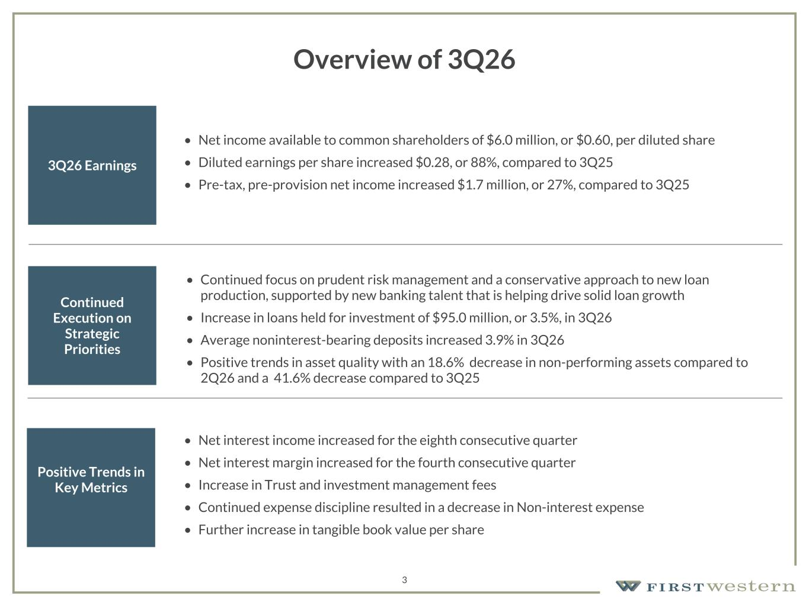
157 180 196 164 166 168 62 94 111 154 161 132 122 125 129 76 78 86 255 255 255 Chart color Table color Special Headlines Slide Headlines / Text on light background Primary Colors Secondary Colors Primary Background / Call Out Boxes / Text on dark background Chart color Table Color Tertiary Colors Chart color Table Color Chart Color Chart Color Approved Fonts AaBbCc 123 Lora (bold) Slide Headlines / Special Headlines AaBbCc 123 Lato(regular, bold, italics) Body Copy / Subheadings / Small Text Descriptions Overview of 3Q26 3Q26 Earnings • Net income available to common shareholders of $6.0 million, or $0.60, per diluted share • Diluted earnings per share increased $0.28, or 88%, compared to 3Q25 • Pre-tax, pre-provision net income increased $1.7 million, or 27%, compared to 3Q25 Continued Execution on Strategic Priorities • Continued focus on prudent risk management and a conservative approach to new loan production, supported by new banking talent that is helping drive solid loan growth • Increase in loans held for investment of $95.0 million, or 3.5%, in 3Q26 • Average noninterest-bearing deposits increased 3.9% in 3Q26 • Positive trends in asset quality with an 18.6% decrease in non-performing assets compared to 2Q26 and a 41.6% decrease compared to 3Q25 Positive Trends in Key Metrics • Net interest income increased for the eighth consecutive quarter • Net interest margin increased for the fourth consecutive quarter • Increase in Trust and investment management fees • Continued expense discipline resulted in a decrease in Non-interest expense • Further increase in tangible book value per share 3

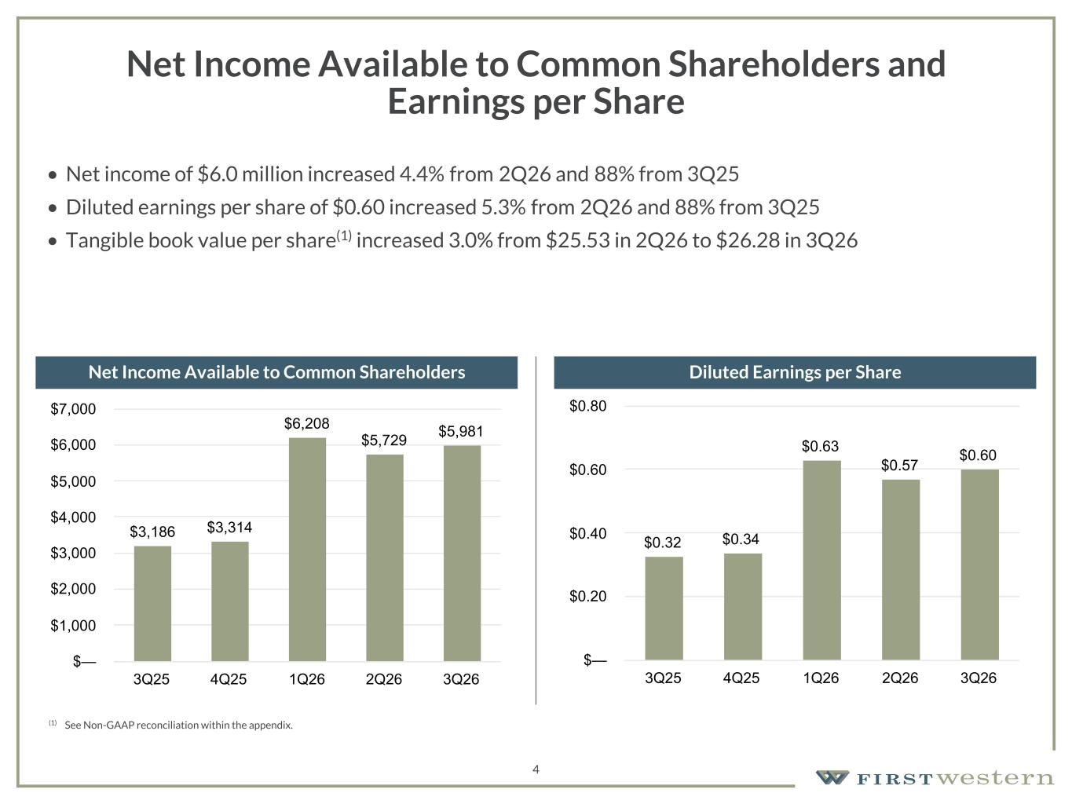
157 180 196 164 166 168 62 94 111 154 161 132 122 125 129 76 78 86 255 255 255 Chart color Table color Special Headlines Slide Headlines / Text on light background Primary Colors Secondary Colors Primary Background / Call Out Boxes / Text on dark background Chart color Table Color Tertiary Colors Chart color Table Color Chart Color Chart Color Approved Fonts AaBbCc 123 Lora (bold) Slide Headlines / Special Headlines AaBbCc 123 Lato(regular, bold, italics) Body Copy / Subheadings / Small Text Descriptions 4 Net Income Available to Common Shareholders and Earnings per Share • Net income of $6.0 million increased 4.4% from 2Q26 and 88% from 3Q25 • Diluted earnings per share of $0.60 increased 5.3% from 2Q26 and 88% from 3Q25 • Tangible book value per share(1) increased 3.0% from $25.53 in 2Q26 to $26.28 in 3Q26 Net Income Available to Common Shareholders Diluted Earnings per Share $3,186 $3,314 $6,208 $5,729 $5,981 3Q25 4Q25 1Q26 2Q26 3Q26 $— $1,000 $2,000 $3,000 $4,000 $5,000 $6,000 $7,000 $0.32 $0.34 $0.63 $0.57 $0.60 3Q25 4Q25 1Q26 2Q26 3Q26 $— $0.20 $0.40 $0.60 $0.80 (1) See Non-GAAP reconciliation within the appendix.

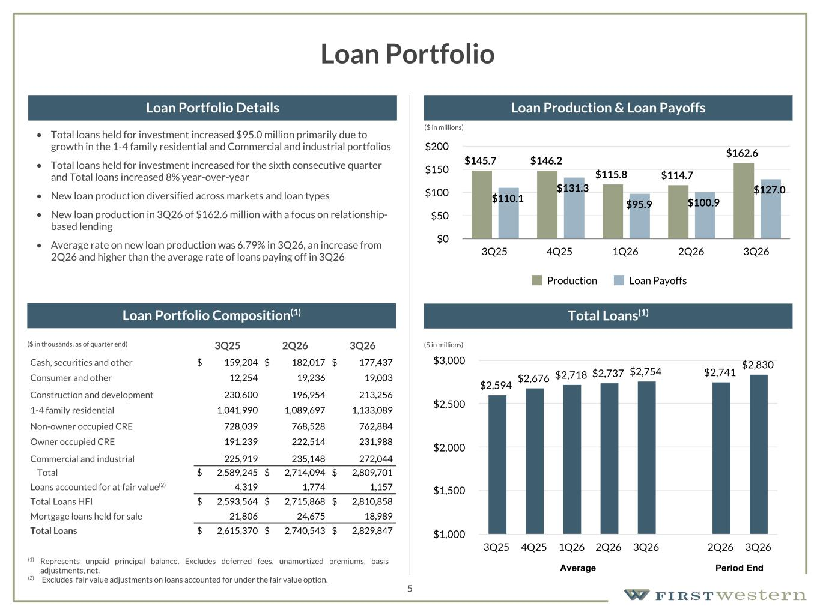
157 180 196 164 166 168 62 94 111 154 161 132 122 125 129 76 78 86 255 255 255 Chart color Table color Special Headlines Slide Headlines / Text on light background Primary Colors Secondary Colors Primary Background / Call Out Boxes / Text on dark background Chart color Table Color Tertiary Colors Chart color Table Color Chart Color Chart Color Approved Fonts AaBbCc 123 Lora (bold) Slide Headlines / Special Headlines AaBbCc 123 Lato (regular, bold, italics) Body Copy / Subheadings / Small Text Descriptions 5 Loan Portfolio • Total loans held for investment increased $95.0 million primarily due to growth in the 1-4 family residential and Commercial and industrial portfolios • Total loans held for investment increased for the sixth consecutive quarter and Total loans increased 8% year-over-year • New loan production diversified across markets and loan types • New loan production in 3Q26 of $162.6 million with a focus on relationship- based lending • Average rate on new loan production was 6.79% in 3Q26, an increase from 2Q26 and higher than the average rate of loans paying off in 3Q26 3Q25 2Q26 3Q26 Cash, securities and other $ 159,204 $ 182,017 $ 177,437 Consumer and other 12,254 19,236 19,003 Construction and development 230,600 196,954 213,256 1-4 family residential 1,041,990 1,089,697 1,133,089 Non-owner occupied CRE 728,039 768,528 762,884 Owner occupied CRE 191,239 222,514 231,988 Commercial and industrial 225,919 235,148 272,044 Total $ 2,589,245 $ 2,714,094 $ 2,809,701 Loans accounted for at fair value(2) 4,319 1,774 1,157 Total Loans HFI $ 2,593,564 $ 2,715,868 $ 2,810,858 Mortgage loans held for sale 21,806 24,675 18,989 Total Loans $ 2,615,370 $ 2,740,543 $ 2,829,847 (1) Represents unpaid principal balance. Excludes deferred fees, unamortized premiums, basis adjustments, net. (2) Excludes fair value adjustments on loans accounted for under the fair value option. ($ in thousands, as of quarter end) Loan Portfolio Composition(1) Loan Portfolio Details Loan Production & Loan Payoffs Total Loans(1) $2,594 $2,676 $2,718 $2,737 $2,754 $2,741 $2,830 3Q25 4Q25 1Q26 2Q26 3Q26 2Q26 3Q26 $1,000 $1,500 $2,000 $2,500 $3,000 Average Period End $145.7 $146.2 $115.8 $114.7 $162.6 $110.1 $131.3 $95.9 $100.9 $127.0 Production Loan Payoffs 3Q25 4Q25 1Q26 2Q26 3Q26 $0 $50 $100 $150 $200 ($ in millions) ($ in millions)

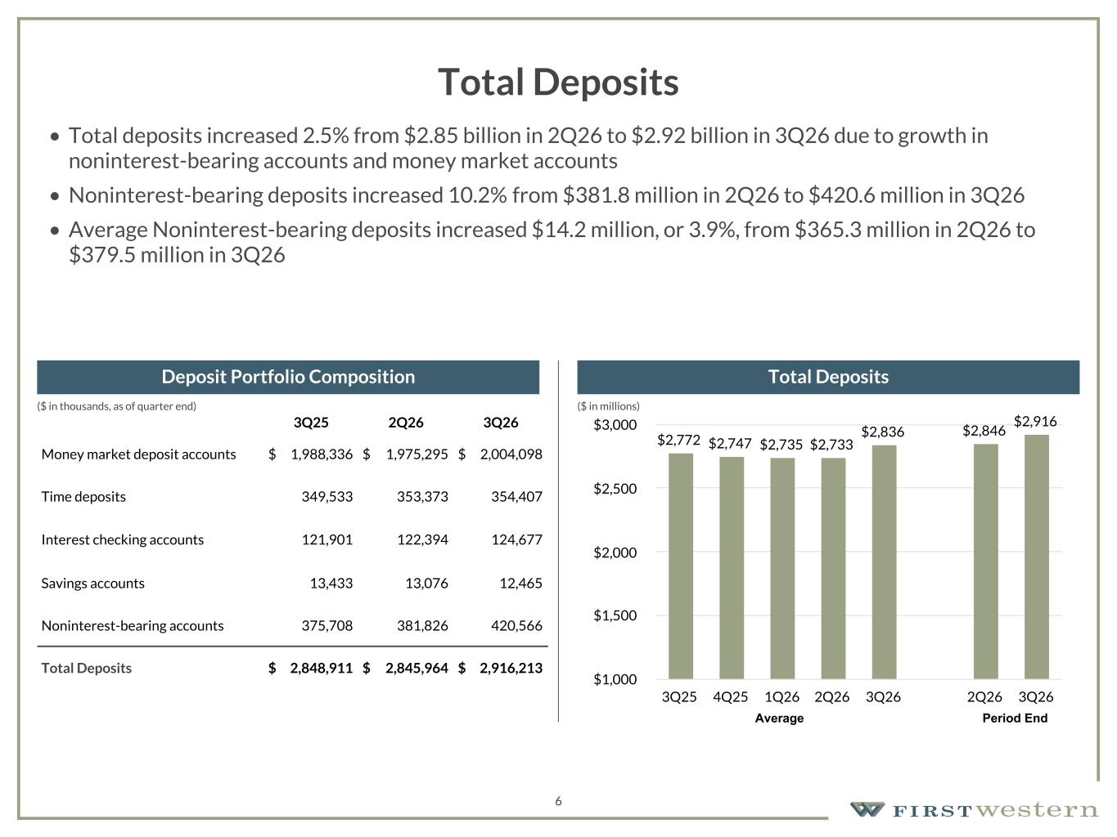
157 180 196 164 166 168 62 94 111 154 161 132 122 125 129 76 78 86 255 255 255 Chart color Table color Special Headlines Slide Headlines / Text on light background Primary Colors Secondary Colors Primary Background / Call Out Boxes / Text on dark background Chart color Table Color Tertiary Colors Chart color Table Color Chart Color Chart Color Approved Fonts AaBbCc 123 Lora (bold) Slide Headlines / Special Headlines AaBbCc 123 Lato (regular, bold, italics) Body Copy / Subheadings / Small Text Descriptions 6 Total Deposits • Total deposits increased 2.5% from $2.85 billion in 2Q26 to $2.92 billion in 3Q26 due to growth in noninterest-bearing accounts and money market accounts • Noninterest-bearing deposits increased 10.2% from $381.8 million in 2Q26 to $420.6 million in 3Q26 • Average Noninterest-bearing deposits increased $14.2 million, or 3.9%, from $365.3 million in 2Q26 to $379.5 million in 3Q26 3Q25 2Q26 3Q26 Money market deposit accounts $ 1,988,336 $ 1,975,295 $ 2,004,098 Time deposits 349,533 353,373 354,407 Interest checking accounts 121,901 122,394 124,677 Savings accounts 13,433 13,076 12,465 Noninterest-bearing accounts 375,708 381,826 420,566 Total Deposits $ 2,848,911 $ 2,845,964 $ 2,916,213 Deposit Portfolio Composition Total Deposits $2,772 $2,747 $2,735 $2,733 $2,836 $2,846 $2,916 3Q25 4Q25 1Q26 2Q26 3Q26 2Q26 3Q26 $1,000 $1,500 $2,000 $2,500 $3,000 Average Period End ($ in millions)($ in thousands, as of quarter end)

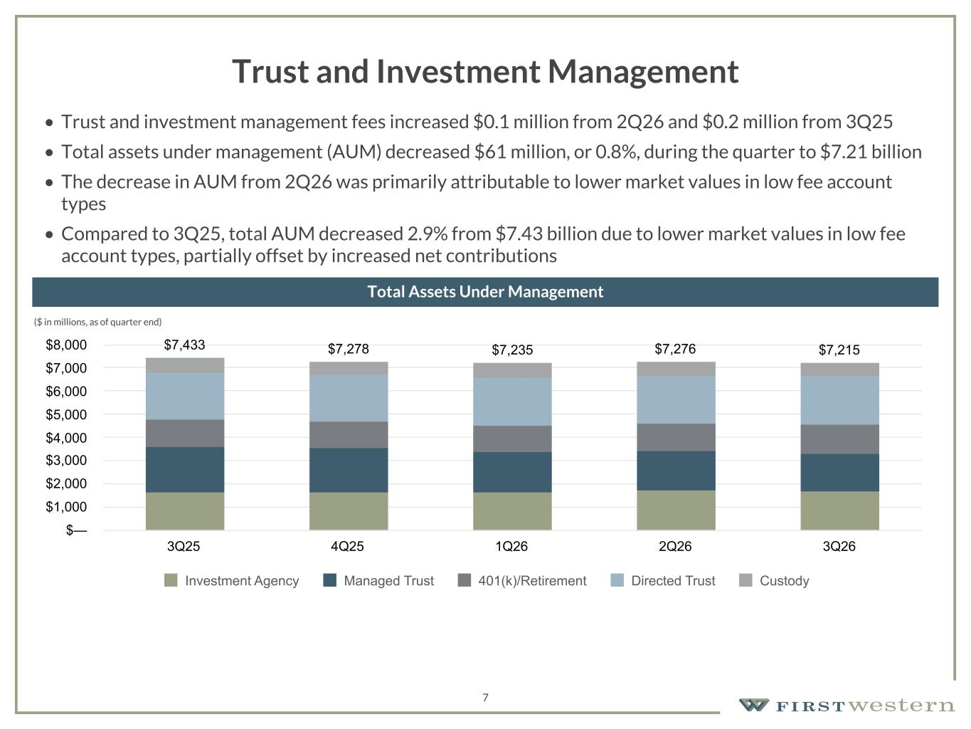
157 180 196 164 166 168 62 94 111 154 161 132 122 125 129 76 78 86 255 255 255 Chart color Table color Special Headlines Slide Headlines / Text on light background Primary Colors Secondary Colors Primary Background / Call Out Boxes / Text on dark background Chart color Table Color Tertiary Colors Chart color Table Color Chart Color Chart Color Approved Fonts AaBbCc 123 Lora (bold) Slide Headlines / Special Headlines AaBbCc 123 Lato (regular, bold, italics) Body Copy / Subheadings / Small Text Descriptions 7 Trust and Investment Management • Trust and investment management fees increased $0.1 million from 2Q26 and $0.2 million from 3Q25 • Total assets under management (AUM) decreased $61 million, or 0.8%, during the quarter to $7.21 billion • The decrease in AUM from 2Q26 was primarily attributable to lower market values in low fee account types • Compared to 3Q25, total AUM decreased 2.9% from $7.43 billion due to lower market values in low fee account types, partially offset by increased net contributions • ($ in millions, as of quarter end) Total Assets Under Management $7,433 $7,278 $7,235 $7,276 $7,215 Investment Agency Managed Trust 401(k)/Retirement Directed Trust Custody 3Q25 4Q25 1Q26 2Q26 3Q26 $— $1,000 $2,000 $3,000 $4,000 $5,000 $6,000 $7,000 $8,000

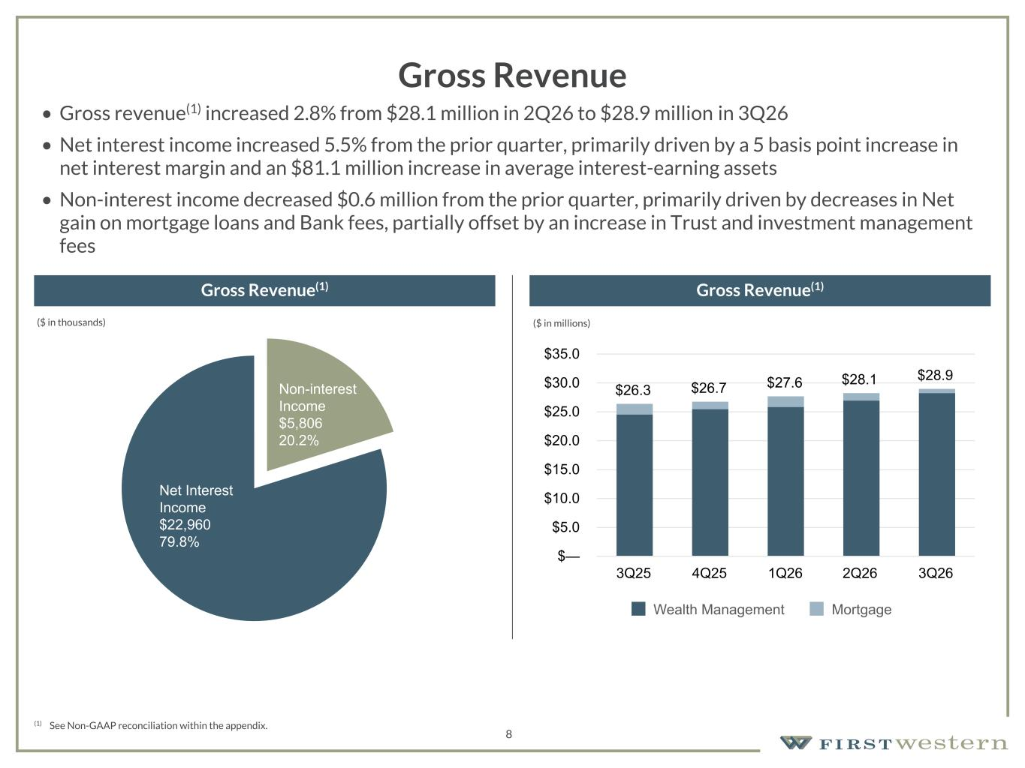
157 180 196 164 166 168 62 94 111 154 161 132 122 125 129 76 78 86 255 255 255 Chart color Table color Special Headlines Slide Headlines / Text on light background Primary Colors Secondary Colors Primary Background / Call Out Boxes / Text on dark background Chart color Table Color Tertiary Colors Chart color Table Color Chart Color Chart Color Approved Fonts AaBbCc 123 Lora (bold) Slide Headlines / Special Headlines AaBbCc 123 Lato (regular, bold, italics) Body Copy / Subheadings / Small Text Descriptions (1) See Non-GAAP reconciliation within the appendix. Gross Revenue Gross Revenue(1) Gross Revenue(1) 8 $26.3 $26.7 $27.6 $28.1 $28.9 Wealth Management Mortgage 3Q25 4Q25 1Q26 2Q26 3Q26 $— $5.0 $10.0 $15.0 $20.0 $25.0 $30.0 $35.0 • Gross revenue(1) increased 2.8% from $28.1 million in 2Q26 to $28.9 million in 3Q26 • Net interest income increased 5.5% from the prior quarter, primarily driven by a 5 basis point increase in net interest margin and an $81.1 million increase in average interest-earning assets • Non-interest income decreased $0.6 million from the prior quarter, primarily driven by decreases in Net gain on mortgage loans and Bank fees, partially offset by an increase in Trust and investment management fees Non-interest Income $5,806 20.2% Net Interest Income $22,960 79.8% ($ in thousands) ($ in millions)

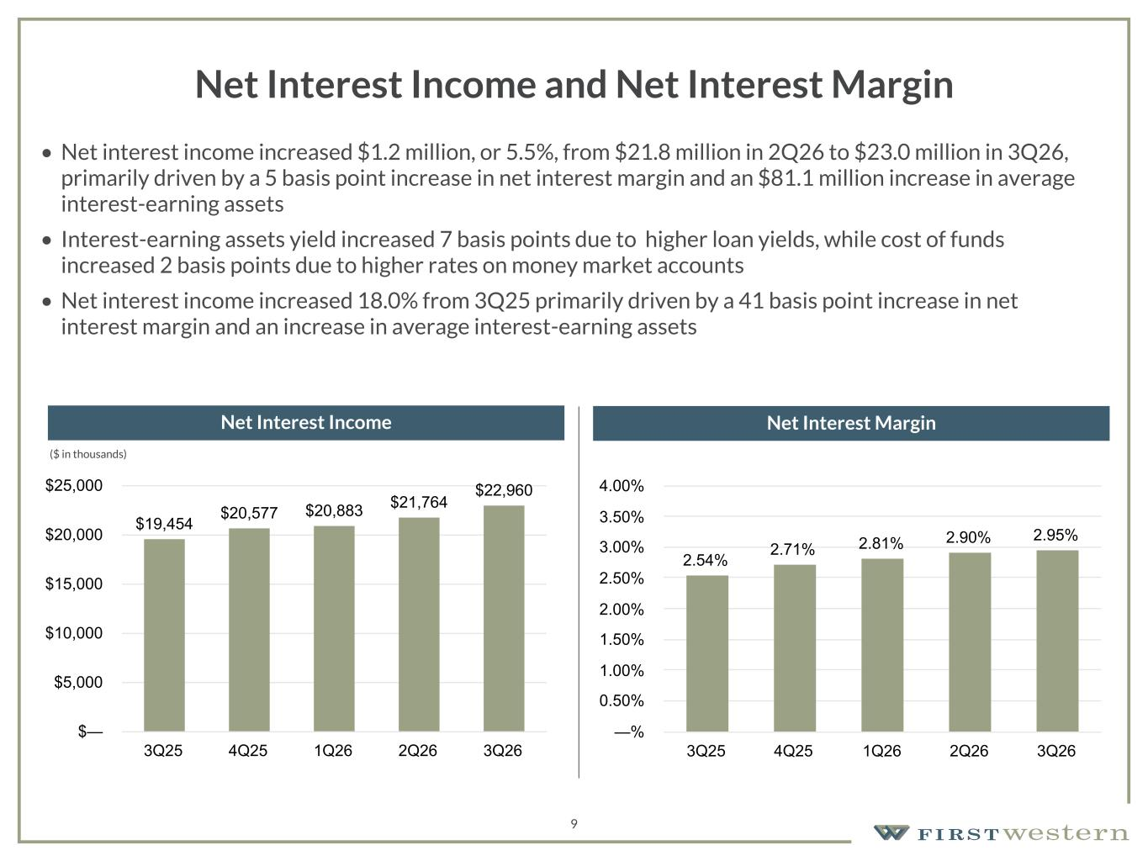
157 180 196 164 166 168 62 94 111 154 161 132 122 125 129 76 78 86 255 255 255 Chart color Table color Special Headlines Slide Headlines / Text on light background Primary Colors Secondary Colors Primary Background / Call Out Boxes / Text on dark background Chart color Table Color Tertiary Colors Chart color Table Color Chart Color Chart Color Approved Fonts AaBbCc 123 Lora (bold) Slide Headlines / Special Headlines AaBbCc 123 Lato (regular, bold, italics) Body Copy / Subheadings / Small Text Descriptions 9 Net Interest Income and Net Interest Margin • Net interest income increased $1.2 million, or 5.5%, from $21.8 million in 2Q26 to $23.0 million in 3Q26, primarily driven by a 5 basis point increase in net interest margin and an $81.1 million increase in average interest-earning assets • Interest-earning assets yield increased 7 basis points due to higher loan yields, while cost of funds increased 2 basis points due to higher rates on money market accounts • Net interest income increased 18.0% from 3Q25 primarily driven by a 41 basis point increase in net interest margin and an increase in average interest-earning assets Net Interest Income Net Interest Margin $19,454 $20,577 $20,883 $21,764 $22,960 3Q25 4Q25 1Q26 2Q26 3Q26 $— $5,000 $10,000 $15,000 $20,000 $25,000 2.54% 2.71% 2.81% 2.90% 2.95% 3Q25 4Q25 1Q26 2Q26 3Q26 —% 0.50% 1.00% 1.50% 2.00% 2.50% 3.00% 3.50% 4.00% ($ in thousands)

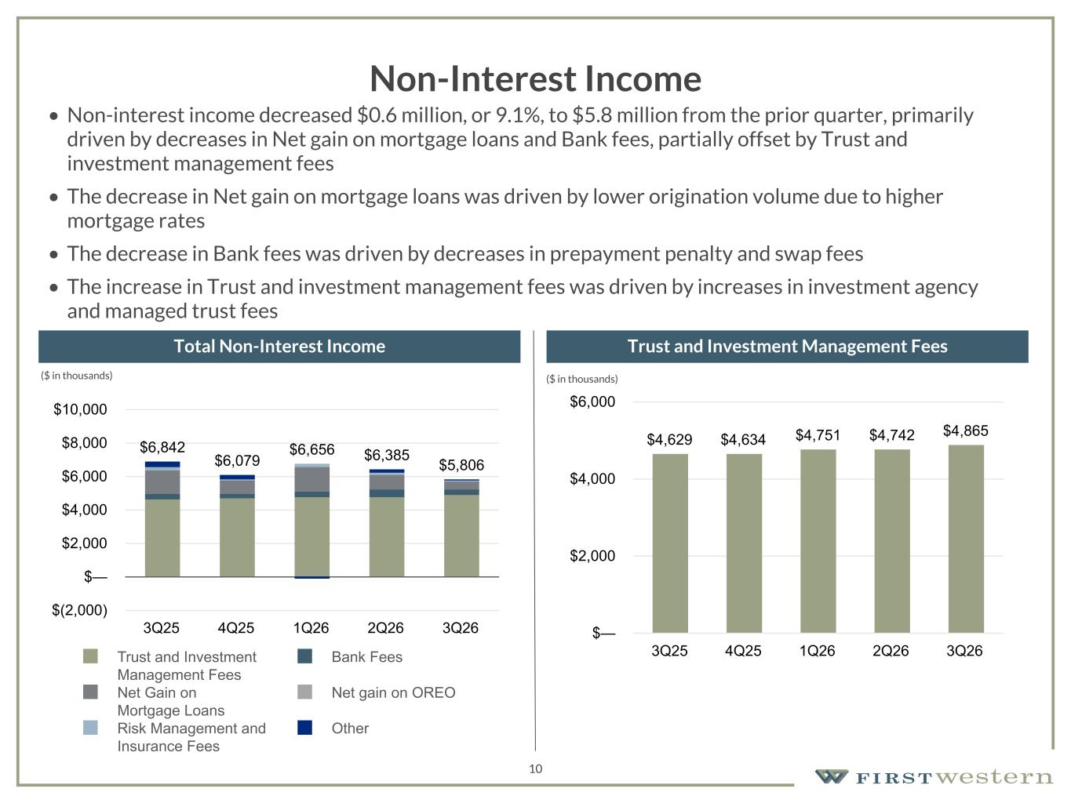
157 180 196 164 166 168 62 94 111 154 161 132 122 125 129 76 78 86 255 255 255 Chart color Table color Special Headlines Slide Headlines / Text on light background Primary Colors Secondary Colors Primary Background / Call Out Boxes / Text on dark background Chart color Table Color Tertiary Colors Chart color Table Color Chart Color Chart Color Approved Fonts AaBbCc 123 Lora (bold) Slide Headlines / Special Headlines AaBbCc 123 Lato (regular, bold, italics) Body Copy / Subheadings / Small Text Descriptions 10 Non-Interest Income • Non-interest income decreased $0.6 million, or 9.1%, to $5.8 million from the prior quarter, primarily driven by decreases in Net gain on mortgage loans and Bank fees, partially offset by Trust and investment management fees • The decrease in Net gain on mortgage loans was driven by lower origination volume due to higher mortgage rates • The decrease in Bank fees was driven by decreases in prepayment penalty and swap fees • The increase in Trust and investment management fees was driven by increases in investment agency and managed trust fees Total Non-Interest Income Trust and Investment Management Fees $6,842 $6,079 $6,656 $6,385 $5,806 Trust and Investment Management Fees Bank Fees Net Gain on Mortgage Loans Net gain on OREO Risk Management and Insurance Fees Other 3Q25 4Q25 1Q26 2Q26 3Q26 $(2,000) $— $2,000 $4,000 $6,000 $8,000 $10,000 $4,629 $4,634 $4,751 $4,742 $4,865 3Q25 4Q25 1Q26 2Q26 3Q26 $— $2,000 $4,000 $6,000 ($ in thousands) ($ in thousands)

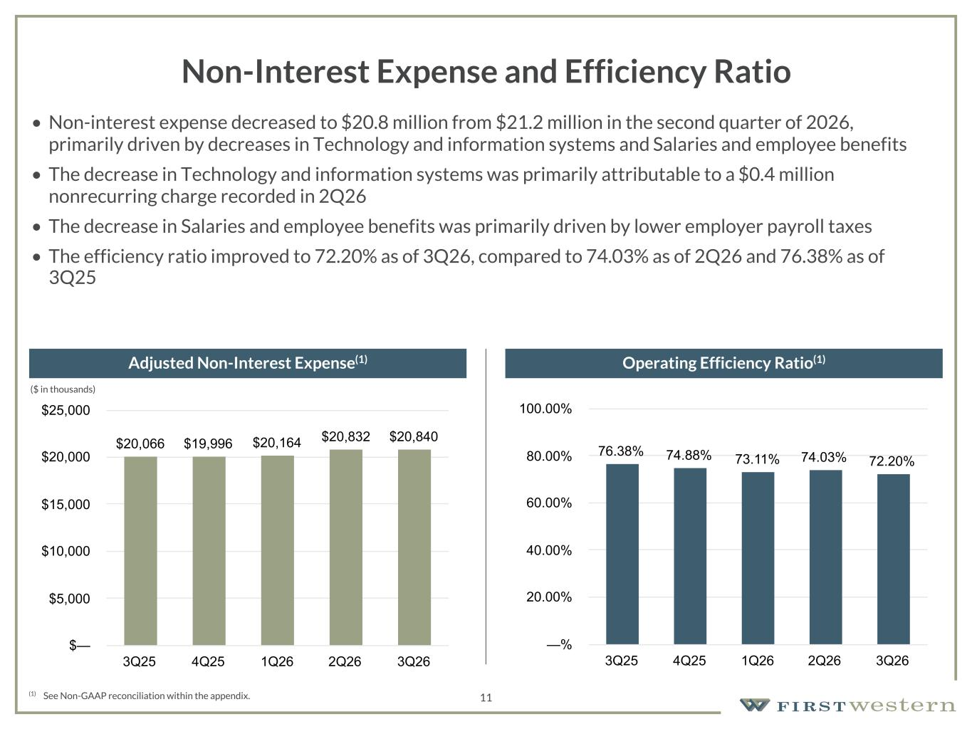
157 180 196 164 166 168 62 94 111 154 161 132 122 125 129 76 78 86 255 255 255 Chart color Table color Special Headlines Slide Headlines / Text on light background Primary Colors Secondary Colors Primary Background / Call Out Boxes / Text on dark background Chart color Table Color Tertiary Colors Chart color Table Color Chart Color Chart Color Approved Fonts AaBbCc 123 Lora (bold) Slide Headlines / Special Headlines AaBbCc 123 Lato (regular, bold, italics) Body Copy / Subheadings / Small Text Descriptions 11 Non-Interest Expense and Efficiency Ratio • Non-interest expense decreased to $20.8 million from $21.2 million in the second quarter of 2026, primarily driven by decreases in Technology and information systems and Salaries and employee benefits • The decrease in Technology and information systems was primarily attributable to a $0.4 million nonrecurring charge recorded in 2Q26 • The decrease in Salaries and employee benefits was primarily driven by lower employer payroll taxes • The efficiency ratio improved to 72.20% as of 3Q26, compared to 74.03% as of 2Q26 and 76.38% as of 3Q25 (1) See Non-GAAP reconciliation within the appendix. Adjusted Non-Interest Expense(1) Operating Efficiency Ratio(1) (1) (1) (1) $20,066 $19,996 $20,164 $20,832 $20,840 3Q25 4Q25 1Q26 2Q26 3Q26 $— $5,000 $10,000 $15,000 $20,000 $25,000 76.38% 74.88% 73.11% 74.03% 72.20% 3Q25 4Q25 1Q26 2Q26 3Q26 —% 20.00% 40.00% 60.00% 80.00% 100.00% ($ in thousands)

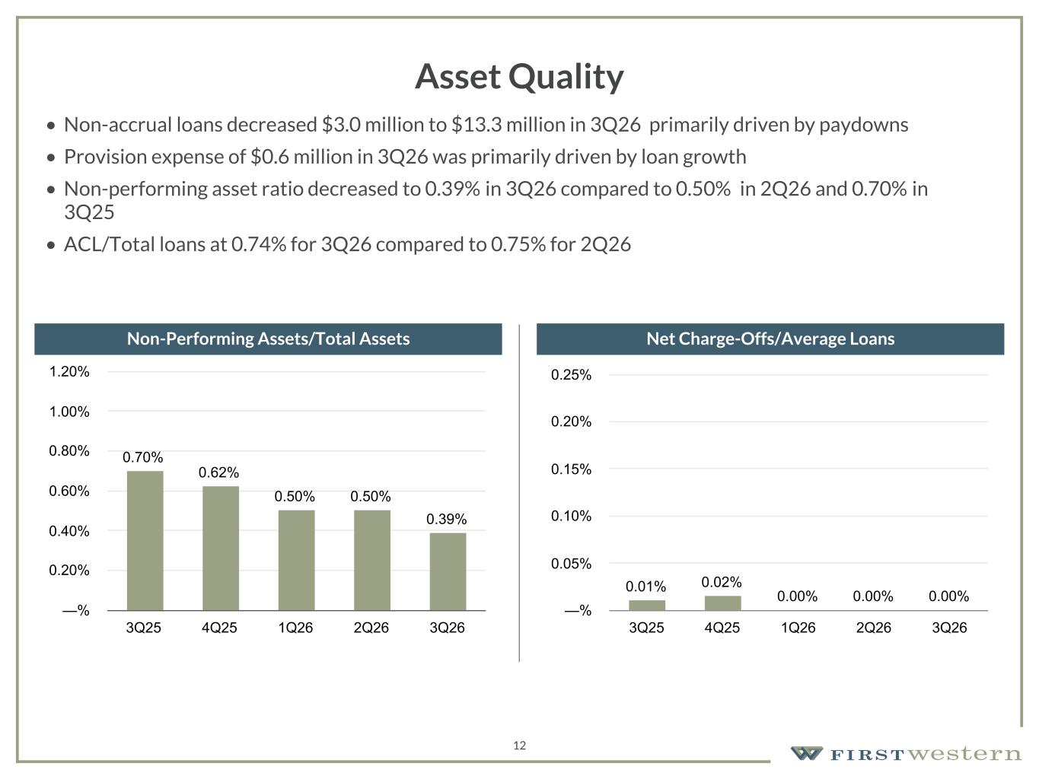
157 180 196 164 166 168 62 94 111 154 161 132 122 125 129 76 78 86 255 255 255 Chart color Table color Special Headlines Slide Headlines / Text on light background Primary Colors Secondary Colors Primary Background / Call Out Boxes / Text on dark background Chart color Table Color Tertiary Colors Chart color Table Color Chart Color Chart Color Approved Fonts AaBbCc 123 Lora (bold) Slide Headlines / Special Headlines AaBbCc 123 Lato (regular, bold, italics) Body Copy / Subheadings / Small Text Descriptions 12 Asset Quality • Non-accrual loans decreased $3.0 million to $13.3 million in 3Q26 primarily driven by paydowns • Provision expense of $0.6 million in 3Q26 was primarily driven by loan growth • Non-performing asset ratio decreased to 0.39% in 3Q26 compared to 0.50% in 2Q26 and 0.70% in 3Q25 • ACL/Total loans at 0.74% for 3Q26 compared to 0.75% for 2Q26 Non-Performing Assets/Total Assets Net Charge-Offs/Average Loans 0.70% 0.62% 0.50% 0.50% 0.39% 3Q25 4Q25 1Q26 2Q26 3Q26 —% 0.20% 0.40% 0.60% 0.80% 1.00% 1.20% 0.01% 0.02% 0.00% 0.00% 0.00% 3Q25 4Q25 1Q26 2Q26 3Q26 —% 0.05% 0.10% 0.15% 0.20% 0.25%

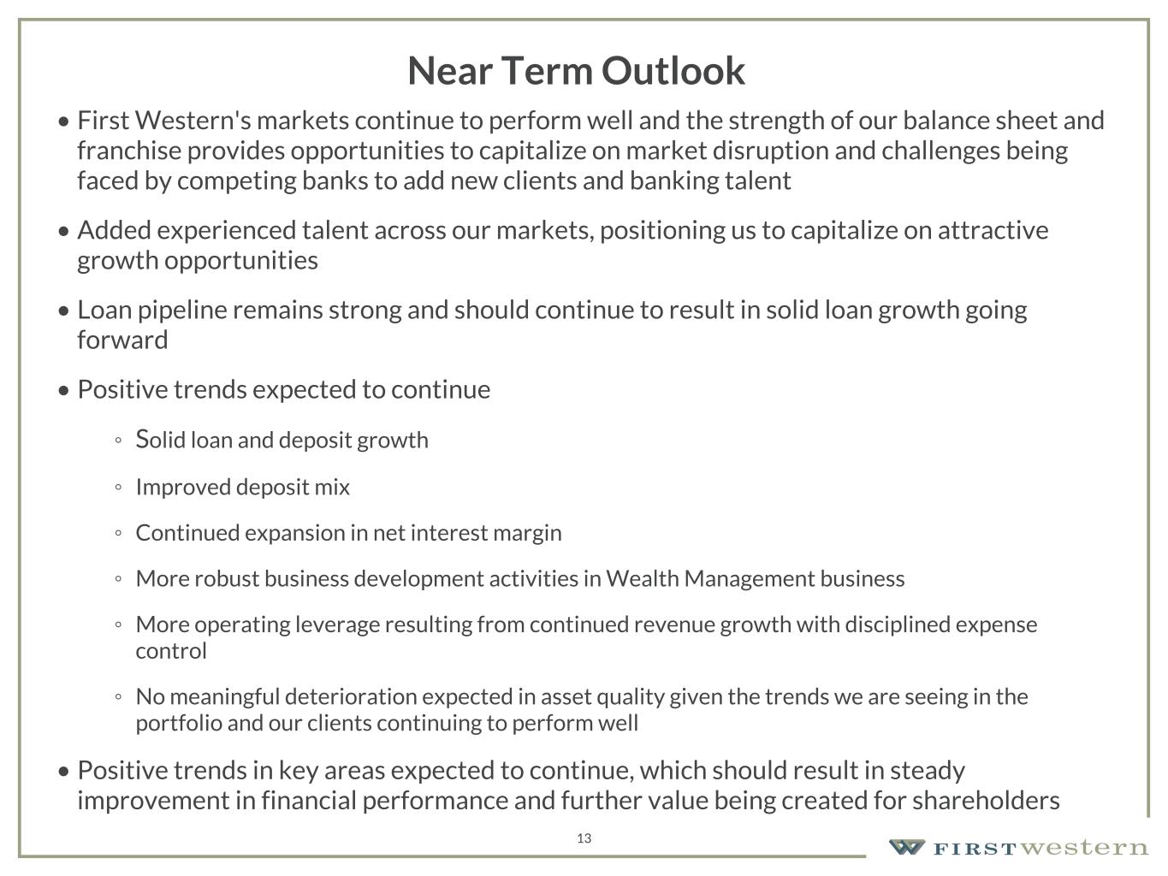
157 180 196 164 166 168 62 94 111 154 161 132 122 125 129 76 78 86 255 255 255 Chart color Table color Special Headlines Slide Headlines / Text on light background Primary Colors Secondary Colors Primary Background / Call Out Boxes / Text on dark background Chart color Table Color Tertiary Colors Chart color Table Color Chart Color Chart Color Approved Fonts AaBbCc 123 Lora (bold) Slide Headlines / Special Headlines AaBbCc 123 Lato (regular, bold, italics) Body Copy / Subheadings / Small Text Descriptions 13 Near Term Outlook • First Western's markets continue to perform well and the strength of our balance sheet and franchise provides opportunities to capitalize on market disruption and challenges being faced by competing banks to add new clients and banking talent • Added experienced talent across our markets, positioning us to capitalize on attractive growth opportunities • Loan pipeline remains strong and should continue to result in solid loan growth going forward • Positive trends expected to continue ◦ Solid loan and deposit growth ◦ Improved deposit mix ◦ Continued expansion in net interest margin ◦ More robust business development activities in Wealth Management business ◦ More operating leverage resulting from continued revenue growth with disciplined expense control ◦ No meaningful deterioration expected in asset quality given the trends we are seeing in the portfolio and our clients continuing to perform well • Positive trends in key areas expected to continue, which should result in steady improvement in financial performance and further value being created for shareholders


Appendix 14

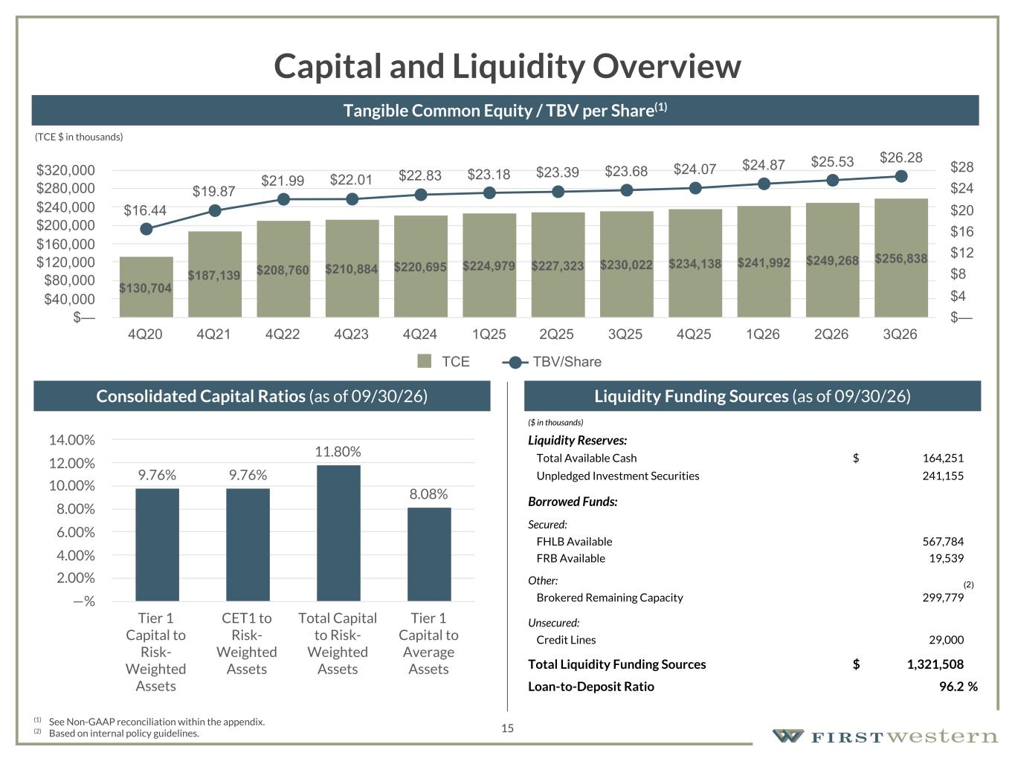
157 180 196 164 166 168 62 94 111 154 161 132 122 125 129 76 78 86 255 255 255 Chart color Table color Special Headlines Slide Headlines / Text on light background Primary Colors Secondary Colors Primary Background / Call Out Boxes / Text on dark background Chart color Table Color Tertiary Colors Chart color Table Color Chart Color Chart Color Approved Fonts AaBbCc 123 Lora (bold) Slide Headlines / Special Headlines AaBbCc 123 Lato (regular, bold, italics) Body Copy / Subheadings / Small Text Descriptions 15 Capital and Liquidity Overview Liquidity Funding Sources (as of 09/30/26) (1) See Non-GAAP reconciliation within the appendix. (2) Based on internal policy guidelines. Consolidated Capital Ratios (as of 09/30/26) Tangible Common Equity / TBV per Share(1) ($ in thousands) Liquidity Reserves: Total Available Cash $ 164,251 Unpledged Investment Securities 241,155 Borrowed Funds: Secured: FHLB Available 567,784 FRB Available 19,539 Other: Brokered Remaining Capacity 299,779 Unsecured: Credit Lines 29,000 Total Liquidity Funding Sources $ 1,321,508 Loan-to-Deposit Ratio 96.2 % 9.76% 9.76% 11.80% 8.08% Tier 1 Capital to Risk- Weighted Assets CET1 to Risk- Weighted Assets Total Capital to Risk- Weighted Assets Tier 1 Capital to Average Assets —% 2.00% 4.00% 6.00% 8.00% 10.00% 12.00% 14.00% (2) (TCE $ in thousands) $130,704 $187,139 $208,760 $210,884 $220,695 $224,979 $227,323 $230,022 $234,138 $241,992 $249,268 $256,838 $16.44 $19.87 $21.99 $22.01 $22.83 $23.18 $23.39 $23.68 $24.07 $24.87 $25.53 $26.28 TCE TBV/Share 4Q20 4Q21 4Q22 4Q23 4Q24 1Q25 2Q25 3Q25 4Q25 1Q26 2Q26 3Q26 $— $40,000 $80,000 $120,000 $160,000 $200,000 $240,000 $280,000 $320,000 $— $4 $8 $12 $16 $20 $24 $28

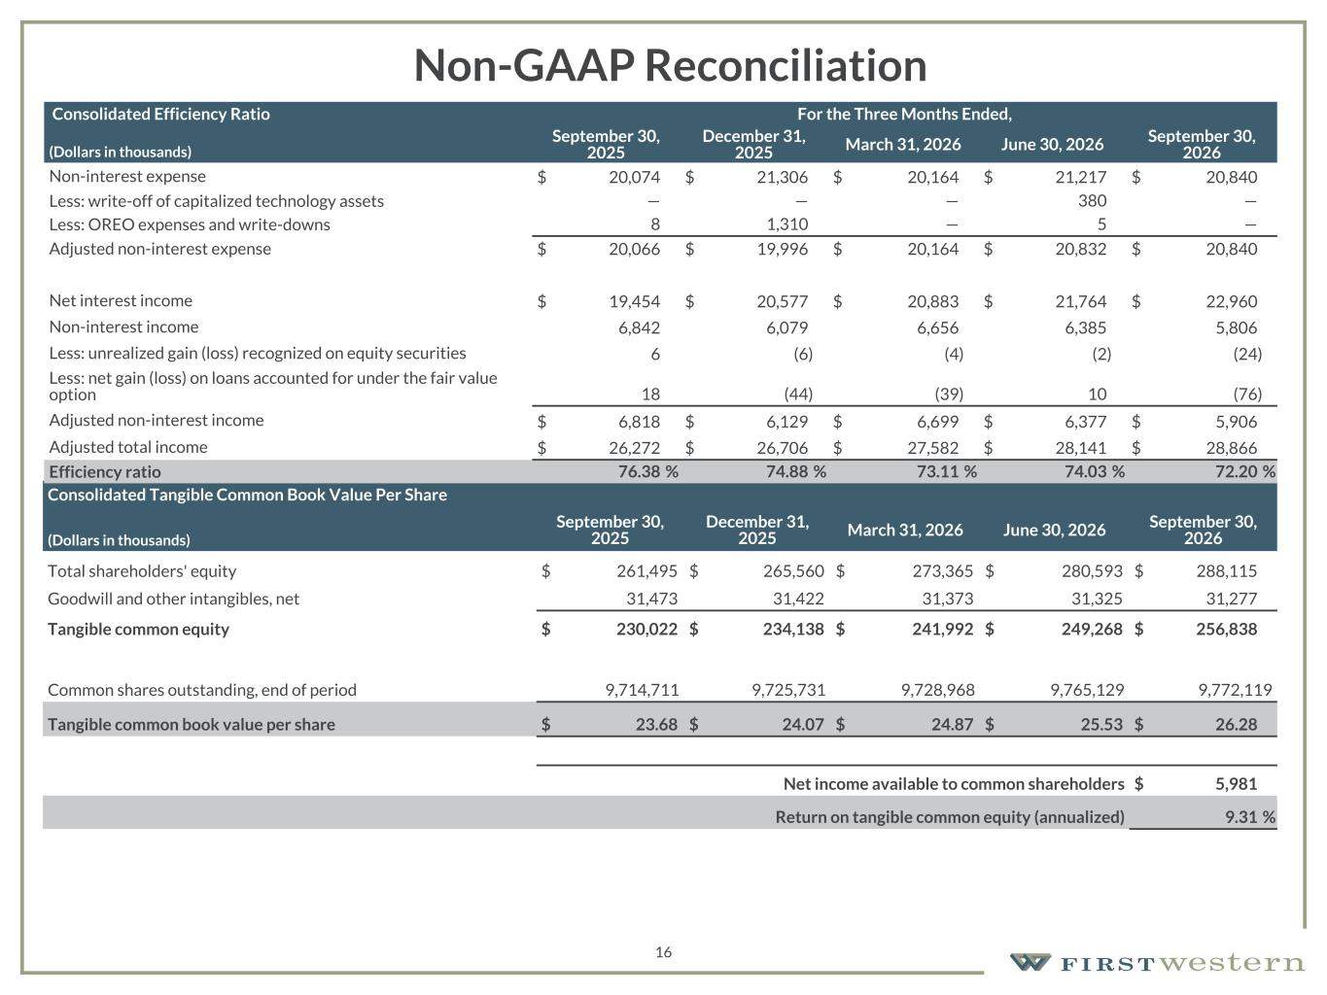
157 180 196 164 166 168 62 94 111 154 161 132 122 125 129 76 78 86 255 255 255 Chart color Table color Special Headlines Slide Headlines / Text on light background Primary Colors Secondary Colors Primary Background / Call Out Boxes / Text on dark background Chart color Table Color Tertiary Colors Chart color Table Color Chart Color Chart Color Approved Fonts AaBbCc 123 Lora (bold) Slide Headlines / Special Headlines AaBbCc 123 Lato (regular, bold, italics) Body Copy / Subheadings / Small Text Descriptions 16 Non-GAAP Reconciliation Consolidated Tangible Common Book Value Per Share (Dollars in thousands) September 30, 2025 December 31, 2025 March 31, 2026 June 30, 2026 September 30, 2026 Total shareholders' equity $ 261,495 $ 265,560 $ 273,365 $ 280,593 $ 288,115 Goodwill and other intangibles, net 31,473 31,422 31,373 31,325 31,277 Tangible common equity $ 230,022 $ 234,138 $ 241,992 $ 249,268 $ 256,838 Common shares outstanding, end of period 9,714,711 9,725,731 9,728,968 9,765,129 9,772,119 Tangible common book value per share $ 23.68 $ 24.07 $ 24.87 $ 25.53 $ 26.28 Net income available to common shareholders $ 5,981 Return on tangible common equity (annualized) 9.31 % Consolidated Efficiency Ratio For the Three Months Ended, (Dollars in thousands) September 30, 2025 December 31, 2025 March 31, 2026 June 30, 2026 September 30, 2026 Non-interest expense $ 20,074 $ 21,306 $ 20,164 $ 21,217 $ 20,840 Less: write-off of capitalized technology assets — — — 380 — Less: OREO expenses and write-downs 8 1,310 — 5 — Adjusted non-interest expense $ 20,066 $ 19,996 $ 20,164 $ 20,832 $ 20,840 Net interest income $ 19,454 $ 20,577 $ 20,883 $ 21,764 $ 22,960 Non-interest income 6,842 6,079 6,656 6,385 5,806 Less: unrealized gain (loss) recognized on equity securities 6 (6) (4) (2) (24) Less: net gain (loss) on loans accounted for under the fair value option 18 (44) (39) 10 (76) Adjusted non-interest income $ 6,818 $ 6,129 $ 6,699 $ 6,377 $ 5,906 Adjusted total income $ 26,272 $ 26,706 $ 27,582 $ 28,141 $ 28,866 Efficiency ratio 76.38 % 74.88 % 73.11 % 74.03 % 72.20 %

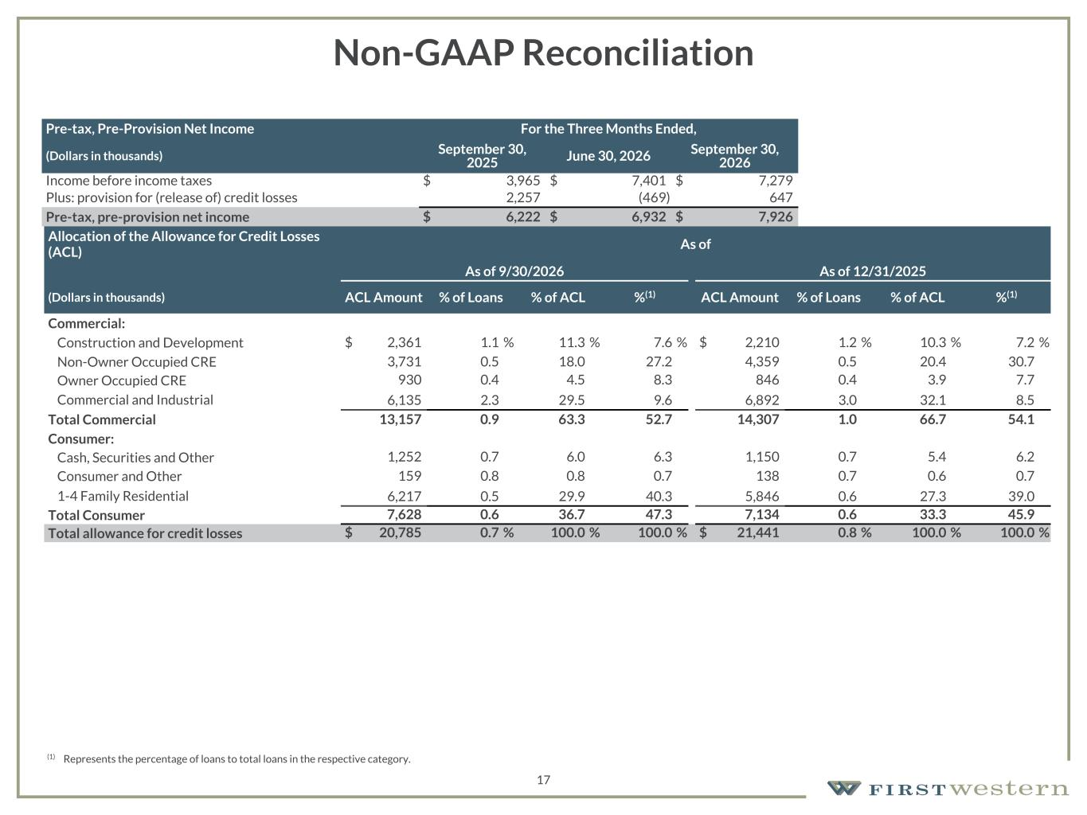
157 180 196 164 166 168 62 94 111 154 161 132 122 125 129 76 78 86 255 255 255 Chart color Table color Special Headlines Slide Headlines / Text on light background Primary Colors Secondary Colors Primary Background / Call Out Boxes / Text on dark background Chart color Table Color Tertiary Colors Chart color Table Color Chart Color Chart Color Approved Fonts AaBbCc 123 Lora (bold) Slide Headlines / Special Headlines AaBbCc 123 Lato (regular, bold, italics) Body Copy / Subheadings / Small Text Descriptions 17 Non-GAAP Reconciliation Pre-tax, Pre-Provision Net Income For the Three Months Ended, (Dollars in thousands) September 30, 2025 June 30, 2026 September 30, 2026 Income before income taxes $ 3,965 $ 7,401 $ 7,279 Plus: provision for (release of) credit losses 2,257 (469) 647 Pre-tax, pre-provision net income $ 6,222 $ 6,932 $ 7,926 Allocation of the Allowance for Credit Losses (ACL) As of As of 9/30/2026 As of 12/31/2025 (Dollars in thousands) ACL Amount % of Loans % of ACL %(1) ACL Amount % of Loans % of ACL %(1) Commercial: Construction and Development $ 2,361 1.1 % 11.3 % 7.6 % $ 2,210 1.2 % 10.3 % 7.2 % Non-Owner Occupied CRE 3,731 0.5 18.0 27.2 4,359 0.5 20.4 30.7 Owner Occupied CRE 930 0.4 4.5 8.3 846 0.4 3.9 7.7 Commercial and Industrial 6,135 2.3 29.5 9.6 6,892 3.0 32.1 8.5 Total Commercial 13,157 0.9 63.3 52.7 14,307 1.0 66.7 54.1 Consumer: Cash, Securities and Other 1,252 0.7 6.0 6.3 1,150 0.7 5.4 6.2 Consumer and Other 159 0.8 0.8 0.7 138 0.7 0.6 0.7 1-4 Family Residential 6,217 0.5 29.9 40.3 5,846 0.6 27.3 39.0 Total Consumer 7,628 0.6 36.7 47.3 7,134 0.6 33.3 45.9 Total allowance for credit losses $ 20,785 0.7 % 100.0 % 100.0 % $ 21,441 0.8 % 100.0 % 100.0 % (1) Represents the percentage of loans to total loans in the respective category.

