UNITED STATES
SECURITIES AND EXCHANGE COMMISSION
Washington, D.C. 20549
FORM 8-K
CURRENT REPORT
Pursuant to Section 13 or 15(d) of The Securities Exchange Act of 1934
Date of Report (Date of earliest event reported): July 23, 2026
FIRST WESTERN FINANCIAL, INC.
(Exact name of registrant as specified in its charter)
Colorado |  |  | 001-38595 |  |  | 37-1442266
(State or other jurisdiction of  incorporation or organization) |  |  | (Commission  File Number) |  |  | (I.R.S. Employer  Identification No.)
1900 16th Street, Suite 1200  Denver, Colorado |  |  |  |  |  | 80202
(Address of principal executive offices) |  |  |  |  |  | (Zip Code)
Registrant’s telephone number, including area code: 303.531.8100
Former name or former address, if changed since last report: Not Applicable
Check the appropriate box below if the Form 8-K filing is intended to simultaneously satisfy the filing obligation of the registrant under any of the following provisions:
o |  |  | Written communications pursuant to Rule 425 under the Securities Act (17 CFR 230.425)
o |  |  | Soliciting material pursuant to Rule 14a-12 under the Exchange Act (17 CFR 240.14a-12)
o |  |  | Pre-commencement communications pursuant to Rule 14d-2(b) under the Exchange Act (17 CFR 240.14d-2(b))
o |  |  | Pre-commencement communications pursuant to Rule 13e-4(c) under the Exchange Act (17 CFR 240.13e-4(c))
Indicate by check mark whether the registrant is an emerging growth company as defined in Rule 405 of the Securities Act of 1933 (§230.405 of this chapter) or Rule 12b-2 of the Securities Exchange Act of 1934 (§240.12b-2 of this chapter).
o |  |  | Emerging growth company
o |  |  | If an emerging growth company, indicate by check mark if the registrant has elected not to use the extended transition period for complying with any new or revised financial accounting standards provided pursuant to Section 13(a) of the Exchange Act.
Securities registered pursuant to Section 12(b) of the Act:
Title of each class |  |  | Trading Symbol |  |  | Name of each exchange on which registered
Common Stock, no par value |  |  | MYFW |  |  | NASDAQ Stock Market LLC

Item 2.02 Results of Operations and Financial Condition.
On July 23, 2026, First Western Financial, Inc. (the “Company”) issued a press release announcing its financial results for the second quarter ended June 30, 2026. A copy of the press release is furnished as Exhibit 99.1 and is incorporated by reference herein.
The information in this Item 2.02, including Exhibit 99.1, is being furnished pursuant to Item 2.02 of Form 8-K and shall not be deemed “filed” for purposes of Section 18 of the Securities Exchange Act of 1934, as amended (the “Exchange Act”), or otherwise subject to liabilities of that section, nor shall it be deemed incorporated by reference into any filing under the Securities Act of 1933, as amended (the “Securities Act”), or the Exchange Act, unless specifically identified therein as being incorporated therein by reference.

Item 7.01 Regulation FD Disclosure.
The Company intends to hold an investor call and webcast to discuss its financial results for the second quarter ended June 30, 2026 on Friday, July 24, 2026, at 10:00 a.m. Mountain Time. The Company’s presentation to analysts and investors contains additional information about the Company’s financial results for the second quarter ended June 30, 2026 and is furnished as Exhibit 99.2 and is incorporated by reference herein.
The information in this Item 7.01, including Exhibit 99.2, is being furnished pursuant to Item 7.01 of Form 8-K and shall not be deemed “filed” for purposes of Section 18 of the Exchange Act, or otherwise subject to liabilities of that section, nor shall it be deemed incorporated by reference into any filing under the Securities Act or the Exchange Act, unless specifically identified therein as being incorporated therein by reference.

Item 9.01 Financial Statements and Exhibits.
(d) Exhibits.
Exhibit  Number |  |  |  |  |  | Description
99.1 |  |  |  |  |  | Press Release issued by First Western Financial, Inc. dated July 23, 2026
99.2 |  |  |  |  |  | First Western Financial, Inc. Earnings Presentation
104 |  |  |  |  |  | Cover Page Interactive Data File (the cover page XBRL tags are embedded in the Inline XBRL document)

2

SIGNATURES
Pursuant to the requirements of the Securities Exchange Act of 1934, the registrant has duly caused this report to be signed on its behalf by the undersigned, thereunto duly authorized.
 |  |  |  |  |  | FIRST WESTERN FINANCIAL, INC.
Date: July 23, 2026 |  |  |  |  |  | By: /s/ Scott C. Wylie
 |  |  |  |  |  | Scott C. Wylie
 |  |  |  |  |  | Chairman, Chief Executive Officer and President

3
Exhibit 99.1

First Western Reports Second Quarter 2026 Financial Results
Second Quarter 2026 Summary
•Net income available to common shareholders of $5.7 million, or $0.57 per diluted shares, in Q2 2026
•Net interest income increased $0.9 million, or 4.3%, from $20.9 million in Q1 2026 to $21.8 million in Q2 2026
•Net interest margin increased 9 basis points from 2.81% in Q1 2026 to 2.90% in Q2 2026
•Average noninterest-bearing deposits increased $17.8 million, or 5.1%, from $347.5 million in Q1 2026 to $365.3 million in Q2 2026

Denver, Colo., July 23, 2026 – First Western Financial, Inc. (“First Western” or the “Company”) (NASDAQ: MYFW), today reported financial results for the second quarter ended June 30, 2026.
Net income available to common shareholders was $5.7 million, or $0.57 per diluted share, for the second quarter of 2026. This compares to net income of $6.2 million, or $0.63 per diluted share, for the first quarter of 2026, and net income of $2.5 million, or $0.26 per diluted share, for the second quarter of 2025.
Scott C. Wylie, CEO of First Western, commented, “Our second quarter performance reflected continued execution across the franchise, highlighted by growth in net interest income, expansion in our net interest margin, disciplined expense management, stable asset quality, and positive noninterest-bearing deposit trends. Healthy economic activity across our markets continues to support high quality loan demand, while our focus on relationship-based banking is helping us steadily expand our deposit base. Coupled with careful balance sheet management, these efforts contributed to further growth in both book value and tangible book value per share during the quarter.

“Supported by strong loan and deposit pipelines and favorable trends across our business, we are well positioned to build on our momentum and continue delivering attractive financial performance and long-term value for our shareholders throughout 2026,” said Mr. Wylie.

 |  |  | For the Three Months Ended
 |  |  | June 30, |  |  |  |  |  | March 31, |  |  |  |  |  | June 30,
(Dollars in thousands, except per share data) |  |  | 2026 |  |  |  |  |  | 2026 |  |  |  |  |  | 2025
Earnings Summary
Net interest income |  |  | $ | 21,764 |  |  |  |  | $ | 20,883 |  |  |  |  | $ | 17,884
(Release of) provision for credit losses |  |  | (469) |  |  |  |  |  | (728) |  |  |  |  |  | 1,773
Total non-interest income |  |  | 6,385 |  |  |  |  |  | 6,656 |  |  |  |  |  | 6,305
Total non-interest expense |  |  | 21,217 |  |  |  |  |  | 20,164 |  |  |  |  |  | 19,099
Income before income taxes |  |  | 7,401 |  |  |  |  |  | 8,103 |  |  |  |  |  | 3,317
Income tax expense |  |  | 1,672 |  |  |  |  |  | 1,895 |  |  |  |  |  | 814
Net income available to common shareholders |  |  | 5,729 |  |  |  |  |  | 6,208 |  |  |  |  |  | 2,503
Basic earnings per common share |  |  | 0.59 |  |  |  |  |  | 0.64 |  |  |  |  |  | 0.26
Diluted earnings per common share |  |  | 0.57 |  |  |  |  |  | 0.63 |  |  |  |  |  | 0.26
Return on average assets (annualized) |  |  | 0.73 |  | % |  |  |  | 0.79 |  | % |  |  |  | 0.36 |  | %
Return on average shareholders' equity (annualized) |  |  | 8.28 |  |  |  |  |  | 9.32 |  |  |  |  |  | 3.90
Return on tangible common equity (annualized)(1) |  |  | 9.19 |  |  |  |  |  | 10.26 |  |  |  |  |  | 4.40
Net interest margin |  |  | 2.90 |  |  |  |  |  | 2.81 |  |  |  |  |  | 2.67
Efficiency ratio(1) |  |  | 74.03 |  |  |  |  |  | 73.11 |  |  |  |  |  | 78.83
____________________
(1) Represents a Non-GAAP financial measure. See “Reconciliations of Non-GAAP Financial Measures” for a reconciliation of our Non-GAAP measures to the most directly comparable GAAP financial measure.
Operating Results for the Second Quarter 2026
Revenue
Total income before non-interest expense was $28.6 million for the second quarter of 2026, an increase of 1.1% from $28.3 million for the first quarter of 2026. Gross revenue(1) was $28.1 million for the second quarter of 2026, an increase of 1.8% from $27.6 million for the first quarter of 2026. Relative to the first quarter of 2026, the increase in Total income before non-interest expense was primarily driven by an increase in Net interest income, partially offset by a decrease in Non-interest income. Relative to the second quarter of 2025, Total income before non-interest expense increased 27.7% from $22.4 million and Gross revenue increased 16.1% from $24.2 million. Relative to the second quarter of 2025, the increase in Total income before non-interest expense was primarily driven by an increase in Net interest income and a decrease in Provision for credit losses.
(1) Represents a Non-GAAP financial measure. See “Reconciliations of Non-GAAP Financial Measures” for a reconciliation of our Non-GAAP measures to the most directly comparable GAAP financial measure.
Net Interest Margin
Net interest margin for the second quarter of 2026 increased 9 basis points to 2.90% from 2.81% reported in the first quarter of 2026, primarily due to a decrease in cost of funds and an improved mix shift in average interest-earning assets. The yield on interest-earning assets increased 4 basis points to 5.58% from 5.54% reported in the first quarter of 2026, while the cost of funds decreased 4 basis points to 2.86% from 2.90% reported in the first quarter of 2026. The increase in yield on interest-earning assets was primarily driven by an improved mix shift in average interest-earning assets as a result of increases in average debt security and loan balances in the quarter, and an increase in loan yields. The decrease in cost of funds was primarily driven by an improved mix shift in average deposits as a result of an increase in average noninterest-bearing deposits, and lower rates on time deposit accounts.
Relative to the second quarter of 2025, net interest margin increased 23 basis points from 2.67%, primarily due to a 26 basis point decrease in cost of funds, partially offset by a 2 basis point decrease in yield on interest-earning assets.
2
Net Interest Income
Net interest income for the second quarter of 2026 was $21.8 million, an increase of 4.3% from $20.9 million for the first quarter of 2026. The increase quarter-over-quarter was primarily driven by a 9 basis point increase in net interest margin and an increase in day count. Relative to the second quarter of 2025, Net interest income increased 21.8% from $17.9 million. The increase compared to the second quarter of 2025 was primarily driven by an increase in average interest-earning assets and a 23 basis point increase in net interest margin.
Non-interest Income
Non-interest income for the second quarter of 2026 was $6.4 million, a decrease of 4.5% from $6.7 million in the first quarter of 2026. The decrease was primarily driven by decreases in Net gain on mortgage loans and Risk management and insurance fees, partially offset by an increase in Bank fees. The decrease in Net gain on mortgage loans was driven by lower origination volume, while the decrease in Risk management and insurance fees was primarily driven by smaller case size. The increase in Bank fees was driven by increases in prepayment penalty and swap fees.
Relative to the second quarter of 2025, Non-interest income increased $0.1 million, primarily driven by increases in Trust and investment management fees and Bank fees, offset by a decrease in Net gain on mortgage loans. The increase in Trust and investment management fees was primarily driven by increases in fee income from Investment Agency and Managed Trust accounts. The increase in Bank fees was driven by increases in prepayment penalty and swap fees. The decrease in Net gain on mortgage loans was primarily driven by lower margins.
Non-interest Expense
Non-interest expense for the second quarter of 2026 was $21.2 million, an increase of 5.0% from $20.2 million in the first quarter of 2026. The increase was primarily driven by increases in Technology and information systems, Data processing, and Marketing. The increase in Technology and information systems was primarily attributable to a $0.4 million nonrecurring charge related to the write-off of certain previously capitalized technology assets.
Relative to the second quarter of 2025, Non-interest expense increased 11.0% from $19.1 million, primarily driven by an increase in Salaries and employee benefits due to an increase in headcount and bonus accruals.
The Company’s efficiency ratio(1) was 74.0% in the second quarter of 2026, compared to 73.1% in the first quarter of 2026 and 78.8% in the second quarter of 2025.
(1) Represents a Non-GAAP financial measure. See “Reconciliations of Non-GAAP Financial Measures” for a reconciliation of our Non-GAAP measures to the most directly comparable GAAP financial measure.
Income Taxes
The Company recorded Income tax expense of $1.7 million for the second quarter of 2026, compared to $1.9 million for the first quarter of 2026, and $0.8 million for the second quarter of 2025.
Loans
Total loans held for investment were $2.72 billion as of June 30, 2026, an increase of $23.1 million, or 0.9%, from $2.69 billion as of March 31, 2026. Changes in the quarter included growth in the 1-4 family residential and Cash, securities, and other portfolios. Relative to the second quarter of 2025, total loans held for investment increased 6.8% from $2.54 billion as of June 30, 2025, primarily driven by growth in Non-owner occupied commercial real estate, 1-4 family residential, Owner occupied commercial real estate, and Cash, securities, and other portfolios, partially offset by a decrease in the Construction and development portfolio.
3
Deposits
Total deposits were $2.85 billion as of June 30, 2026, an increase of 0.4%, from $2.84 billion as of March 31, 2026. The increase was primarily driven by an increase in money market deposit accounts, partially offset by a decrease in time deposit accounts. Relative to the second quarter of 2025, Total deposits increased 12.6% from $2.53 billion as of June 30, 2025, primarily driven by increases in money market deposit accounts and Noninterest-bearing accounts, partially offset by a decrease in time deposit accounts.
Borrowings
Federal Home Loan Bank (“FHLB”) borrowings were $36.4 million as of June 30, 2026, a decrease of $13.6 million from $50.0 million as of March 31, 2026. The decrease when compared to March 31, 2026 was primarily driven by the pay down of FHLB borrowings. Relative to the second quarter of 2025, borrowings decreased $127.0 million from $163.4 million as of June 30, 2025 driven by the pay down of FHLB borrowings.
Subordinated notes were $44.8 million as of June 30, 2026 and March 31, 2026. Subordinated notes increased $0.1 million from $44.7 million as of June 30, 2025.
Assets Under Management
Assets Under Management (“AUM”) was $7.28 billion as of June 30, 2026, an increase of $41 million, or 0.6%, from $7.23 billion as of March 31, 2026. The increase in AUM during the quarter was primarily attributable to improving market conditions. Compared to June 30, 2025, total AUM decreased 2.9% from $7.50 billion primarily attributable to net withdrawals in fixed-fee accounts.
Credit Quality
Non-performing assets totaled $16.3 million, or 0.50%, of Total assets as of June 30, 2026 and March 31, 2026. As of June 30, 2025, non-performing assets totaled $18.8 million, or 0.62%, of Total assets. Relative to the second quarter of 2025, the decrease in non-performing assets was primarily driven by the sale of an OREO property in the first quarter of 2026, pay downs, and a charge-off, partially offset by additions to non-accrual loans.
Non-accrual loans totaled $16.3 million as of June 30, 2026 and March 31, 2026. As of June 30, 2025, non-accrual loans totaled $14.4 million. Relative to the second quarter of 2025, the increase was primarily driven by additions to non-accrual loans, partially offset by pay downs and a charge-off.
During the second quarter of 2026, the Company recorded a provision release of $0.5 million, compared to a provision release of $0.7 million in the first quarter of 2026, and provision of $1.8 million in the second quarter of 2025. The release of $0.5 million in the second quarter of 2026 was primarily driven by decreased reserves on individually analyzed loans and a decrease in general reserves due to improved economic forecasts. As of June 30, 2026 and March 31, 2026, the Allowance for credit losses as a percentage of Total loans was 75 basis points and 77 basis points, respectively.
4
Capital
As of June 30, 2026, First Western (“Consolidated”) and First Western Trust Bank (“Bank”) exceeded the minimum capital levels required by their respective regulators. As of June 30, 2026, the Bank was classified as “well capitalized,” as summarized in the following table:
 |  |  | June 30,
 |  |  | 2026
Consolidated Capital
Tier 1 capital to risk-weighted assets |  |  | 9.93 |  | %
CET1 to risk-weighted assets |  |  | 9.93
Total capital to risk-weighted assets |  |  | 12.47
Tier 1 capital to average assets |  |  | 8.06
Bank Capital
Tier 1 capital to risk-weighted assets |  |  | 11.37 |  | %
CET1 to risk-weighted assets |  |  | 11.37
Total capital to risk-weighted assets |  |  | 12.20
Tier 1 capital to average assets |  |  | 9.22
Book value per common share increased 2.2% from $28.10 as of March 31, 2026 to $28.73 as of June 30, 2026. Book value per common share increased 7.8% from $26.64 as of June 30, 2025.
Tangible book value per common share(1) increased 2.7% from $24.87 as of March 31, 2026 to $25.53 as of June 30, 2026. Tangible book value per common share increased 9.1% from $23.39 as of June 30, 2025.
(1) Represents a Non-GAAP financial measure. See “Reconciliations of Non-GAAP Financial Measures” for a reconciliation of our Non-GAAP measures to the most directly comparable GAAP financial measure.
Conference Call, Webcast and Slide Presentation
The Company will host a conference call and webcast at 10:00 a.m. MT/ 12:00 p.m. ET on Friday, July 24, 2026. Telephone access: https://register-conf.media-server.com/register/BI620e7cc229a04eecacb0dc725f48f6cf

A slide presentation relating to the second quarter 2026 results will be accessible prior to the scheduled conference call. The slide presentation and webcast of the conference call can be accessed on the Events and Presentations page of the Company’s investor relations website at https://myfw.gcs-web.com.
About First Western
First Western is a financial services holding company headquartered in Denver, Colorado, with operations in Colorado, Arizona, Wyoming, California, and Montana. First Western and its subsidiaries provide a fully integrated suite of wealth management services on a private trust bank platform, which includes a comprehensive selection of deposit, loan, trust, wealth planning and investment management products and services. First Western’s common stock is traded on the Nasdaq Global Select Market under the symbol “MYFW.” For more information, please visit www.myfw.com.
5
Non-GAAP Financial Measures
Some of the financial measures included in this press release are not measures of financial performance recognized in accordance with generally accepted accounting principles in the United States (“GAAP”). These non-GAAP financial measures include “Tangible Common Equity,” “Tangible Common Book Value per Share,” “Return on Tangible Common Equity,” “Efficiency Ratio,” and “Gross Revenue”. The Company believes these non-GAAP financial measures provide both management and investors a more complete understanding of the Company’s financial position and performance. These non-GAAP financial measures are supplemental and are not a substitute for any analysis based on GAAP financial measures. Not all companies use the same calculation of these measures; therefore, this presentation may not be comparable to other similarly titled measures as presented by other companies. Reconciliation of non-GAAP financial measures to GAAP financial measures are provided at the end of this press release.

6
Forward-Looking Statements
Statements in this news release regarding our expectations and beliefs about our future financial performance and financial condition, as well as trends in our business and markets are “forward-looking statements” as defined in the Private Securities Litigation Reform Act of 1995. Forward-looking statements often include words such as “believe,” “expect,” “anticipate,” “intend,” “plan,” “estimate,” “project,” “position,” “outlook,” or words of similar meaning, or future or conditional verbs such as “will,” “would,” “should,” “could,” or “may.” The forward-looking statements in this news release are based on current information and on assumptions that we make about future events and circumstances that are subject to a number of risks and uncertainties that are often difficult to predict and beyond our control. As a result of those risks and uncertainties, our actual financial results in the future could differ, possibly materially, from those expressed in or implied by the forward-looking statements contained in this news release and could cause us to make changes to our future plans. Those risks and uncertainties include, without limitation, the risk of geographic concentration in Colorado, Arizona, Wyoming, California, and Montana; the risk of changes in the economy affecting real estate values and liquidity; the risk in our ability to continue to originate residential real estate loans and sell such loans; risks specific to commercial loans and borrowers; the risk of claims and litigation pertaining to our fiduciary responsibilities; the risk of changes in interest rates could reduce our net interest margins and Net interest income; increased credit risk, including as a result of deterioration in economic conditions, could require us to increase our allowance for credit losses and could have a material adverse effect on our results of operations and financial condition; the risk in our ability to maintain a strong core deposit base or other low-cost funding sources. Additional information regarding these and other risks and uncertainties to which our business and future financial performance are subject is contained in our Annual Report on Form 10-K filed with the U.S. Securities and Exchange Commission (“SEC”) on February 27, 2026 (“Form 10-K”), and other documents we file with the SEC from time to time. We urge readers of this news release to review the “Risk Factors” section our Form 10-K and any updates to those risk factors set forth in our subsequent Quarterly Reports on Form 10-Q, Current Reports on Form 8-K, and our other filings with the SEC. Also, our actual financial results in the future may differ from those currently expected due to additional risks and uncertainties of which we are not currently aware or which we do not currently view as, but in the future may become, material to our business or operating results. Due to these and other possible uncertainties and risks, readers are cautioned not to place undue reliance on the forward-looking statements contained in this news release, which speak only as of today’s date, or to make predictions based solely on historical financial performance. Any forward-looking statement speaks only as of the date on which it is made, and we do not undertake any obligation to update or review any forward-looking statement, whether as a result of new information, future developments or otherwise, except as required by law.
Contacts:
Financial Profiles, Inc.
Lisa Fortuna
310-622-8251
MYFW@finprofiles.com
IR@myfw.com

7
First Western Financial, Inc.
Condensed Consolidated Statements of Income (unaudited)
 |  |  | Three Months Ended
 |  |  | June 30, |  |  |  |  |  | March 31, |  |  |  |  |  | June 30,
(dollars in thousands, except per share amounts) |  |  | 2026 |  |  |  |  |  | 2026 |  |  |  |  |  | 2025
Interest and dividend income:
Loans, including fees |  |  | $ | 38,967 |  |  |  |  | $ | 38,125 |  |  |  |  | $ | 35,065
Loans accounted for under the fair value option |  |  | 23 |  |  |  |  |  | 39 |  |  |  |  |  | 85
Investment securities |  |  | 1,845 |  |  |  |  |  | 1,464 |  |  |  |  |  | 819
Interest-bearing deposits in other financial institutions |  |  | 876 |  |  |  |  |  | 1,341 |  |  |  |  |  | 1,376
Dividends, restricted stock |  |  | 142 |  |  |  |  |  | 136 |  |  |  |  |  | 155
Total interest and dividend income |  |  | 41,853 |  |  |  |  |  | 41,105 |  |  |  |  |  | 37,500
Interest expense:
Deposits |  |  | 18,980 |  |  |  |  |  | 19,017 |  |  |  |  |  | 18,208
Other borrowed funds |  |  | 1,109 |  |  |  |  |  | 1,205 |  |  |  |  |  | 1,408
Total interest expense |  |  | 20,089 |  |  |  |  |  | 20,222 |  |  |  |  |  | 19,616
Net interest income |  |  | 21,764 |  |  |  |  |  | 20,883 |  |  |  |  |  | 17,884
Less: (Release of) provision for credit losses |  |  | (469) |  |  |  |  |  | (728) |  |  |  |  |  | 1,773
Net interest income, after provision for credit losses |  |  | 22,233 |  |  |  |  |  | 21,611 |  |  |  |  |  | 16,111
Non-interest income:
Trust and investment management fees |  |  | 4,742 |  |  |  |  |  | 4,751 |  |  |  |  |  | 4,512
Net gain on mortgage loans |  |  | 906 |  |  |  |  |  | 1,458 |  |  |  |  |  | 1,187
Bank fees |  |  | 429 |  |  |  |  |  | 305 |  |  |  |  |  | 293
Risk management and insurance fees |  |  | 112 |  |  |  |  |  | 249 |  |  |  |  |  | 47
Income on company-owned life insurance |  |  | 119 |  |  |  |  |  | 116 |  |  |  |  |  | 112
Net gain (loss) on loans accounted for under the fair value option |  |  | 10 |  |  |  |  |  | (39) |  |  |  |  |  | 26
Net loss on other real estate owned |  |  | — |  |  |  |  |  | (7) |  |  |  |  |  | —
Unrealized (loss) gain recognized on equity securities |  |  | (2) |  |  |  |  |  | (4) |  |  |  |  |  | 3
Other |  |  | 69 |  |  |  |  |  | (173) |  |  |  |  |  | 125
Total non-interest income |  |  | 6,385 |  |  |  |  |  | 6,656 |  |  |  |  |  | 6,305
Total income before non-interest expense |  |  | 28,618 |  |  |  |  |  | 28,267 |  |  |  |  |  | 22,416
Non-interest expense:
Salaries and employee benefits |  |  | 13,034 |  |  |  |  |  | 12,935 |  |  |  |  |  | 11,019
Occupancy and equipment |  |  | 1,983 |  |  |  |  |  | 1,903 |  |  |  |  |  | 2,246
Professional services |  |  | 1,490 |  |  |  |  |  | 1,596 |  |  |  |  |  | 1,855
Technology and information systems |  |  | 1,478 |  |  |  |  |  | 999 |  |  |  |  |  | 1,008
Data processing |  |  | 1,359 |  |  |  |  |  | 1,186 |  |  |  |  |  | 1,166
Marketing |  |  | 358 |  |  |  |  |  | 193 |  |  |  |  |  | 267
Amortization of other intangible assets |  |  | 48 |  |  |  |  |  | 48 |  |  |  |  |  | 52
Other |  |  | 1,467 |  |  |  |  |  | 1,304 |  |  |  |  |  | 1,486
Total non-interest expense |  |  | 21,217 |  |  |  |  |  | 20,164 |  |  |  |  |  | 19,099
Income before income taxes |  |  | 7,401 |  |  |  |  |  | 8,103 |  |  |  |  |  | 3,317
Income tax expense |  |  | 1,672 |  |  |  |  |  | 1,895 |  |  |  |  |  | 814
Net income available to common shareholders |  |  | $ | 5,729 |  |  |  |  | $ | 6,208 |  |  |  |  | $ | 2,503
Earnings per common share:
Basic |  |  | $ | 0.59 |  |  |  |  | $ | 0.64 |  |  |  |  | $ | 0.26
Diluted |  |  | 0.57 |  |  |  |  |  | 0.63 |  |  |  |  |  | 0.26
8
First Western Financial, Inc.
Condensed Consolidated Balance Sheets (unaudited)
 |  |  | June 30, |  |  |  |  |  | March 31, |  |  |  |  |  | June 30,
(dollars in thousands) |  |  | 2026 |  |  |  |  |  | 2026 |  |  |  |  |  | 2025
Assets
Cash and cash equivalents:
Cash and due from banks |  |  | $ | 14,310 |  |  |  |  | $ | 10,907 |  |  |  |  | $ | 12,353
Interest-bearing deposits in other financial institutions |  |  | 160,576 |  |  |  |  |  | 253,144 |  |  |  |  |  | 221,861
Total cash and cash equivalents |  |  | 174,886 |  |  |  |  |  | 264,051 |  |  |  |  |  | 234,214
Available-for-sale debt securities, at fair value (amortized cost of $89,745, $41,937, and $0, respectively) |  |  | 89,615 |  |  |  |  |  | 41,939 |  |  |  |  |  | —
Held-to-maturity debt securities (fair value of $112,617, $90,775 and $93,979, respectively), net of allowance for credit losses of $151, $83, and $71, respectively |  |  | 116,766 |  |  |  |  |  | 95,030 |  |  |  |  |  | 99,825
Correspondent bank stock, at cost |  |  | 5,695 |  |  |  |  |  | 6,424 |  |  |  |  |  | 11,254
Mortgage loans held for sale, at fair value |  |  | 24,675 |  |  |  |  |  | 28,426 |  |  |  |  |  | 24,151
Loans (includes $1,758, $2,468, and $5,099 measured at fair value, respectively) |  |  | 2,711,803 |  |  |  |  |  | 2,690,115 |  |  |  |  |  | 2,540,096
Allowance for credit losses |  |  | (20,297) |  |  |  |  |  | (20,801) |  |  |  |  |  | (18,994)
Loans, net |  |  | 2,691,506 |  |  |  |  |  | 2,669,314 |  |  |  |  |  | 2,521,102
Premises and equipment, net |  |  | 25,641 |  |  |  |  |  | 25,704 |  |  |  |  |  | 24,488
Accrued interest receivable |  |  | 11,338 |  |  |  |  |  | 11,582 |  |  |  |  |  | 10,783
Accounts receivable |  |  | 4,781 |  |  |  |  |  | 5,461 |  |  |  |  |  | 4,435
Other receivables |  |  | 171 |  |  |  |  |  | 1,318 |  |  |  |  |  | 4,915
Other real estate owned, net |  |  | — |  |  |  |  |  | — |  |  |  |  |  | 4,385
Goodwill and other intangible assets, net |  |  | 31,325 |  |  |  |  |  | 31,373 |  |  |  |  |  | 31,524
Deferred tax assets, net |  |  | 2,679 |  |  |  |  |  | 3,073 |  |  |  |  |  | 2,809
Company-owned life insurance |  |  | 17,651 |  |  |  |  |  | 17,532 |  |  |  |  |  | 17,184
Other assets |  |  | 41,277 |  |  |  |  |  | 39,490 |  |  |  |  |  | 35,728
Total assets |  |  | $ | 3,238,006 |  |  |  |  | $ | 3,240,717 |  |  |  |  | $ | 3,026,797
Liabilities
Deposits:
Noninterest-bearing |  |  | $ | 381,826 |  |  |  |  | $ | 380,072 |  |  |  |  | $ | 361,656
Interest-bearing |  |  | 2,464,138 |  |  |  |  |  | 2,461,543 |  |  |  |  |  | 2,167,473
Total deposits |  |  | 2,845,964 |  |  |  |  |  | 2,841,615 |  |  |  |  |  | 2,529,129
Borrowings:
Federal Home Loan Bank and Federal Reserve borrowings |  |  | 36,431 |  |  |  |  |  | 50,006 |  |  |  |  |  | 163,416
Subordinated notes |  |  | 44,849 |  |  |  |  |  | 44,810 |  |  |  |  |  | 44,673
Accrued interest payable |  |  | 1,243 |  |  |  |  |  | 1,593 |  |  |  |  |  | 1,406
Other liabilities |  |  | 28,926 |  |  |  |  |  | 29,328 |  |  |  |  |  | 29,326
Total liabilities |  |  | 2,957,413 |  |  |  |  |  | 2,967,352 |  |  |  |  |  | 2,767,950
Shareholders’ Equity
Total shareholders’ equity |  |  | 280,593 |  |  |  |  |  | 273,365 |  |  |  |  |  | 258,847
Total liabilities and shareholders’ equity |  |  | $ | 3,238,006 |  |  |  |  | $ | 3,240,717 |  |  |  |  | $ | 3,026,797
9
First Western Financial, Inc.
Consolidated Financial Summary (unaudited)
 |  |  | June 30, |  |  |  |  |  | March 31, |  |  |  |  |  | June 30,
(dollars in thousands) |  |  | 2026 |  |  |  |  |  | 2026 |  |  |  |  |  | 2025
Loan Portfolio
Cash, securities, and other |  |  | $ | 182,017 |  |  |  |  | $ | 164,119 |  |  |  |  | $ | 161,725
Consumer and other |  |  | 19,236 |  |  |  |  |  | 20,036 |  |  |  |  |  | 15,778
Construction and development |  |  | 196,954 |  |  |  |  |  | 195,230 |  |  |  |  |  | 255,870
1-4 family residential |  |  | 1,089,697 |  |  |  |  |  | 1,069,542 |  |  |  |  |  | 1,012,662
Non-owner occupied CRE |  |  | 768,528 |  |  |  |  |  | 780,279 |  |  |  |  |  | 655,954
Owner occupied CRE |  |  | 222,514 |  |  |  |  |  | 212,177 |  |  |  |  |  | 196,692
Commercial and industrial |  |  | 235,148 |  |  |  |  |  | 248,875 |  |  |  |  |  | 239,278
Total |  |  | 2,714,094 |  |  |  |  |  | 2,690,258 |  |  |  |  |  | 2,537,959
Loans accounted for under the fair value option |  |  | 1,774 |  |  |  |  |  | 2,492 |  |  |  |  |  | 5,235
Total loans held for investment |  |  | 2,715,868 |  |  |  |  |  | 2,692,750 |  |  |  |  |  | 2,543,194
Deferred fees, unamortized premiums, basis adjustments, net(1)(2) |  |  | (4,065) |  |  |  |  |  | (2,635) |  |  |  |  |  | (3,098)
Loans (includes $1,758, $2,468, and $5,099 measured at fair value, respectively) |  |  | $ | 2,711,803 |  |  |  |  | $ | 2,690,115 |  |  |  |  | $ | 2,540,096
Mortgage loans held for sale |  |  | 24,675 |  |  |  |  |  | 28,426 |  |  |  |  |  | 24,151
Deposit Portfolio
Money market deposit accounts |  |  | $ | 1,975,295 |  |  |  |  | $ | 1,945,207 |  |  |  |  | $ | 1,632,997
Time deposits |  |  | 353,373 |  |  |  |  |  | 371,889 |  |  |  |  |  | 397,006
Interest checking accounts |  |  | 122,394 |  |  |  |  |  | 130,821 |  |  |  |  |  | 123,967
Savings accounts |  |  | 13,076 |  |  |  |  |  | 13,626 |  |  |  |  |  | 13,503
Total interest-bearing deposits |  |  | 2,464,138 |  |  |  |  |  | 2,461,543 |  |  |  |  |  | 2,167,473
Noninterest-bearing accounts |  |  | 381,826 |  |  |  |  |  | 380,072 |  |  |  |  |  | 361,656
Total deposits |  |  | $ | 2,845,964 |  |  |  |  | $ | 2,841,615 |  |  |  |  | $ | 2,529,129
____________________
(1) Includes fair value adjustments on loans held for investment accounted for under the fair value option.
(2) Includes basis adjustments related to the hedged portfolio accounted for under the portfolio layer method.

10
First Western Financial, Inc.
Consolidated Financial Summary (unaudited) (continued)
 |  |  | As of or for the Three Months Ended
 |  |  | June 30, |  |  |  |  |  | March 31, |  |  |  |  |  | June 30,
(dollars in thousands) |  |  | 2026 |  |  |  |  |  | 2026 |  |  |  |  |  | 2025
Average Balance Sheets
Assets
Interest-earning assets:
Interest-bearing deposits in other financial institutions |  |  | $ | 94,533 |  |  |  |  | $ | 145,676 |  |  |  |  | $ | 123,850
Debt securities |  |  | 167,993 |  |  |  |  |  | 138,537 |  |  |  |  |  | 85,739
Correspondent bank stock |  |  | 7,369 |  |  |  |  |  | 6,421 |  |  |  |  |  | 7,199
Gross loans |  |  | 2,712,366 |  |  |  |  |  | 2,684,756 |  |  |  |  |  | 2,443,758
Mortgage loans held for sale |  |  | 22,800 |  |  |  |  |  | 30,682 |  |  |  |  |  | 18,803
Loans held at fair value |  |  | 2,249 |  |  |  |  |  | 2,955 |  |  |  |  |  | 5,690
Total interest-earning assets |  |  | 3,007,310 |  |  |  |  |  | 3,009,027 |  |  |  |  |  | 2,685,039
Noninterest-earning assets |  |  | 121,384 |  |  |  |  |  | 123,719 |  |  |  |  |  | 124,497
Total assets |  |  | $ | 3,128,694 |  |  |  |  | $ | 3,132,747 |  |  |  |  | $ | 2,809,536
Liabilities and Shareholders’ Equity
Interest-bearing liabilities:
Interest-bearing deposits |  |  | $ | 2,367,442 |  |  |  |  | $ | 2,387,214 |  |  |  |  | $ | 2,047,570
FHLB and Federal Reserve borrowings |  |  | 41,409 |  |  |  |  |  | 50,338 |  |  |  |  |  | 75,362
Subordinated notes |  |  | 44,823 |  |  |  |  |  | 44,785 |  |  |  |  |  | 44,639
Total interest-bearing liabilities |  |  | 2,453,674 |  |  |  |  |  | 2,482,337 |  |  |  |  |  | 2,167,571
Noninterest-bearing liabilities:
Noninterest-bearing deposits |  |  | 365,291 |  |  |  |  |  | 347,520 |  |  |  |  |  | 352,391
Other liabilities |  |  | 32,898 |  |  |  |  |  | 36,459 |  |  |  |  |  | 32,794
Total noninterest-bearing liabilities |  |  | 398,189 |  |  |  |  |  | 383,979 |  |  |  |  |  | 385,185
Total shareholders’ equity |  |  | 276,831 |  |  |  |  |  | 266,430 |  |  |  |  |  | 256,780
Total liabilities and shareholders’ equity |  |  | $ | 3,128,694 |  |  |  |  | $ | 3,132,747 |  |  |  |  | $ | 2,809,536
Yields/Cost of funds (annualized)
Interest-bearing deposits in other financial institutions |  |  | 3.72 |  | % |  |  |  | 3.73 |  | % |  |  |  | 4.46 |  | %
Debt securities |  |  | 4.41 |  |  |  |  |  | 4.29 |  |  |  |  |  | 3.83
Correspondent bank stock |  |  | 7.73 |  |  |  |  |  | 8.59 |  |  |  |  |  | 8.64
Loans |  |  | 5.72 |  |  |  |  |  | 5.70 |  |  |  |  |  | 5.70
Loan held at fair value |  |  | 4.10 |  |  |  |  |  | 5.35 |  |  |  |  |  | 5.99
Mortgage loans held for sale |  |  | 5.54 |  |  |  |  |  | 5.34 |  |  |  |  |  | 6.61
Total interest-earning assets |  |  | 5.58 |  |  |  |  |  | 5.54 |  |  |  |  |  | 5.60
Interest-bearing deposits |  |  | 3.22 |  |  |  |  |  | 3.23 |  |  |  |  |  | 3.57
Total deposits |  |  | 2.79 |  |  |  |  |  | 2.82 |  |  |  |  |  | 3.04
FHLB and Federal Reserve borrowings |  |  | 3.86 |  |  |  |  |  | 4.03 |  |  |  |  |  | 4.14
Subordinated notes |  |  | 6.35 |  |  |  |  |  | 6.38 |  |  |  |  |  | 5.66
Total interest-bearing liabilities |  |  | 3.28 |  |  |  |  |  | 3.30 |  |  |  |  |  | 3.63
Net interest margin |  |  | 2.90 |  |  |  |  |  | 2.81 |  |  |  |  |  | 2.67
Net interest rate spread |  |  | 2.30 |  |  |  |  |  | 2.24 |  |  |  |  |  | 1.97
11
First Western Financial, Inc.
Consolidated Financial Summary (unaudited) (continued)
 |  |  | As of or for the Three Months Ended
 |  |  | June 30, |  |  |  |  |  | March 31, |  |  |  |  |  | June 30,
(dollars in thousands, except share and per share amounts) |  |  | 2026 |  |  |  |  |  | 2026 |  |  |  |  |  | 2025
Asset Quality
Non-accrual loans |  |  | $ | 16,285 |  |  |  |  | $ | 16,324 |  |  |  |  | $ | 14,394
Non-performing assets |  |  | 16,285 |  |  |  |  |  | 16,324 |  |  |  |  |  | 18,779
Net (recoveries) charge-offs |  |  | (4) |  |  |  |  |  | (20) |  |  |  |  |  | 657
Non-accrual loans to total loans |  |  | 0.60 |  | % |  |  |  | 0.61 |  | % |  |  |  | 0.57 |  | %
Non-performing assets to total assets |  |  | 0.50 |  |  |  |  |  | 0.50 |  |  |  |  |  | 0.62
Allowance for credit losses to non-accrual loans |  |  | 124.64 |  |  |  |  |  | 127.43 |  |  |  |  |  | 131.96
Allowance for credit losses to total loans |  |  | 0.75 |  |  |  |  |  | 0.77 |  |  |  |  |  | 0.75
Net charge-offs to average loans |  |  | * |  |  |  |  |  | * |  |  |  |  |  | 0.03
Assets Under Management |  |  | $ | 7,275,876 |  |  |  |  | $ | 7,234,541 |  |  |  |  | $ | 7,497,361
Market Data
Book value per share at period end |  |  | $ | 28.73 |  |  |  |  | $ | 28.10 |  |  |  |  | $ | 26.64
Tangible book value per common share(1) |  |  | $ | 25.53 |  |  |  |  | $ | 24.87 |  |  |  |  | $ | 23.39
Weighted average outstanding shares, basic |  |  | 9,760,529 |  |  |  |  |  | 9,733,704 |  |  |  |  |  | 9,707,924
Weighted average outstanding shares, diluted |  |  | 9,949,307 |  |  |  |  |  | 9,900,420 |  |  |  |  |  | 9,809,321
Shares outstanding at period end |  |  | 9,765,129 |  |  |  |  |  | 9,728,968 |  |  |  |  |  | 9,717,922
Consolidated Capital
Tier 1 capital to risk-weighted assets |  |  | 9.93 |  | % |  |  |  | 9.90 |  | % |  |  |  | 9.96 |  | %
CET1 to risk-weighted assets |  |  | 9.93 |  |  |  |  |  | 9.90 |  |  |  |  |  | 9.96
Total capital to risk-weighted assets |  |  | 12.47 |  |  |  |  |  | 12.52 |  |  |  |  |  | 12.67
Tier 1 capital to average assets |  |  | 8.06 |  |  |  |  |  | 7.88 |  |  |  |  |  | 8.31
Bank Capital
Tier 1 capital to risk-weighted assets |  |  | 11.37 |  | % |  |  |  | 11.33 |  | % |  |  |  | 11.36 |  | %
CET1 to risk-weighted assets |  |  | 11.37 |  |  |  |  |  | 11.33 |  |  |  |  |  | 11.36
Total capital to risk-weighted assets |  |  | 12.20 |  |  |  |  |  | 12.21 |  |  |  |  |  | 12.13
Tier 1 capital to average assets |  |  | 9.22 |  |  |  |  |  | 9.01 |  |  |  |  |  | 9.49
____________________
(1) Represents a Non-GAAP financial measure. See “Reconciliation of Non-GAAP Financial Measures” for a reconciliation of our Non-GAAP measures to the most directly comparable GAAP financial measure.
*Represents percentages that are not meaningful.
12
First Western Financial, Inc.
Consolidated Financial Summary (unaudited) (continued)
Reconciliations of Non-GAAP Financial Measures
 |  |  | As of or for the Three Months Ended
 |  |  | June 30, |  |  |  |  |  | March 31, |  |  |  |  |  | June 30,
(dollars in thousands, except share and per share amounts) |  |  | 2026 |  |  |  |  |  | 2026 |  |  |  |  |  | 2025
Tangible Common
Total shareholders' equity |  |  | $ | 280,593 |  |  |  |  | $ | 273,365 |  |  |  |  | $ | 258,847
Less: goodwill and other intangibles, net |  |  | 31,325 |  |  |  |  |  | 31,373 |  |  |  |  |  | 31,524
Tangible common equity |  |  | $ | 249,268 |  |  |  |  | $ | 241,992 |  |  |  |  | $ | 227,323
Common shares outstanding, end of period |  |  | 9,765,129 |  |  |  |  |  | 9,728,968 |  |  |  |  |  | 9,717,922
Tangible common book value per share |  |  | $ | 25.53 |  |  |  |  | $ | 24.87 |  |  |  |  | $ | 23.39
Net income available to common shareholders |  |  | 5,729 |  |  |  |  |  | 6,208 |  |  |  |  |  | 2,503
Return on tangible common equity (annualized) |  |  | 9.19 |  | % |  |  |  | 10.26 |  | % |  |  |  | 4.40 |  | %
Efficiency
Non-interest expense |  |  | $ | 21,217 |  |  |  |  | $ | 20,164 |  |  |  |  | $ | 19,099
Less: write-off of capitalized technology assets |  |  | 380 |  |  |  |  |  | — |  |  |  |  |  | —
Less: OREO expenses |  |  | 5 |  |  |  |  |  | — |  |  |  |  |  | 53
Adjusted non-interest expense |  |  | $ | 20,832 |  |  |  |  | $ | 20,164 |  |  |  |  | $ | 19,046
Total income before non-interest expense |  |  | $ | 28,618 |  |  |  |  | $ | 28,267 |  |  |  |  | $ | 22,416
Less: unrealized (loss) gain recognized on equity securities |  |  | (2) |  |  |  |  |  | (4) |  |  |  |  |  | 3
Less: net gain (loss) on loans accounted for under the fair value option |  |  | 10 |  |  |  |  |  | (39) |  |  |  |  |  | 26
Plus: (release of) provision for of credit losses |  |  | (469) |  |  |  |  |  | (728) |  |  |  |  |  | 1,773
Gross revenue |  |  | $ | 28,141 |  |  |  |  | $ | 27,582 |  |  |  |  | $ | 24,160
Efficiency ratio |  |  | 74.03 |  | % |  |  |  | 73.11 |  | % |  |  |  | 78.83 |  | %

13
Second Quarter 2026 Conference Call


Safe Harbor 2 This presentation contains “forward-looking statements” within the meaning of Section 27A of the Securities Act of 1933, as amended, and Section 21E of the Securities Exchange Act of 1934, as amended. These forward-looking statements reflect the current views of First Western Financial, Inc.’s (“First Western”) management with respect to, among other things, future events and First Western’s financial performance. These statements are often, but not always, made through the use of words or phrases such as “may,” “should,” “could,” “predict,” “potential,” “believe,” “will likely result,” “expect,” “continue,” “will,” “anticipate,” “seek,” “estimate,” “intend,” “plan,” “position,” “project,” “future” “forecast,” “goal,” “target,” “would” and “outlook,” or the negative variations of those words or other comparable words of a future or forward-looking nature. These forward-looking statements are not historical facts, and are based on current expectations, estimates and projections about First Western’s industry, management’s beliefs and certain assumptions made by management, many of which, by their nature, are inherently uncertain and beyond First Western’s control. Accordingly, First Western cautions you that any such forward-looking statements are not guarantees of future performance and are subject to risks, assumptions and uncertainties that are difficult to predict. Although First Western believes that the expectations reflected in these forward-looking statements are reasonable as of the date made, actual results may prove to be materially different from the results expressed or implied by the forward-looking statements. The following risks and uncertainties, among others, could cause actual results and future events to differ materially from those set forth or contemplated in the forward-looking statements: the risk of geographic concentration in Colorado, Arizona, Wyoming, California, and Montana; the risk of changes in the economy affecting real estate values and liquidity; the risk in our ability to continue to originate residential real estate loans and sell such loans; risks specific to commercial loans and borrowers; the risk of claims and litigation pertaining to our fiduciary responsibilities; the risk of changes in interest rates could reduce our net interest margins and Net interest income; increased credit risk, including as a result of deterioration in economic conditions, could require us to increase our allowance for credit losses and could have a material adverse effect on our results of operations and financial condition; the risk in our ability to maintain a strong core deposit base or other low-cost funding sources. Additional information regarding these and other risks and uncertainties to which our business and future financial performance are subject is contained in our Annual Report on Form 10-K filed with the U.S. Securities and Exchange Commission (“SEC”) on February 27, 2026 and other documents we file with the SEC from time to time. All subsequent written and oral forward-looking statements attributable to First Western or persons acting on First Western’s behalf are expressly qualified in their entirety by this paragraph. Forward-looking statements speak only as of the date of this presentation. First Western undertakes no obligation to publicly update or otherwise revise any forward-looking statements, whether as a result of new information, future events or otherwise (except as required by law). This presentation contains certain non-GAAP financial measures intended to supplement, not substitute for, comparable GAAP measures. Reconciliations of non-GAAP financial measures to GAAP financial measures are provided at the end of this presentation. Numbers in the presentation may not sum due to rounding. Our common stock is not a deposit or savings account. Our common stock is not insured by the Federal Deposit Insurance Corporation or any governmental agency or instrumentality. Except as otherwise indicated, this presentation speaks as of the date hereof. The delivery of this presentation shall not, under any circumstances, create any implication that there has been no change in the affairs of the Company after the date hereof.

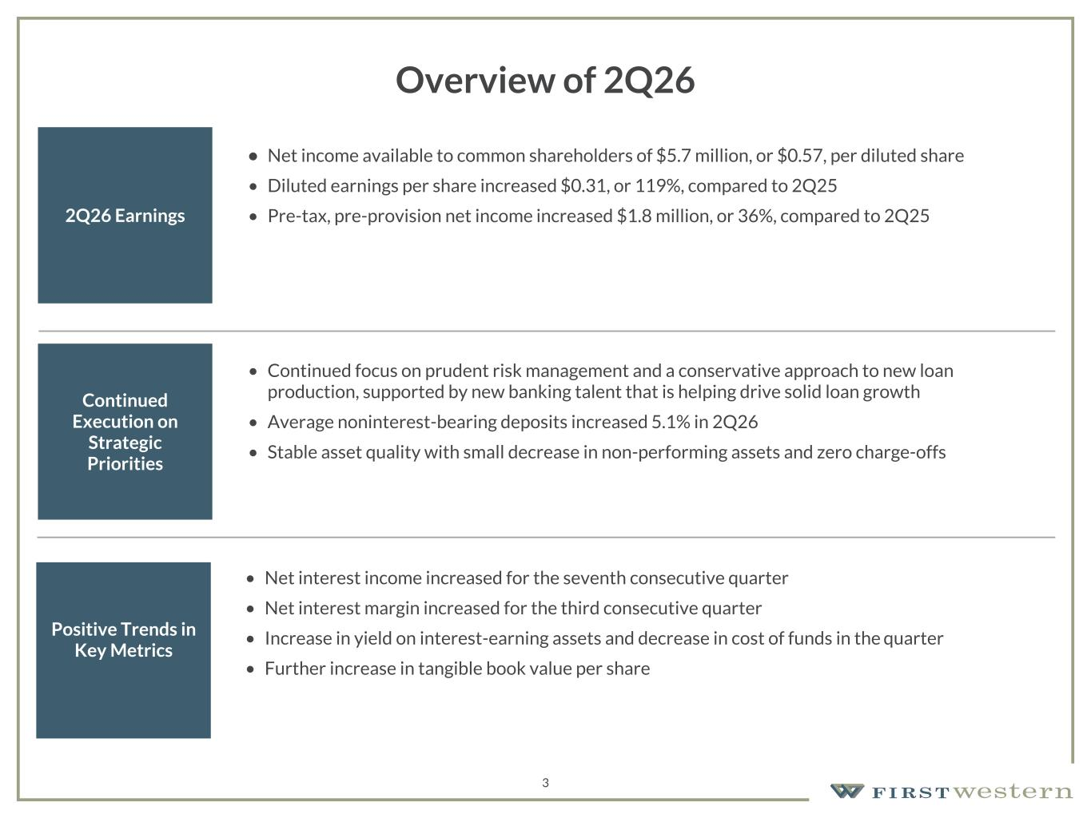
157 180 196 164 166 168 62 94 111 154 161 132 122 125 129 76 78 86 255 255 255 Chart color Table color Special Headlines Slide Headlines / Text on light background Primary Colors Secondary Colors Primary Background / Call Out Boxes / Text on dark background Chart color Table Color Tertiary Colors Chart color Table Color Chart Color Chart Color Approved Fonts AaBbCc 123 Lora (bold) Slide Headlines / Special Headlines AaBbCc 123 Lato(regular, bold, italics) Body Copy / Subheadings / Small Text Descriptions Overview of 2Q26 2Q26 Earnings • Net income available to common shareholders of $5.7 million, or $0.57, per diluted share • Diluted earnings per share increased $0.31, or 119%, compared to 2Q25 • Pre-tax, pre-provision net income increased $1.8 million, or 36%, compared to 2Q25 Continued Execution on Strategic Priorities • Continued focus on prudent risk management and a conservative approach to new loan production, supported by new banking talent that is helping drive solid loan growth • Average noninterest-bearing deposits increased 5.1% in 2Q26 • Stable asset quality with small decrease in non-performing assets and zero charge-offs Positive Trends in Key Metrics • Net interest income increased for the seventh consecutive quarter • Net interest margin increased for the third consecutive quarter • Increase in yield on interest-earning assets and decrease in cost of funds in the quarter • Further increase in tangible book value per share 3

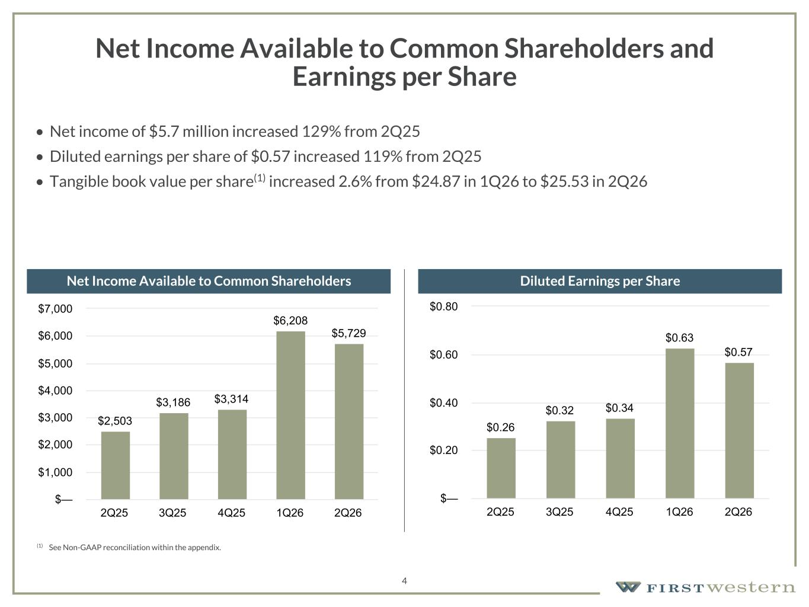
157 180 196 164 166 168 62 94 111 154 161 132 122 125 129 76 78 86 255 255 255 Chart color Table color Special Headlines Slide Headlines / Text on light background Primary Colors Secondary Colors Primary Background / Call Out Boxes / Text on dark background Chart color Table Color Tertiary Colors Chart color Table Color Chart Color Chart Color Approved Fonts AaBbCc 123 Lora (bold) Slide Headlines / Special Headlines AaBbCc 123 Lato(regular, bold, italics) Body Copy / Subheadings / Small Text Descriptions 4 Net Income Available to Common Shareholders and Earnings per Share • Net income of $5.7 million increased 129% from 2Q25 • Diluted earnings per share of $0.57 increased 119% from 2Q25 • Tangible book value per share(1) increased 2.6% from $24.87 in 1Q26 to $25.53 in 2Q26 Net Income Available to Common Shareholders Diluted Earnings per Share $2,503 $3,186 $3,314 $6,208 $5,729 2Q25 3Q25 4Q25 1Q26 2Q26 $— $1,000 $2,000 $3,000 $4,000 $5,000 $6,000 $7,000 $0.26 $0.32 $0.34 $0.63 $0.57 2Q25 3Q25 4Q25 1Q26 2Q26 $— $0.20 $0.40 $0.60 $0.80 (1) See Non-GAAP reconciliation within the appendix.

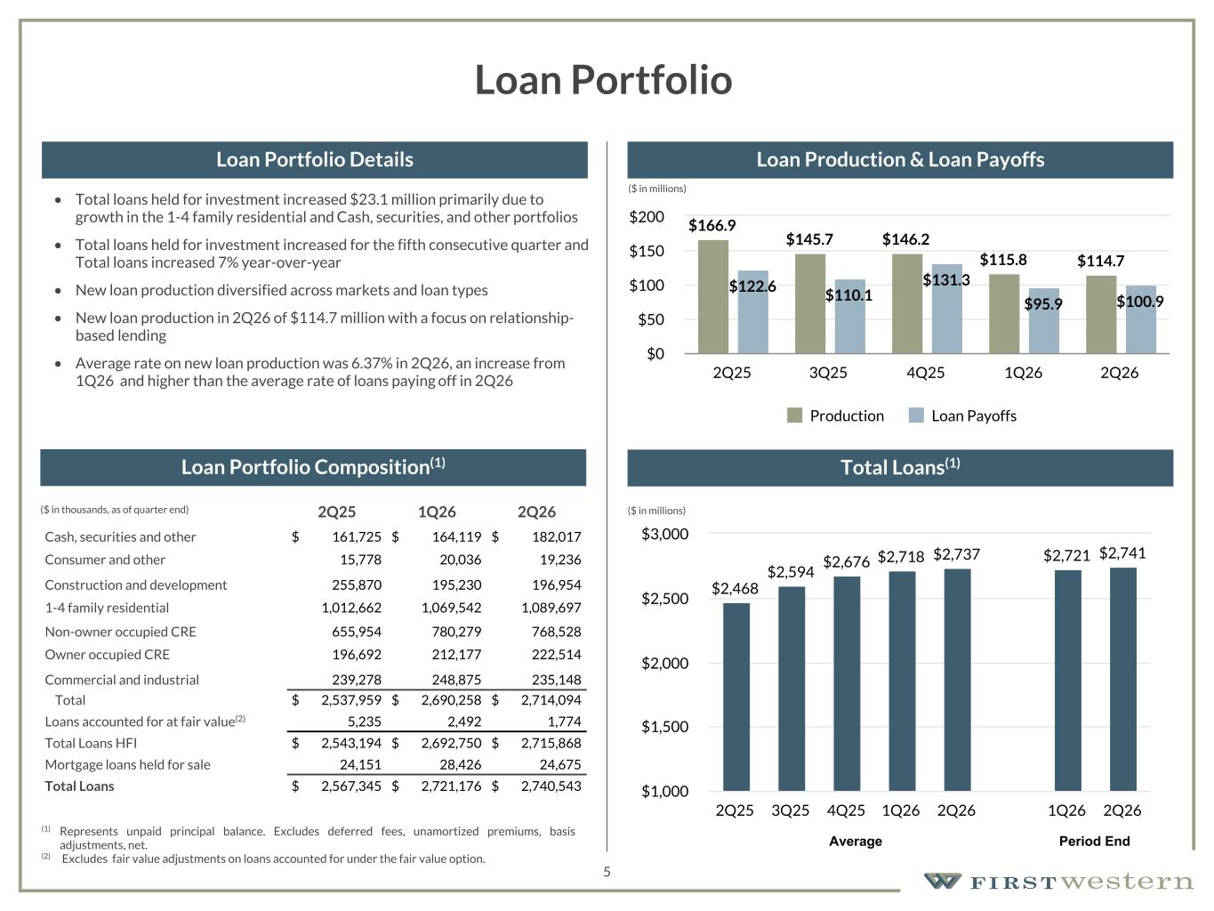
157 180 196 164 166 168 62 94 111 154 161 132 122 125 129 76 78 86 255 255 255 Chart color Table color Special Headlines Slide Headlines / Text on light background Primary Colors Secondary Colors Primary Background / Call Out Boxes / Text on dark background Chart color Table Color Tertiary Colors Chart color Table Color Chart Color Chart Color Approved Fonts AaBbCc 123 Lora (bold) Slide Headlines / Special Headlines AaBbCc 123 Lato (regular, bold, italics) Body Copy / Subheadings / Small Text Descriptions 5 Loan Portfolio • Total loans held for investment increased $23.1 million primarily due to growth in the 1-4 family residential and Cash, securities, and other portfolios • Total loans held for investment increased for the fifth consecutive quarter and Total loans increased 7% year-over-year • New loan production diversified across markets and loan types • New loan production in 2Q26 of $114.7 million with a focus on relationship- based lending • Average rate on new loan production was 6.37% in 2Q26, an increase from 1Q26 and higher than the average rate of loans paying off in 2Q26 2Q25 1Q26 2Q26 Cash, securities and other $ 161,725 $ 164,119 $ 182,017 Consumer and other 15,778 20,036 19,236 Construction and development 255,870 195,230 196,954 1-4 family residential 1,012,662 1,069,542 1,089,697 Non-owner occupied CRE 655,954 780,279 768,528 Owner occupied CRE 196,692 212,177 222,514 Commercial and industrial 239,278 248,875 235,148 Total $ 2,537,959 $ 2,690,258 $ 2,714,094 Loans accounted for at fair value(2) 5,235 2,492 1,774 Total Loans HFI $ 2,543,194 $ 2,692,750 $ 2,715,868 Mortgage loans held for sale 24,151 28,426 24,675 Total Loans $ 2,567,345 $ 2,721,176 $ 2,740,543 (1) Represents unpaid principal balance. Excludes deferred fees, unamortized premiums, basis adjustments, net. (2) Excludes fair value adjustments on loans accounted for under the fair value option. ($ in thousands, as of quarter end) Loan Portfolio Composition(1) Loan Portfolio Details Loan Production & Loan Payoffs Total Loans(1) $2,468 $2,594 $2,676 $2,718 $2,737 $2,721 $2,741 2Q25 3Q25 4Q25 1Q26 2Q26 1Q26 2Q26 $1,000 $1,500 $2,000 $2,500 $3,000 Average Period End $166.9 $145.7 $146.2 $115.8 $114.7 $122.6 $110.1 $131.3 $95.9 $100.9 Production Loan Payoffs 2Q25 3Q25 4Q25 1Q26 2Q26 $0 $50 $100 $150 $200 ($ in millions) ($ in millions)

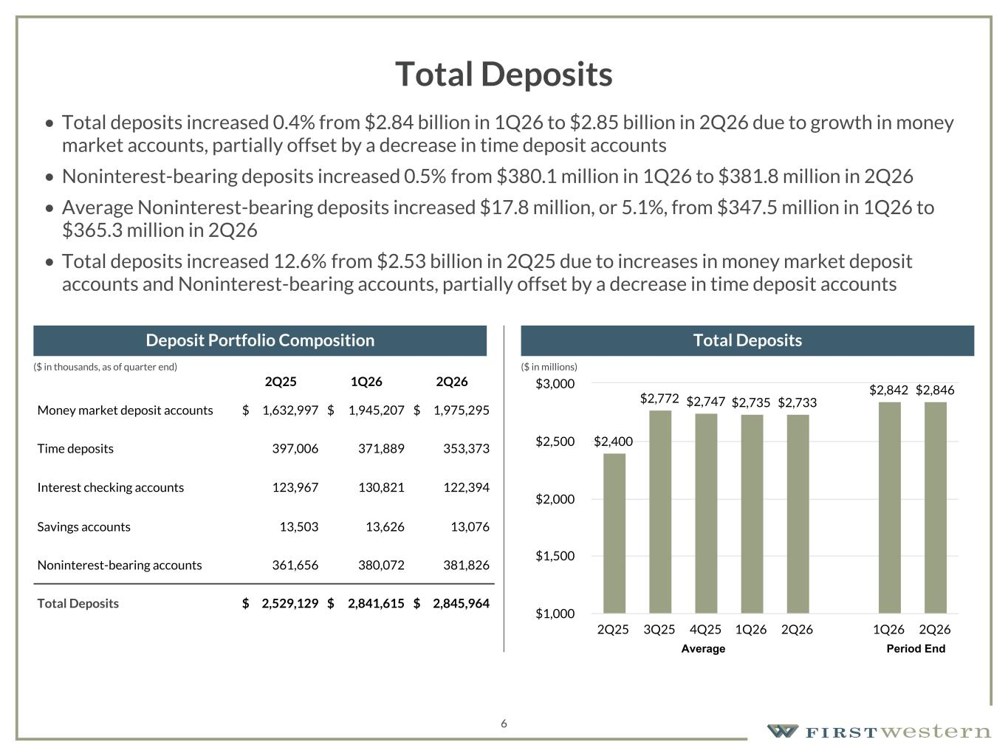
157 180 196 164 166 168 62 94 111 154 161 132 122 125 129 76 78 86 255 255 255 Chart color Table color Special Headlines Slide Headlines / Text on light background Primary Colors Secondary Colors Primary Background / Call Out Boxes / Text on dark background Chart color Table Color Tertiary Colors Chart color Table Color Chart Color Chart Color Approved Fonts AaBbCc 123 Lora (bold) Slide Headlines / Special Headlines AaBbCc 123 Lato (regular, bold, italics) Body Copy / Subheadings / Small Text Descriptions 6 Total Deposits • Total deposits increased 0.4% from $2.84 billion in 1Q26 to $2.85 billion in 2Q26 due to growth in money market accounts, partially offset by a decrease in time deposit accounts • Noninterest-bearing deposits increased 0.5% from $380.1 million in 1Q26 to $381.8 million in 2Q26 • Average Noninterest-bearing deposits increased $17.8 million, or 5.1%, from $347.5 million in 1Q26 to $365.3 million in 2Q26 • Total deposits increased 12.6% from $2.53 billion in 2Q25 due to increases in money market deposit accounts and Noninterest-bearing accounts, partially offset by a decrease in time deposit accounts 2Q25 1Q26 2Q26 Money market deposit accounts $ 1,632,997 $ 1,945,207 $ 1,975,295 Time deposits 397,006 371,889 353,373 Interest checking accounts 123,967 130,821 122,394 Savings accounts 13,503 13,626 13,076 Noninterest-bearing accounts 361,656 380,072 381,826 Total Deposits $ 2,529,129 $ 2,841,615 $ 2,845,964 Deposit Portfolio Composition Total Deposits $2,400 $2,772 $2,747 $2,735 $2,733 $2,842 $2,846 2Q25 3Q25 4Q25 1Q26 2Q26 1Q26 2Q26 $1,000 $1,500 $2,000 $2,500 $3,000 Average Period End ($ in millions)($ in thousands, as of quarter end)

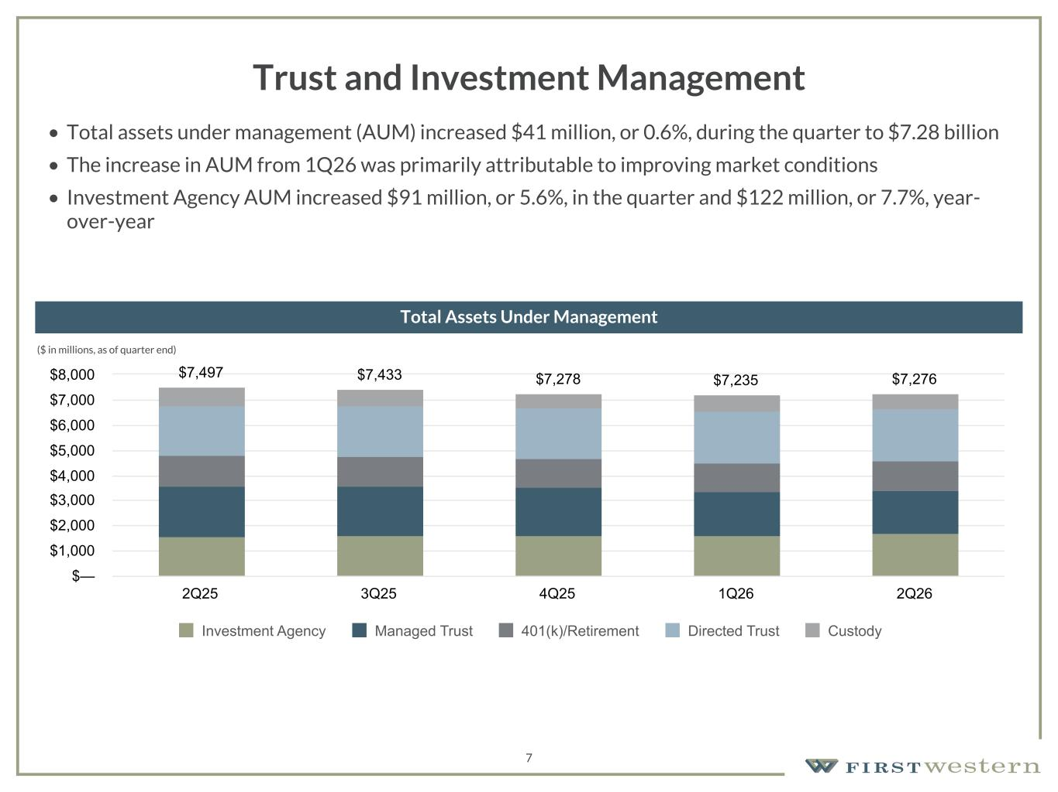
157 180 196 164 166 168 62 94 111 154 161 132 122 125 129 76 78 86 255 255 255 Chart color Table color Special Headlines Slide Headlines / Text on light background Primary Colors Secondary Colors Primary Background / Call Out Boxes / Text on dark background Chart color Table Color Tertiary Colors Chart color Table Color Chart Color Chart Color Approved Fonts AaBbCc 123 Lora (bold) Slide Headlines / Special Headlines AaBbCc 123 Lato (regular, bold, italics) Body Copy / Subheadings / Small Text Descriptions 7 Trust and Investment Management • Total assets under management (AUM) increased $41 million, or 0.6%, during the quarter to $7.28 billion • The increase in AUM from 1Q26 was primarily attributable to improving market conditions • Investment Agency AUM increased $91 million, or 5.6%, in the quarter and $122 million, or 7.7%, year- over-year ($ in millions, as of quarter end) Total Assets Under Management $7,497 $7,433 $7,278 $7,235 $7,276 Investment Agency Managed Trust 401(k)/Retirement Directed Trust Custody 2Q25 3Q25 4Q25 1Q26 2Q26 $— $1,000 $2,000 $3,000 $4,000 $5,000 $6,000 $7,000 $8,000

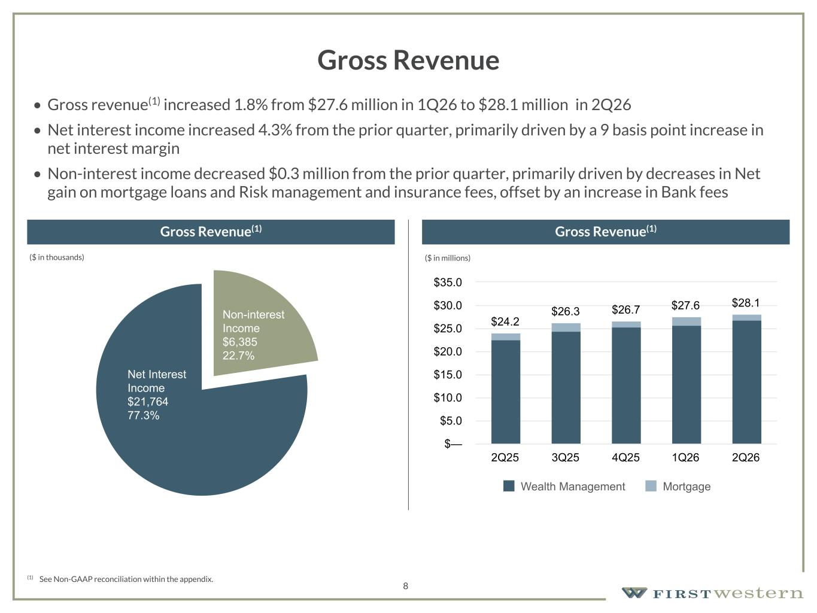
157 180 196 164 166 168 62 94 111 154 161 132 122 125 129 76 78 86 255 255 255 Chart color Table color Special Headlines Slide Headlines / Text on light background Primary Colors Secondary Colors Primary Background / Call Out Boxes / Text on dark background Chart color Table Color Tertiary Colors Chart color Table Color Chart Color Chart Color Approved Fonts AaBbCc 123 Lora (bold) Slide Headlines / Special Headlines AaBbCc 123 Lato (regular, bold, italics) Body Copy / Subheadings / Small Text Descriptions (1) See Non-GAAP reconciliation within the appendix. Gross Revenue Gross Revenue(1) Gross Revenue(1) 8 $24.2 $26.3 $26.7 $27.6 $28.1 Wealth Management Mortgage 2Q25 3Q25 4Q25 1Q26 2Q26 $— $5.0 $10.0 $15.0 $20.0 $25.0 $30.0 $35.0 • Gross revenue(1) increased 1.8% from $27.6 million in 1Q26 to $28.1 million in 2Q26 • Net interest income increased 4.3% from the prior quarter, primarily driven by a 9 basis point increase in net interest margin • Non-interest income decreased $0.3 million from the prior quarter, primarily driven by decreases in Net gain on mortgage loans and Risk management and insurance fees, offset by an increase in Bank fees Non-interest Income $6,385 22.7% Net Interest Income $21,764 77.3% ($ in thousands) ($ in millions)

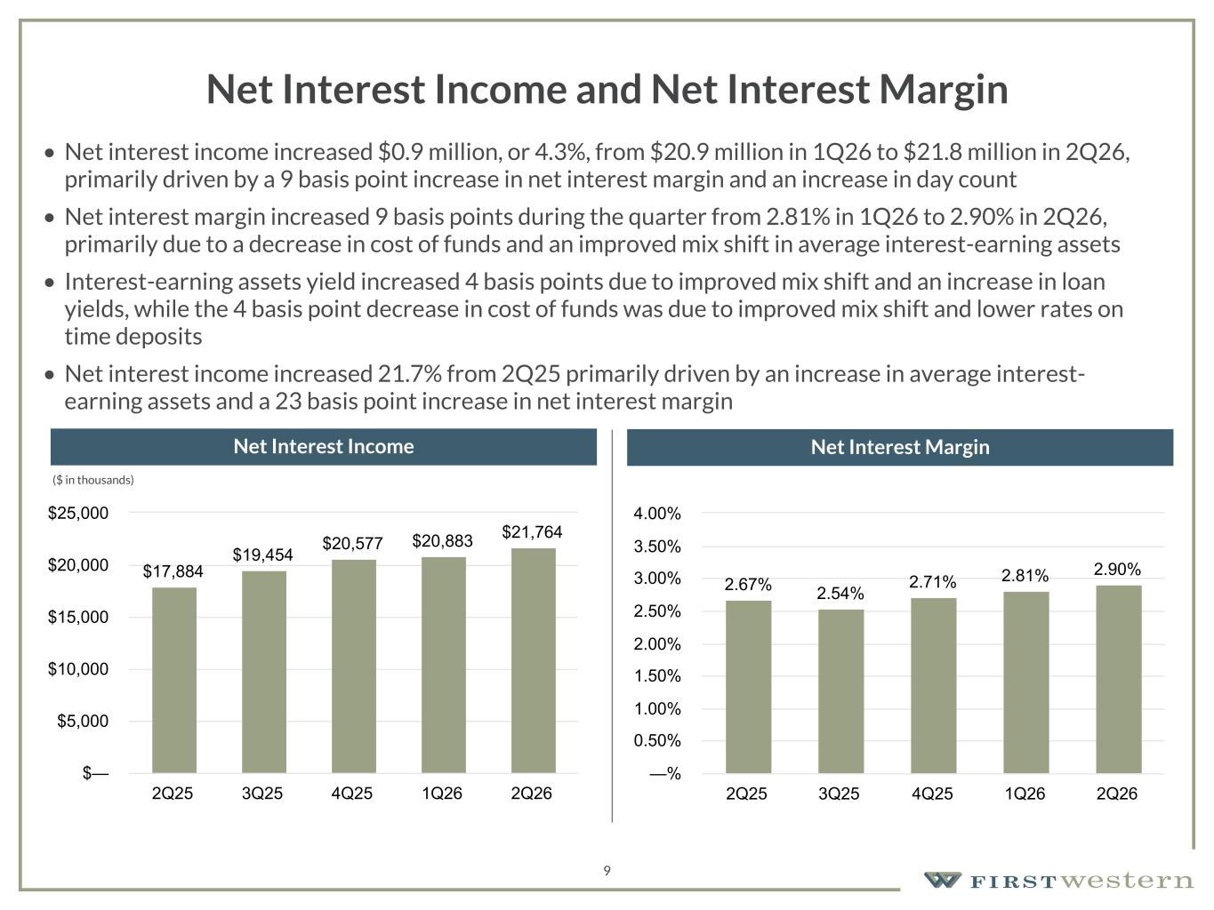
157 180 196 164 166 168 62 94 111 154 161 132 122 125 129 76 78 86 255 255 255 Chart color Table color Special Headlines Slide Headlines / Text on light background Primary Colors Secondary Colors Primary Background / Call Out Boxes / Text on dark background Chart color Table Color Tertiary Colors Chart color Table Color Chart Color Chart Color Approved Fonts AaBbCc 123 Lora (bold) Slide Headlines / Special Headlines AaBbCc 123 Lato (regular, bold, italics) Body Copy / Subheadings / Small Text Descriptions 9 Net Interest Income and Net Interest Margin • Net interest income increased $0.9 million, or 4.3%, from $20.9 million in 1Q26 to $21.8 million in 2Q26, primarily driven by a 9 basis point increase in net interest margin and an increase in day count • Net interest margin increased 9 basis points during the quarter from 2.81% in 1Q26 to 2.90% in 2Q26, primarily due to a decrease in cost of funds and an improved mix shift in average interest-earning assets • Interest-earning assets yield increased 4 basis points due to improved mix shift and an increase in loan yields, while the 4 basis point decrease in cost of funds was due to improved mix shift and lower rates on time deposits • Net interest income increased 21.7% from 2Q25 primarily driven by an increase in average interest- earning assets and a 23 basis point increase in net interest margin Net Interest Income Net Interest Margin $17,884 $19,454 $20,577 $20,883 $21,764 2Q25 3Q25 4Q25 1Q26 2Q26 $— $5,000 $10,000 $15,000 $20,000 $25,000 2.67% 2.54% 2.71% 2.81% 2.90% 2Q25 3Q25 4Q25 1Q26 2Q26 —% 0.50% 1.00% 1.50% 2.00% 2.50% 3.00% 3.50% 4.00% ($ in thousands)

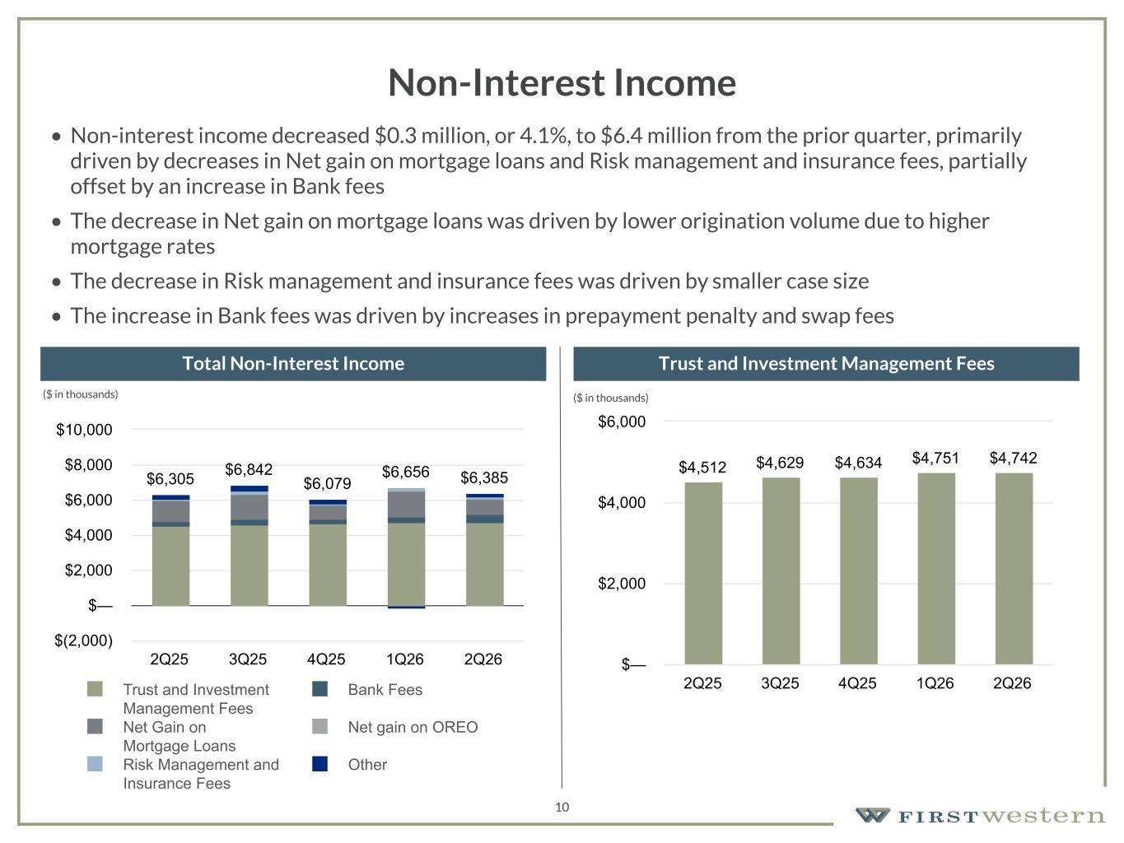
157 180 196 164 166 168 62 94 111 154 161 132 122 125 129 76 78 86 255 255 255 Chart color Table color Special Headlines Slide Headlines / Text on light background Primary Colors Secondary Colors Primary Background / Call Out Boxes / Text on dark background Chart color Table Color Tertiary Colors Chart color Table Color Chart Color Chart Color Approved Fonts AaBbCc 123 Lora (bold) Slide Headlines / Special Headlines AaBbCc 123 Lato (regular, bold, italics) Body Copy / Subheadings / Small Text Descriptions 10 Non-Interest Income • Non-interest income decreased $0.3 million, or 4.1%, to $6.4 million from the prior quarter, primarily driven by decreases in Net gain on mortgage loans and Risk management and insurance fees, partially offset by an increase in Bank fees • The decrease in Net gain on mortgage loans was driven by lower origination volume due to higher mortgage rates • The decrease in Risk management and insurance fees was driven by smaller case size • The increase in Bank fees was driven by increases in prepayment penalty and swap fees Total Non-Interest Income Trust and Investment Management Fees $6,305 $6,842 $6,079 $6,656 $6,385 Trust and Investment Management Fees Bank Fees Net Gain on Mortgage Loans Net gain on OREO Risk Management and Insurance Fees Other 2Q25 3Q25 4Q25 1Q26 2Q26 $(2,000) $— $2,000 $4,000 $6,000 $8,000 $10,000 $4,512 $4,629 $4,634 $4,751 $4,742 2Q25 3Q25 4Q25 1Q26 2Q26 $— $2,000 $4,000 $6,000 ($ in thousands) ($ in thousands)

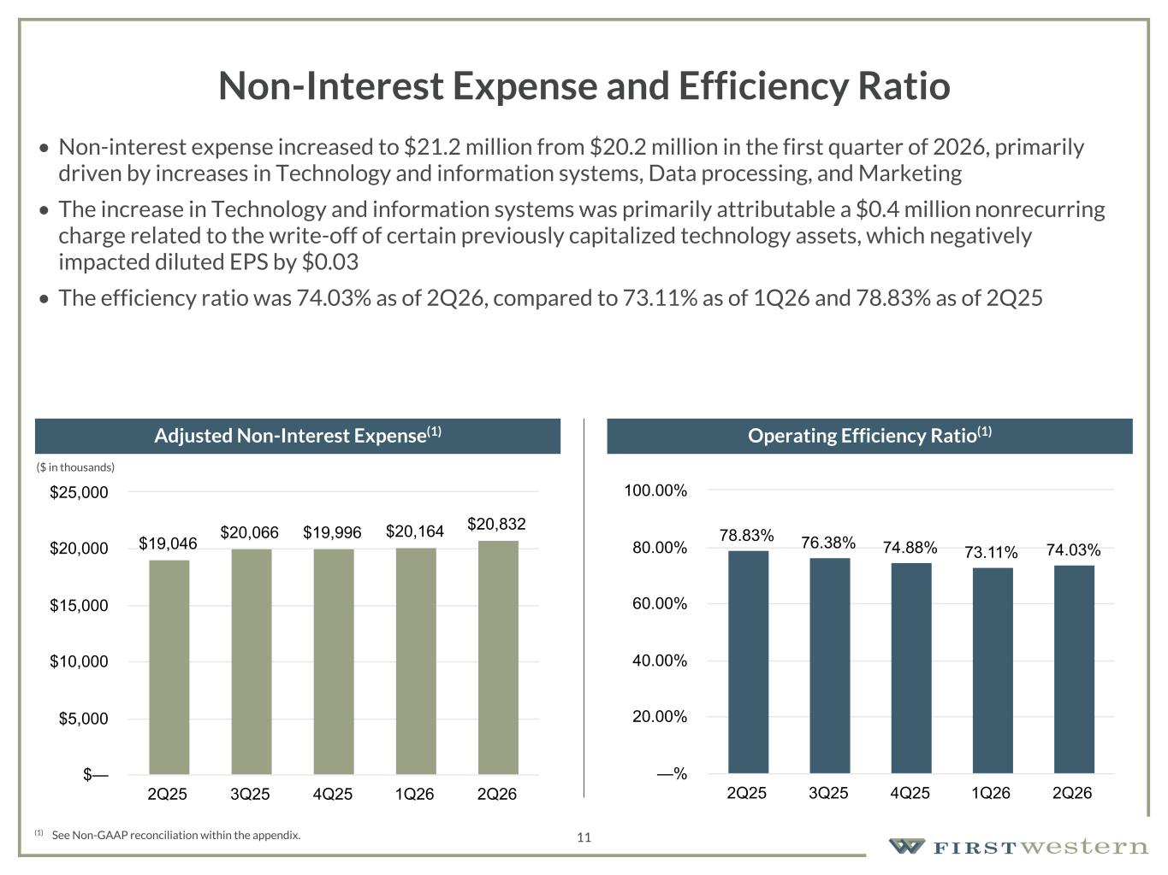
157 180 196 164 166 168 62 94 111 154 161 132 122 125 129 76 78 86 255 255 255 Chart color Table color Special Headlines Slide Headlines / Text on light background Primary Colors Secondary Colors Primary Background / Call Out Boxes / Text on dark background Chart color Table Color Tertiary Colors Chart color Table Color Chart Color Chart Color Approved Fonts AaBbCc 123 Lora (bold) Slide Headlines / Special Headlines AaBbCc 123 Lato (regular, bold, italics) Body Copy / Subheadings / Small Text Descriptions 11 Non-Interest Expense and Efficiency Ratio • Non-interest expense increased to $21.2 million from $20.2 million in the first quarter of 2026, primarily driven by increases in Technology and information systems, Data processing, and Marketing • The increase in Technology and information systems was primarily attributable a $0.4 million nonrecurring charge related to the write-off of certain previously capitalized technology assets, which negatively impacted diluted EPS by $0.03 • The efficiency ratio was 74.03% as of 2Q26, compared to 73.11% as of 1Q26 and 78.83% as of 2Q25 (1) See Non-GAAP reconciliation within the appendix. Adjusted Non-Interest Expense(1) Operating Efficiency Ratio(1) (1) (1) (1) $19,046 $20,066 $19,996 $20,164 $20,832 2Q25 3Q25 4Q25 1Q26 2Q26 $— $5,000 $10,000 $15,000 $20,000 $25,000 78.83% 76.38% 74.88% 73.11% 74.03% 2Q25 3Q25 4Q25 1Q26 2Q26 —% 20.00% 40.00% 60.00% 80.00% 100.00% ($ in thousands)

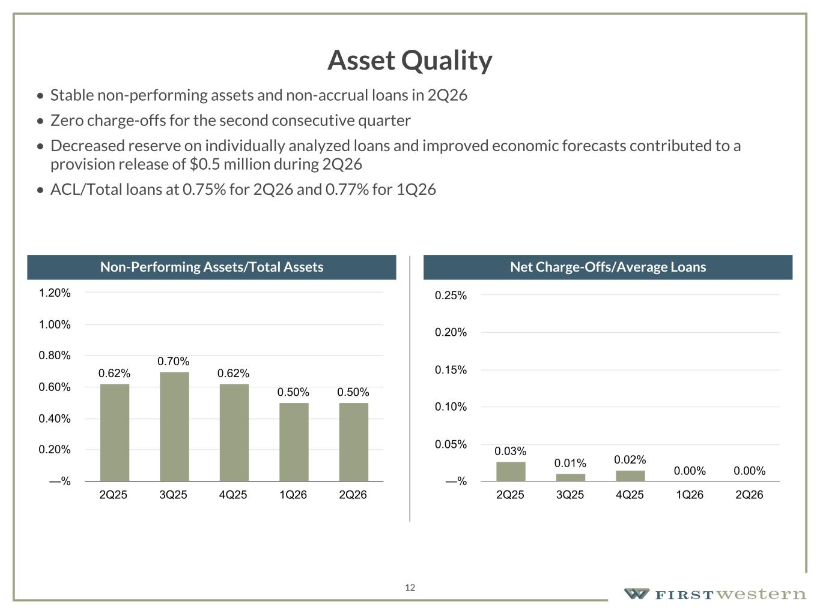
157 180 196 164 166 168 62 94 111 154 161 132 122 125 129 76 78 86 255 255 255 Chart color Table color Special Headlines Slide Headlines / Text on light background Primary Colors Secondary Colors Primary Background / Call Out Boxes / Text on dark background Chart color Table Color Tertiary Colors Chart color Table Color Chart Color Chart Color Approved Fonts AaBbCc 123 Lora (bold) Slide Headlines / Special Headlines AaBbCc 123 Lato (regular, bold, italics) Body Copy / Subheadings / Small Text Descriptions 12 Asset Quality • Stable non-performing assets and non-accrual loans in 2Q26 • Zero charge-offs for the second consecutive quarter • Decreased reserve on individually analyzed loans and improved economic forecasts contributed to a provision release of $0.5 million during 2Q26 • ACL/Total loans at 0.75% for 2Q26 and 0.77% for 1Q26 Non-Performing Assets/Total Assets Net Charge-Offs/Average Loans 0.62% 0.70% 0.62% 0.50% 0.50% 2Q25 3Q25 4Q25 1Q26 2Q26 —% 0.20% 0.40% 0.60% 0.80% 1.00% 1.20% 0.03% 0.01% 0.02% 0.00% 0.00% 2Q25 3Q25 4Q25 1Q26 2Q26 —% 0.05% 0.10% 0.15% 0.20% 0.25%

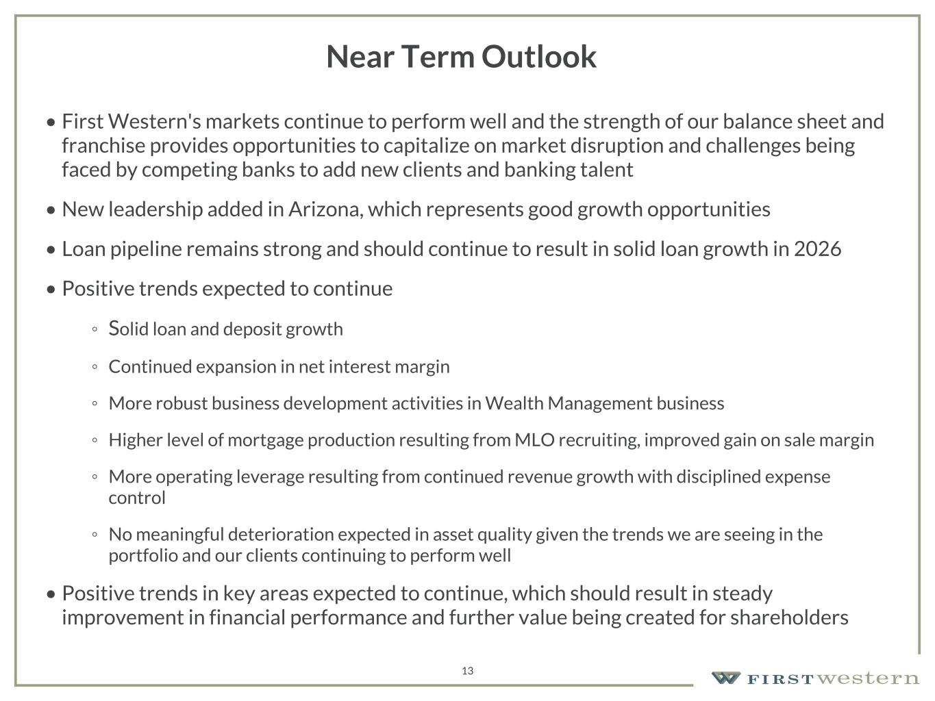
157 180 196 164 166 168 62 94 111 154 161 132 122 125 129 76 78 86 255 255 255 Chart color Table color Special Headlines Slide Headlines / Text on light background Primary Colors Secondary Colors Primary Background / Call Out Boxes / Text on dark background Chart color Table Color Tertiary Colors Chart color Table Color Chart Color Chart Color Approved Fonts AaBbCc 123 Lora (bold) Slide Headlines / Special Headlines AaBbCc 123 Lato (regular, bold, italics) Body Copy / Subheadings / Small Text Descriptions 13 Near Term Outlook • First Western's markets continue to perform well and the strength of our balance sheet and franchise provides opportunities to capitalize on market disruption and challenges being faced by competing banks to add new clients and banking talent • New leadership added in Arizona, which represents good growth opportunities • Loan pipeline remains strong and should continue to result in solid loan growth in 2026 • Positive trends expected to continue ◦ Solid loan and deposit growth ◦ Continued expansion in net interest margin ◦ More robust business development activities in Wealth Management business ◦ Higher level of mortgage production resulting from MLO recruiting, improved gain on sale margin ◦ More operating leverage resulting from continued revenue growth with disciplined expense control ◦ No meaningful deterioration expected in asset quality given the trends we are seeing in the portfolio and our clients continuing to perform well • Positive trends in key areas expected to continue, which should result in steady improvement in financial performance and further value being created for shareholders


Appendix 14

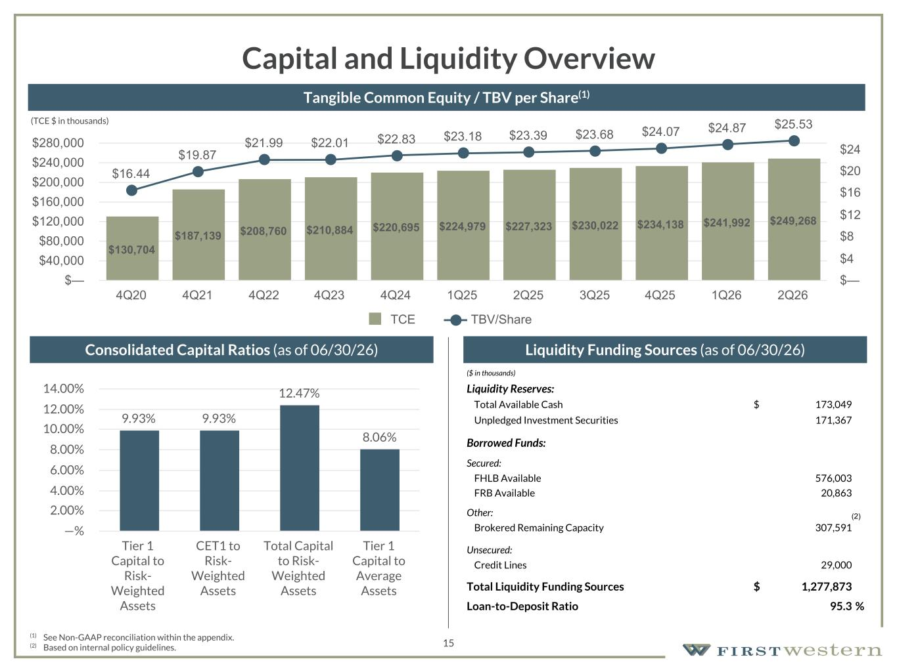
157 180 196 164 166 168 62 94 111 154 161 132 122 125 129 76 78 86 255 255 255 Chart color Table color Special Headlines Slide Headlines / Text on light background Primary Colors Secondary Colors Primary Background / Call Out Boxes / Text on dark background Chart color Table Color Tertiary Colors Chart color Table Color Chart Color Chart Color Approved Fonts AaBbCc 123 Lora (bold) Slide Headlines / Special Headlines AaBbCc 123 Lato (regular, bold, italics) Body Copy / Subheadings / Small Text Descriptions 15 Capital and Liquidity Overview Liquidity Funding Sources (as of 06/30/26) (1) See Non-GAAP reconciliation within the appendix. (2) Based on internal policy guidelines. Consolidated Capital Ratios (as of 06/30/26) Tangible Common Equity / TBV per Share(1) ($ in thousands) Liquidity Reserves: Total Available Cash $ 173,049 Unpledged Investment Securities 171,367 Borrowed Funds: Secured: FHLB Available 576,003 FRB Available 20,863 Other: Brokered Remaining Capacity 307,591 Unsecured: Credit Lines 29,000 Total Liquidity Funding Sources $ 1,277,873 Loan-to-Deposit Ratio 95.3 % 9.93% 9.93% 12.47% 8.06% Tier 1 Capital to Risk- Weighted Assets CET1 to Risk- Weighted Assets Total Capital to Risk- Weighted Assets Tier 1 Capital to Average Assets —% 2.00% 4.00% 6.00% 8.00% 10.00% 12.00% 14.00% (2) (TCE $ in thousands) $130,704 $187,139 $208,760 $210,884 $220,695 $224,979 $227,323 $230,022 $234,138 $241,992 $249,268 $16.44 $19.87 $21.99 $22.01 $22.83 $23.18 $23.39 $23.68 $24.07 $24.87 $25.53 TCE TBV/Share 4Q20 4Q21 4Q22 4Q23 4Q24 1Q25 2Q25 3Q25 4Q25 1Q26 2Q26 $— $40,000 $80,000 $120,000 $160,000 $200,000 $240,000 $280,000 $— $4 $8 $12 $16 $20 $24

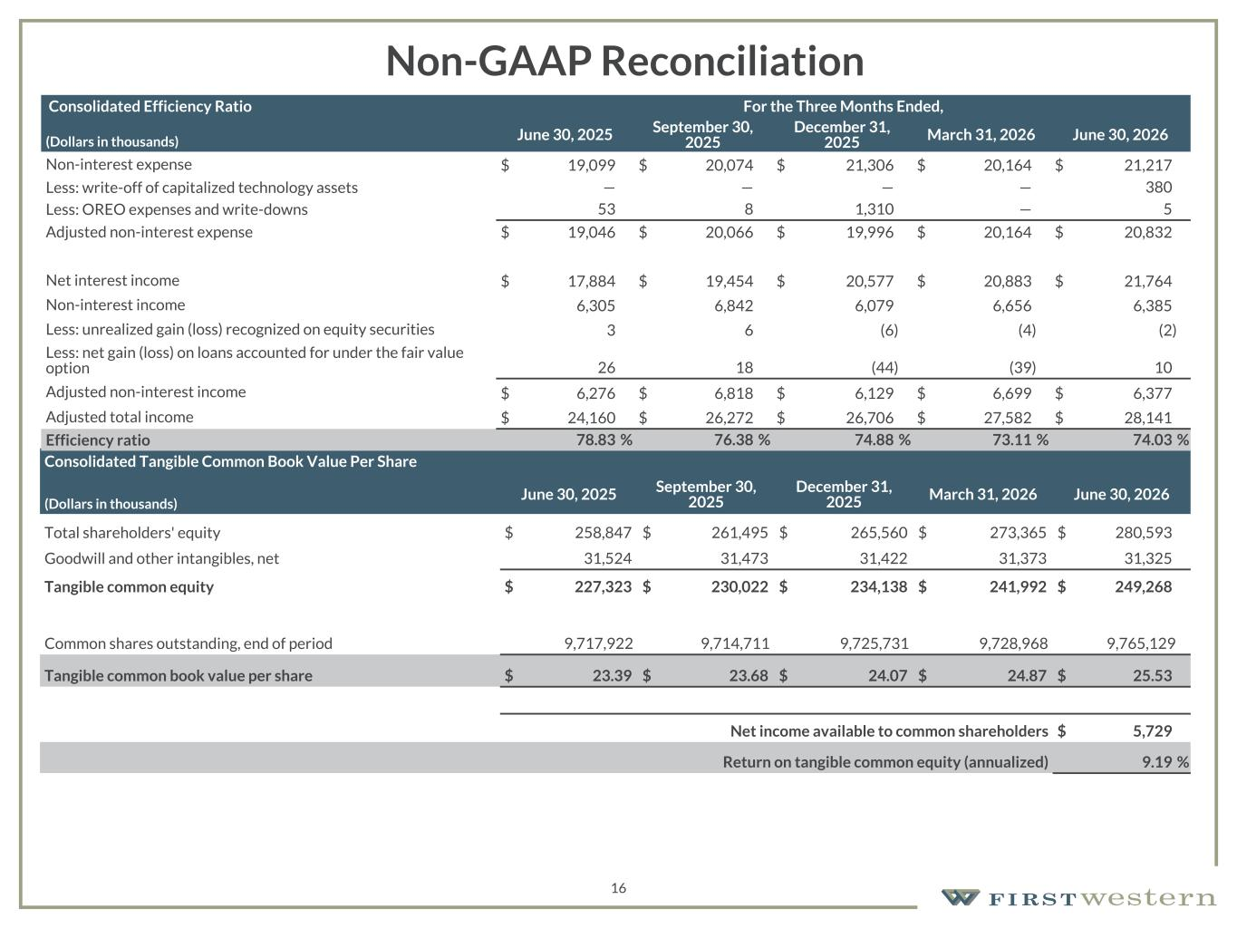
157 180 196 164 166 168 62 94 111 154 161 132 122 125 129 76 78 86 255 255 255 Chart color Table color Special Headlines Slide Headlines / Text on light background Primary Colors Secondary Colors Primary Background / Call Out Boxes / Text on dark background Chart color Table Color Tertiary Colors Chart color Table Color Chart Color Chart Color Approved Fonts AaBbCc 123 Lora (bold) Slide Headlines / Special Headlines AaBbCc 123 Lato (regular, bold, italics) Body Copy / Subheadings / Small Text Descriptions 16 Non-GAAP Reconciliation Consolidated Tangible Common Book Value Per Share (Dollars in thousands) June 30, 2025 September 30, 2025 December 31, 2025 March 31, 2026 June 30, 2026 Total shareholders' equity $ 258,847 $ 261,495 $ 265,560 $ 273,365 $ 280,593 Goodwill and other intangibles, net 31,524 31,473 31,422 31,373 31,325 Tangible common equity $ 227,323 $ 230,022 $ 234,138 $ 241,992 $ 249,268 Common shares outstanding, end of period 9,717,922 9,714,711 9,725,731 9,728,968 9,765,129 Tangible common book value per share $ 23.39 $ 23.68 $ 24.07 $ 24.87 $ 25.53 Net income available to common shareholders $ 5,729 Return on tangible common equity (annualized) 9.19 % Consolidated Efficiency Ratio For the Three Months Ended, (Dollars in thousands) June 30, 2025 September 30, 2025 December 31, 2025 March 31, 2026 June 30, 2026 Non-interest expense $ 19,099 $ 20,074 $ 21,306 $ 20,164 $ 21,217 Less: write-off of capitalized technology assets — — — — 380 Less: OREO expenses and write-downs 53 8 1,310 — 5 Adjusted non-interest expense $ 19,046 $ 20,066 $ 19,996 $ 20,164 $ 20,832 Net interest income $ 17,884 $ 19,454 $ 20,577 $ 20,883 $ 21,764 Non-interest income 6,305 6,842 6,079 6,656 6,385 Less: unrealized gain (loss) recognized on equity securities 3 6 (6) (4) (2) Less: net gain (loss) on loans accounted for under the fair value option 26 18 (44) (39) 10 Adjusted non-interest income $ 6,276 $ 6,818 $ 6,129 $ 6,699 $ 6,377 Adjusted total income $ 24,160 $ 26,272 $ 26,706 $ 27,582 $ 28,141 Efficiency ratio 78.83 % 76.38 % 74.88 % 73.11 % 74.03 %

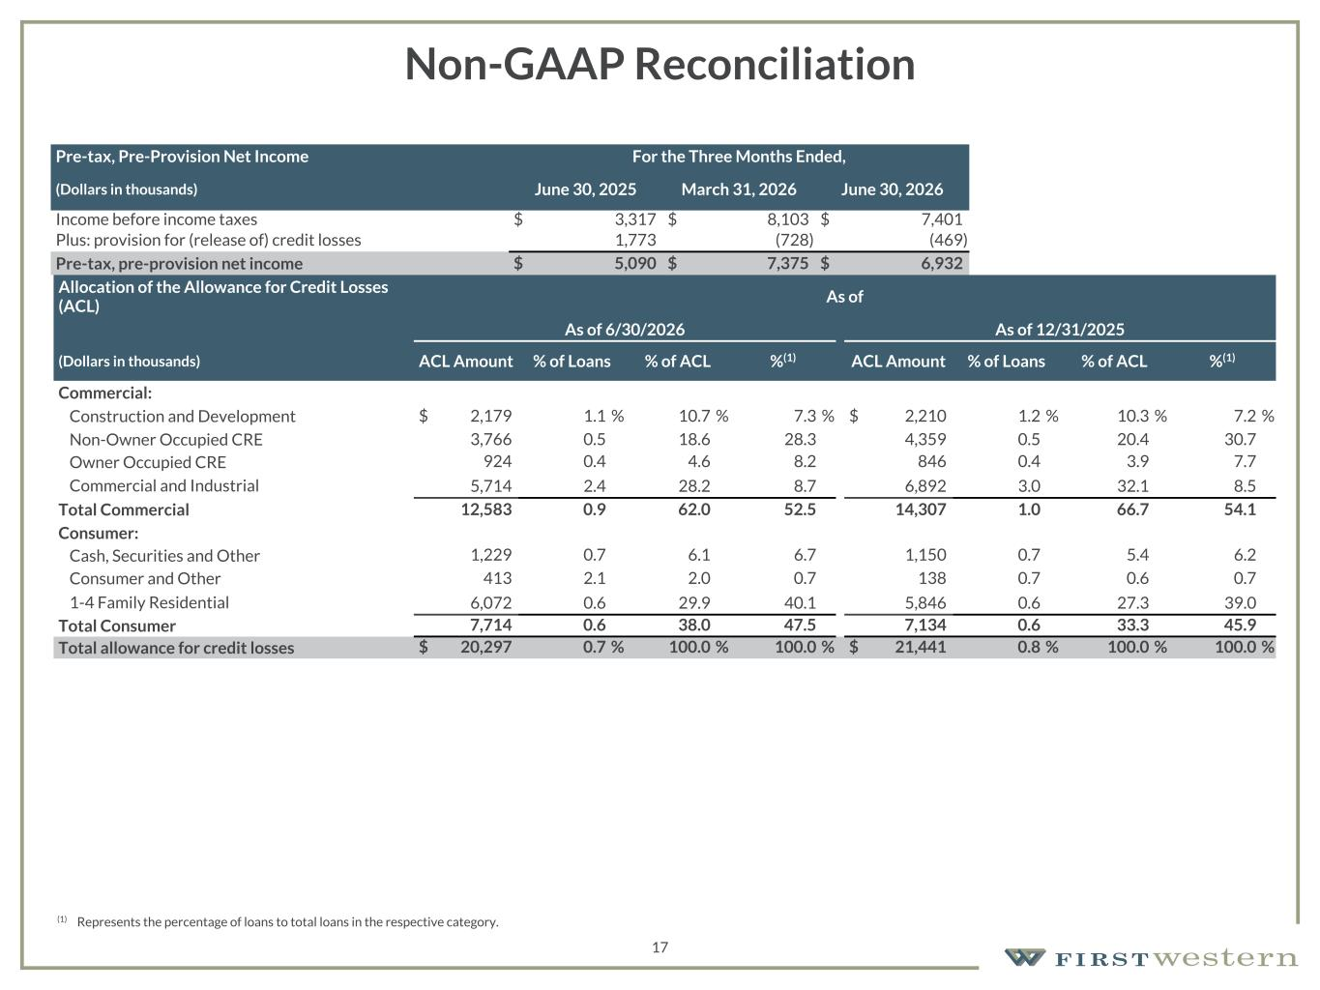
157 180 196 164 166 168 62 94 111 154 161 132 122 125 129 76 78 86 255 255 255 Chart color Table color Special Headlines Slide Headlines / Text on light background Primary Colors Secondary Colors Primary Background / Call Out Boxes / Text on dark background Chart color Table Color Tertiary Colors Chart color Table Color Chart Color Chart Color Approved Fonts AaBbCc 123 Lora (bold) Slide Headlines / Special Headlines AaBbCc 123 Lato (regular, bold, italics) Body Copy / Subheadings / Small Text Descriptions 17 Non-GAAP Reconciliation Pre-tax, Pre-Provision Net Income For the Three Months Ended, (Dollars in thousands) June 30, 2025 March 31, 2026 June 30, 2026 Income before income taxes $ 3,317 $ 8,103 $ 7,401 Plus: provision for (release of) credit losses 1,773 (728) (469) Pre-tax, pre-provision net income $ 5,090 $ 7,375 $ 6,932 Allocation of the Allowance for Credit Losses (ACL) As of As of 6/30/2026 As of 12/31/2025 (Dollars in thousands) ACL Amount % of Loans % of ACL %(1) ACL Amount % of Loans % of ACL %(1) Commercial: Construction and Development $ 2,179 1.1 % 10.7 % 7.3 % $ 2,210 1.2 % 10.3 % 7.2 % Non-Owner Occupied CRE 3,766 0.5 18.6 28.3 4,359 0.5 20.4 30.7 Owner Occupied CRE 924 0.4 4.6 8.2 846 0.4 3.9 7.7 Commercial and Industrial 5,714 2.4 28.2 8.7 6,892 3.0 32.1 8.5 Total Commercial 12,583 0.9 62.0 52.5 14,307 1.0 66.7 54.1 Consumer: Cash, Securities and Other 1,229 0.7 6.1 6.7 1,150 0.7 5.4 6.2 Consumer and Other 413 2.1 2.0 0.7 138 0.7 0.6 0.7 1-4 Family Residential 6,072 0.6 29.9 40.1 5,846 0.6 27.3 39.0 Total Consumer 7,714 0.6 38.0 47.5 7,134 0.6 33.3 45.9 Total allowance for credit losses $ 20,297 0.7 % 100.0 % 100.0 % $ 21,441 0.8 % 100.0 % 100.0 % (1) Represents the percentage of loans to total loans in the respective category.

